Name: _________________________________________ Period: __________
Builder Plans
(Use the Builder Plans PPT to complete these notes)

- Site Plan:

- What does a site plan show?

- Label 5 items on the site plan below from the list on #2.

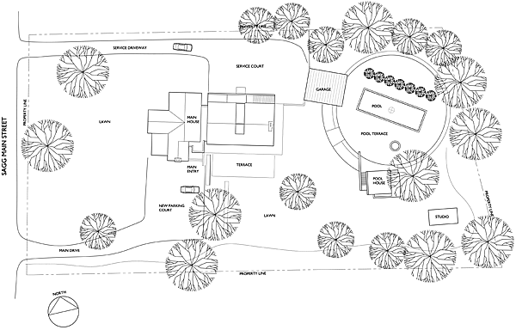
- Floor plan:

- What does a floor plan show?

- Scale for most floor plans is: ______________________
  - ‘=______
  - “=______
  - Exterior walls = ______
  - Interior walls = ______

- 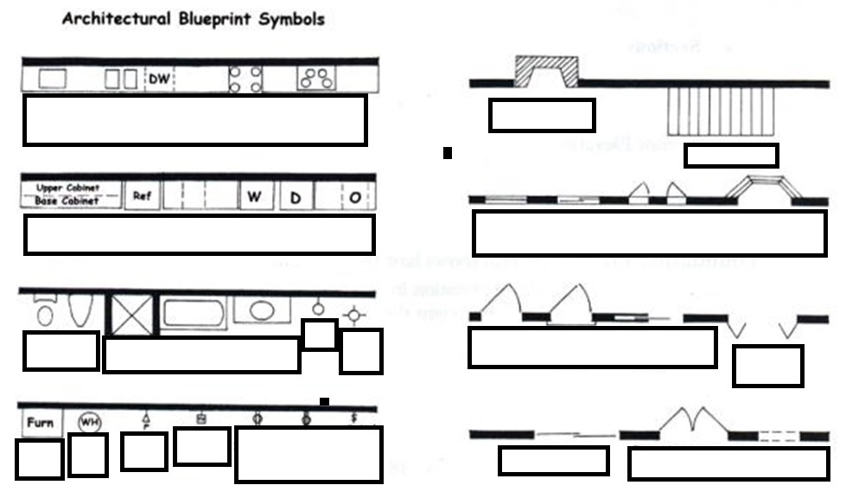Label each of the Blue Print Symbols:

- Elevations:

- Elevations show:

- Electrical and Lighting Plans:

- Electrical and Lighting Plans show:

- Label the Electrical and Lighting symbols on the plan below, using the legend as a key:
CEILING MOUNTED LIGHT, RECESSED DOWN LIGHT, EMERGENCY LIGHT, DUPLEX RECEPTACLE OUTLET,
NURSE CALL, TELEPHONE OUTLET, TV OUTLET, SMOKE DETECTOR,SWITCH, TV, 5' 0", 9' 0", 1' 10", 3' 0", 2' 10"
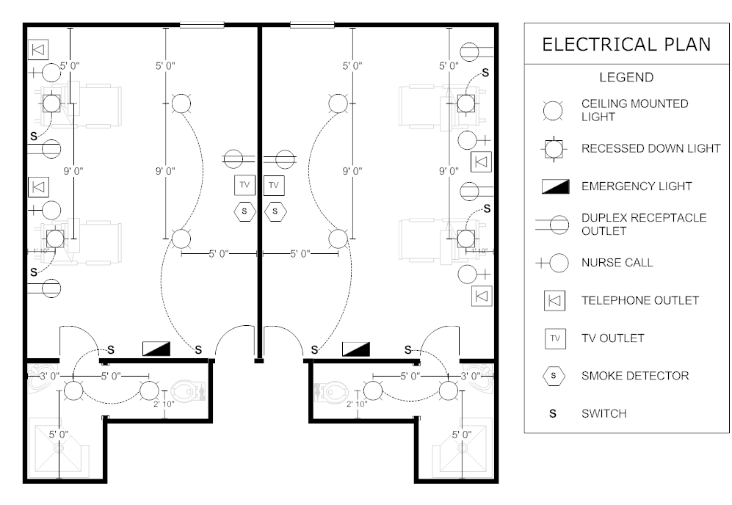

- Identify the pictures on the PPT as: Site plan, Floor plan, Elevation plan, Electrical plan.
13 a. ___________________________
13 b. ___________________________
13 c. ___________________________
13 d. ___________________________
13 e. ___________________________
13 f. ___________________________

NOTE: Chapter 5 and 7 in the Interiors Textbook are great resources for electrical symbols (Ch 5) and blueprint symbols (Ch 7).

