****

**Cell Phone Etiquette:**

***10 Do’s and Don’ts***

**Directions:** *Read the following information on cell phone etiquette and then complete and glue the given cross-word puzzle in your journal.*

Do’s:

1. **Do** keep all cellular “congress” brief and to the point.

 2. **Do** speak softly and try to maintain at least a 10-foot zone from anyone while talking. Cell phones are more sound sensitive and besides, shouting is not going to improve a bad connection.

3. **Do** tell callers when you’re talking on a mobile so they can anticipate distractions and disconnections.

4. **Do** turn your cell phone off during weddings, funerals, movies, live performances,

sports events, classes and dates.

5. **Do** say “NO” to cell phone chatter while driving. Those driving with and next to you

 will definitely benefit from your attention being on the road.

Don’ts:

1. **Don’t** interrupt a face-to-face conversation to take a cell-phone call. The person you are actually with takes priority. If you have a phone conversation in front of that person, you’re showing that he or she is unimportant to you.

2. **Don’t** talk in elevators, libraries, museums, restaurants, cemeteries, theaters, dentist or

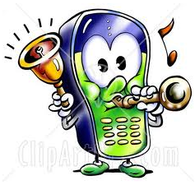 doctor waiting rooms, place of worship, auditoriums, airport gate waiting areas or other enclosed and often cramped public spaces, such as hospital emergency rooms or buses. People can’t escape your conversations.

3. **Don’t** use loud and annoying ring tones that destroy concentration and eardrums. Try

using your phone’s “vibrate” function instead or ringer in public.

4. **Don’t** “multi-task” by making calls while shopping, banking, waiting in line or conducting other personal business.

5. **Don’t** have and emotional conversations in public—ever!! Keep private matters private.



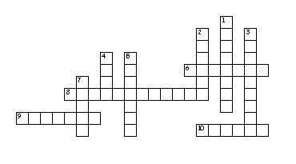

Cell Phone Etiquette: 10 Dos and Don’ts

**Across:**

6. Use this cell phone function in public.

8. Interrupting this kind of conversation will make people feel unimportant.

9. Talking in these type of public places makes it so others can’t escape your cell phone conversation.

10. In public, speak this way on the cell phone.

**Down:**

1. Keep these kind of conversations brief.

2. To avoid annoyances from callers who might get disconnected, let them know you are using a \_\_\_\_\_\_\_\_\_\_.

3. These cell phone conversations are a “no-no” in public.

4. Keep a 10-foot talking \_\_\_\_\_\_\_\_\_\_.

5. Driving and cell phone \_\_\_\_\_\_\_\_ don’t mix.

7. Cell phones should be turned off especially during live performances and these.



HH00442_Telephone Manners

\*\*\*Remember those first impressions can

come via a phone call!\*\*\*

**Directions:** *Read through the guidelines and then complete the questions. Glue your answer sheet into your journal page.*

TELEPHONE GUIDELINES

1. The one closest to the phone should answer it.

2. Say, “Hello,” with a clear and pleasant voice.

3. Give your name when you call someone. Say, “Hello, this is Brad, may I please

speak to Sue?”

4.When you answer the phone and it is for someone else say: “Hold on a moment

 and I’ll get him/her.” Gently, put the phone down and go to the requested

person to tell him/her. YELLING FOR THEM IS BAD MANNERS!

5. If the caller doesn’t identify himself/herself, and the person he/she wants

to talk it isn’t home, ask first, “Who’s calling please?” After you get a name,

ask, “Would you like to leave a message?”

6. Never give a stranger your phone number. First ask what number he/she is

calling. Then tell the caller if it is the right or wrong number.

7. If the call is for a parent and they are not home, never give out that specific

BS00764_ information. Just say they are unable to come to the phone right now and ask if

you can take a message.

8. Take and write down messages as requested and leave them where the person

 can find them!

9. Be respectful of other family member’s rights to the phone.

10. Don’t chew gum or eat while on the phone.

11. Don’t keep the caller waiting too long.

12. Don’t sing, hum or make distracting/rude noises while on the phone.

13. Don’t say “Guess who?” You might be disappointed if they don’t say your

 name!

14. Don’t let young children answer the phone. It is annoying to a caller.

15. Keep phone conversations short. You can wear out your welcome.