Tim Stack
tim@uen.org
my.uen.org/46807
March 2014

iMovie ’11: Narrated Slide Show

Classroom Ideas: Book report, Curriculum report, Lecture archive
Step by Step:
- Create the visuals:
Use Power\Point or Keynote to create the slide for the presentation. Don’t worry about animations, transitions or other special effects since these will not carry over to iMovie.
- Export from PowerPoint as jpgs.
  - Go to File >> Save as Pictures…
  - Select jpgs as file type
  - Click Save
  - The images will be saved into a sub folder next to the ppt.
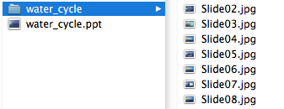
- Open iMovie >> Select File >> New Project
Name it, chose No Theme and set the Aspect Ration to Standard (4:3). This ratio matches the ratio of the slides outputted from PowerPoint.
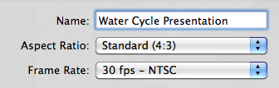
- Insert Images
  - Drag and drop the first slide from the Finder to the Project.
The default duration is 4 seconds. The length of the slide determines how long the recording can be so first lengthen the slide to longer than needed. For the first try 20 seconds.
    - Select the image
    - Click the Gear button and select Clip Adjustment
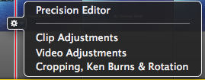
    - Then change the duration from 4:00 to 25:00
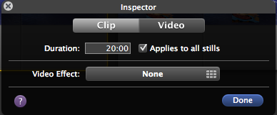
    - Check “Applies to all stills” so all future stills images automatically are set to a duration of 25 seconds.
- Recording Narration
  - Click the Mic button on the middle toolbar
  - Select your Mic from the Voiceover dialogue and adjust the settings as needed.
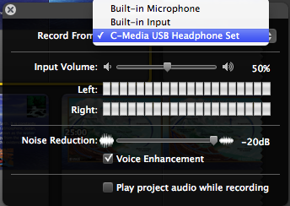
  - Click on the image/clip you want to record the voice over for and a 3 second countdown will start.
  - Begin speaking; notice a red highlight will show the progress of the recording.
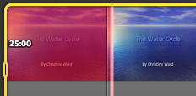
  - When finished click anywhere and the recording will stop. The audio clip will show as under the slide as a purple clip. The audio clip can be dragged to position more precisely.
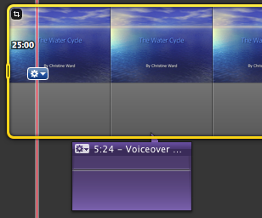
  - Once the voice over is done you can adjust the length of the slide to more closely match the audio by using the Clip Adjustment tool on the slide.
- Adding Video
Maybe you have a piece of video that helps you teach a topic or you want to add some video of yourself giving an intro or conclusion, both can be easily accomplished.
  - Existing Clip:
    - Go to File >> Import >> Movies
    - Browse to clip and select. Clip is added to the event library.
    - Click the Create new Event button and name. This is like a file cabinet drawer for the video associated with this project.
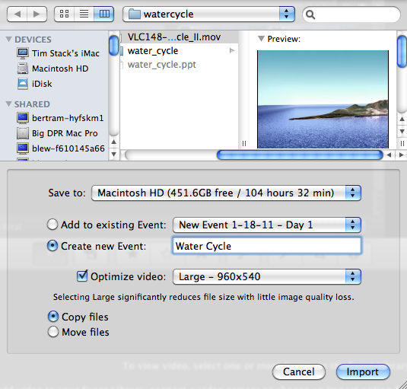
    - Select the clip from the Event Library and drag to the Project timeline.
    - You may also drag a movie file from the finder directly to the Timeline or Event Library

- Finish by adding any additional content and then us the Share menu to export your finished product.

