Tim Stack
tim@uen.org
2014

iMovie ’11: Movie Trailers

Classroom Ideas: Book reports, Fieldtrip highlights, FUN

Planning: Storyboard, script, shoot, import, edit, share

Step by Step:

- Getting Started
  - File >> New Project
  - Choose a Movie Trailer “theme”
Click once to get a preview, description, cast number and duration.
  - Name your project and set the correct Aspect Ratio. To avoid “letter boxing” the aspect ration of the project should match the aspect ratio of the raw footage.
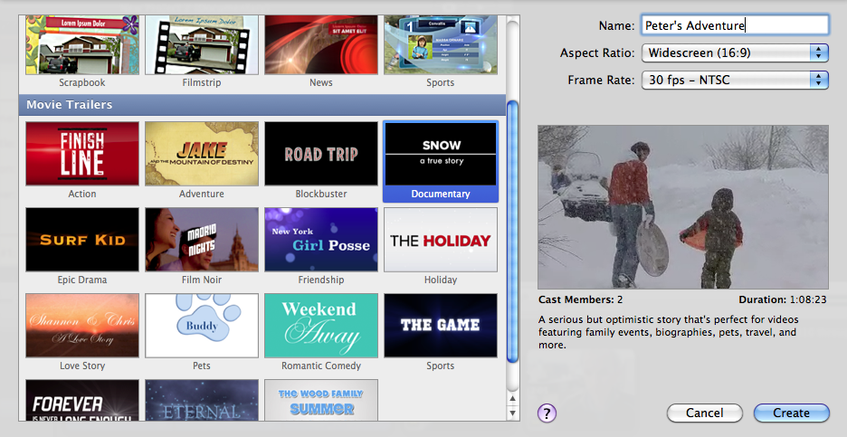
  - If needed import video footage into the Event Library. Go to File >> Import from Camera if footage is still on camera or just Import >> Movies if already on computer.
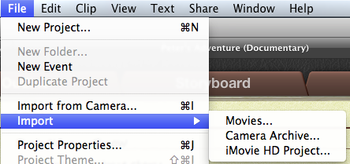
  - Create a New Event and name it the same as the project. This will make it easier to find and manage.
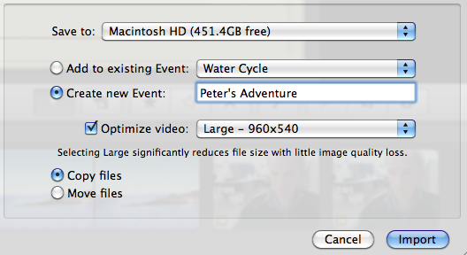
- Outline
  - Use the Outline Tab to edit all the titles, credits, and cast members.
  - Rolling over each section gives a preview.
- Storyboard
  - Each Text section is editable by clicking on it.
  - Adding video clips.
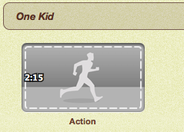
    - Each section gives you a length and shot type.
    - Look through your event library
    - Select an approximate amount of footage
    - Drag and drop onto the place holder
    - Click on the button in the lower left to adjust the portion of video used in this section
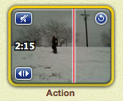
    - Clip audio is also easily muted
    - Continue on to next section
  - The Shot list tab allows you to see the clips grouped by shot types.

When the last clip is placed the video is complete and will play a preview. All parts are still editable through the three tabs.

Finish by exporting through the Share menu.

