Cognitive Demands of Writing
Warm-up: How fluent is your handwriting?

Skills in Writing
Lower-Level Cognitive Skills
Higher-Level Cognitive Demands
Physically forming letters using a pencil on paper.
Writing left to right.
Using story structure or expository structure.
Varying sentence structure.
Spacing words on the page.
Sticking to the plan.
Spelling high-frequency irregular words.
Phonetically spelling unknown words.
Using topic sentences in paragraphs.
Using uppercase letters as appropriate.
Keeping the goal of the composition in mind.
Keeping the audience’s needs in mind.
Using end punctuation.
Checking for insufficient or unnecessary detail.
Choosing precise vocabulary to express ideas.
Indenting paragraphs.

Cognitive Processes of Writing
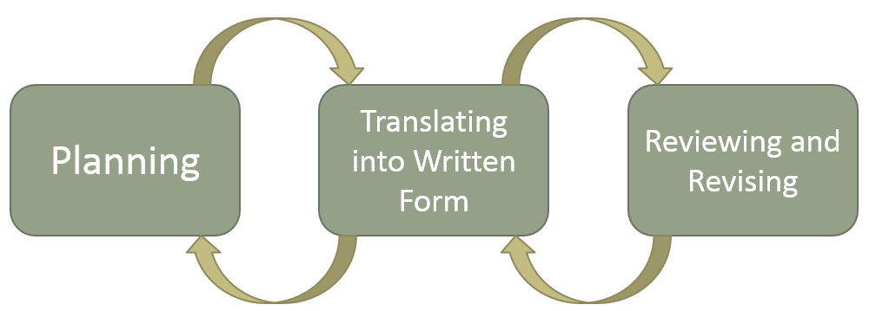

Cognitive Writing Processes
Planning
The planning component of writing involves generating and organizing idea. It should encompass the selection of a purpose for writing, decisions about the organizational structure the author will use, and the audience identification. In the planning process, the writer also may have to draw on ideas prompted by a given stimulus, such as a text, a picture, or an experience. This is the part of writing in which we try to identify what it is that we have to say and how we are going to say it.
Translating
In the translating phase of the writing process, ideas are converted into specific words, and the words are transcribed into written form. Ideas from the planning phase may be reformulated, reorganized, or discarded during the generating of written text. The translating phase of writing requires syntactic formulation, which is the piecing together of sentences that convey intended meaning and that conform to conventional standards of spelling, punctuation, grammar and usage.
Reviewing
In the review phase of the writing process, the writer reviews, edits, and/or rewrites text. Reviewing can take place midstream; it does not always happen after completion of the first draft of text. Many writers edit continually as they translate words onto the page. Reviewing requires the writer to stand back and reflect on what he or she has generated, preferably from the point of view of the person(s) who will be reading the finished work. An effective reviewing phase also requires the writer to evaluate how the piece will be interpreted by the audience.

