Option 3 Parent Readiness

The Price is Right Game
Teacher Information

SUPPLIES:
1. At least 25 containers of baby care products (lotion, shampoo, etc.), with prices listed on the bottom of each. (You may wish to ask students to help collect these containers, then give them extra points or a treat). You should also include pictures of baby furniture, clothes, etc. (along with their descriptions and prices). Cut these from catalogs or find pictures of these items from a store website. Attach each picture to one side of a sheet of construction paper, with its description and price attached to the other side.
You may also do this as a power point. Remember that you will need to update prices and items on a regular basis so that the game is current to the times.
2. Prizes (optional) such as frosted animal crackers for first round winners and a baby food jar full of candy for the grand prize. You could also use extra credit.
3. Calculator.

PROCEDURE:

Select a student to be the hostess and another student to be the mathematician. The teacher is the host. The front row of students, in desks, is the first group of contestants. The hostess will show them the first picture as he/she reads the description on the back. Contestants must guess the price of the object. Have them write their guesses on an index card, or a mini white board. The contestants then shows their guesses. The winner is the person guessing the closest price without going over the actual price.

This process is repeated with the next row of students until all rows have competed.

Those individuals then come to the front of the class and are shown five baby products. The object is to guess the prices of each. The mathematician keeps track of each price and gives the total. The actual price of each product is then revealed and the mathematician totals the actual prices. The person closest to without going over is the winner.

This game can be played many different ways. You could randomly select individuals up to “come on down” and the winner will play in the final round. The most important thing is that the students are made aware of the costs of baby supplies while having fun.
- Graco SnugRide 35 Infant Car Seat – Racer $149.99

Bright Starts Sunshine Carrier Toy Bar $10.99

BOB Revolution Stroller – Black $389.99
- Da Vinci Anastasia 3-in-1 Crib – Oak $299.99
- DaVinci Twilight 6" Crib Mattress $109.99
- South Shore Sweet Morning Changing Table - Romantic Pine $115.49
- Da Vinci Contour Changing Pad - 31in. x 16in. $36.99
- Naturepedic Organic Changing Pad Cover $29.99
- Winnie The Pooh Day with Friends 4-Piece Crib Bedding Set $89.99
- Carter's Deluxe Waterproof Crib Pad $17.99
- Diaper Genie II Elite Diaper Disposal System $39.99
- Playtex Diaper Genie II Refill $6.99
- Pampers Sensitive Baby Wipes - 512 Ct $15.99
- Pampers 180Ct Swaddlers Sensitive Diapers Value Box - Size 1 $40.99
- Desitin Ointment - 4 oz. $5.29
- Johnson & Johnson Baby Lotion - 27 oz. $6.79
- 55-piece Safety Swabs Pack $2.29
- Head-To-Toe Baby Wash $3.79
- Summer Infant Newborn to Toddler Fold Away Bath Tub $24.99
- JJ Cole Mode Diaper Bag - Cocoa Tree $59.99
- JJ Cole Essentials Diapers & Wipes Pod - Cocoa Tree $16.99
- Similac Advance Early Shield Infant Formula - 23.2 oz $22.49
- The First Years Night & Day Bottle Warmer $29.99
- Avent BPA Free 4-Pack Bottle 9 oz. $24.99
- Gerber NUK BPA Free Pacifier Stage 1 - 2 Pack – Neutral $4.99
- BooginHead PaciGrip $4.99
- The First Years Terry Teething Blanket $4.99
- Newborn Mittens - 3-Pack $5.99
- Gerber 3 Pack Terry Burpcloths – Neutral $4.99
- Gerber 5 Pack Onesie - White (3-6 Months) $9.99
- Gerber 6 Pack Sock - White (3-6 Months) $6.99
- Gerber 3 Pack Interlock Burpcloth Set – Neutral $8.99
- Bumkins 3-Pack Organic Cotton Everyday Bibs – Natural $13.99
- Graco Blossom 4-in-1 Highchair Seating System – Bombay $179.99
- Jeep Shopping Cart & High Chair Cover $24.99
- Fisher-Price Rainforest Bouncer $59.99
- Kids Line Soft & Fuzzy Pooh Fluffy Blanket $17.99
- Summer Infant Slim & Secure Handheld Video Monitor $199.99
- Fisher-Price Rainforest Melodies & Lights Deluxe Gym $69.99
- Fisher-Price Ocean Wonders Deep Blue Sea Mobile $49.99
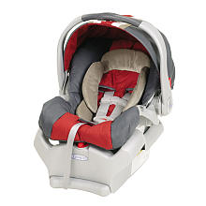

Graco SnugRide 35 Infant Car Seat – Racer

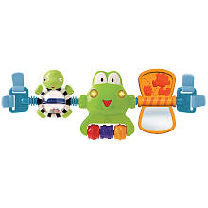

Bright Starts Sunshine Carrier Toy Bar

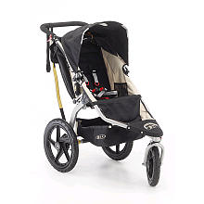

BOB Revolution Stroller - Black

Da Vinci Anastasia 3-in-1 Crib - Oak
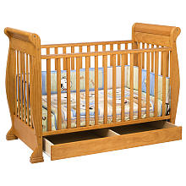

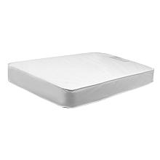
DaVinci Twilight 6" Crib Mattress

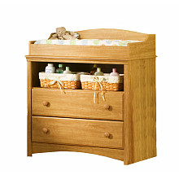

South Shore Sweet Morning Changing Table - Romantic Pine

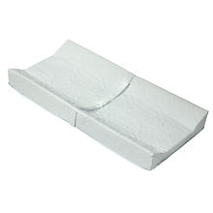

Da Vinci Contour Changing Pad - 31in. x 16in.

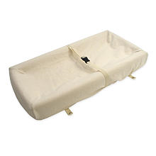

Naturepedic Organic Changing Pad Cover

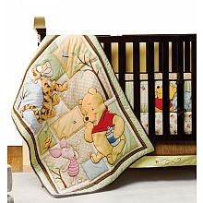

Winnie The Pooh Day with Friends 4-Piece Crib Bedding Set
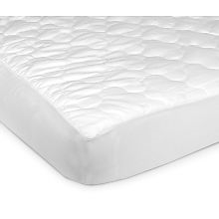

Carter's Deluxe Waterproof Crib Pad

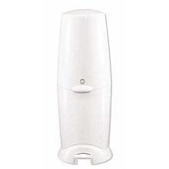

Diaper Genie II Elite Diaper Disposal System

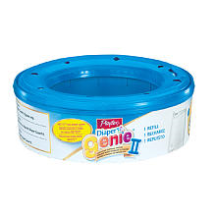

Playtex Diaper Genie II Refill

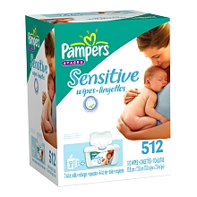

Pampers Sensitive Baby Wipes - 512 Ct

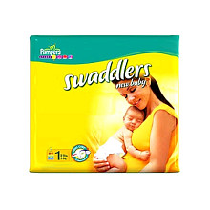

Pampers 180Ct Swaddlers Sensitive Diapers Value Box - Size 1

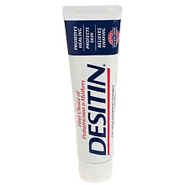

Desitin Ointment - 4 oz.

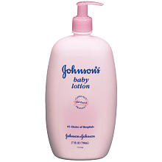

Johnson & Johnson Baby Lotion - 27 oz.

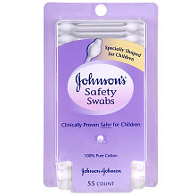

55-piece Safety Swabs Pack

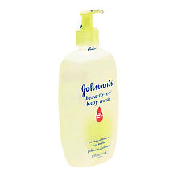

Head-To-Toe Baby Wash

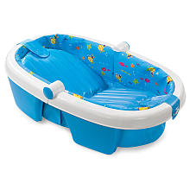

Summer Infant Newborn to Toddler Fold Away Bath Tub

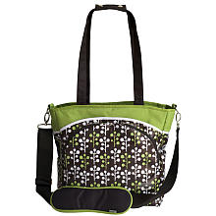

JJ Cole Mode Diaper Bag - Cocoa Tree

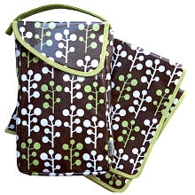

JJ Cole Essentials Diapers & Wipes Pod - Cocoa Tree

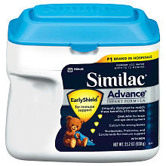

Similac Advance Early Shield Infant Formula - 23.2 oz

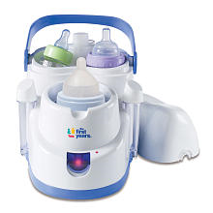

The First Years Night & Day Bottle Warmer

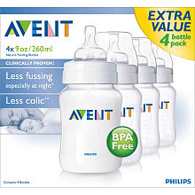

Avent BPA Free 4-Pack Bottle 9 oz.

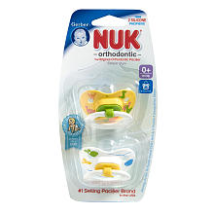

Gerber NUK BPA Free Pacifier Stage 1 - 2 Pack - Neutral
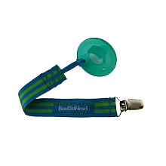

BooginHead PaciGrip

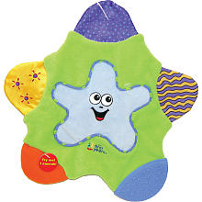

The First Years Terry Teething Blanket
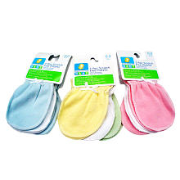

Newborn Mittens - 3-Pack

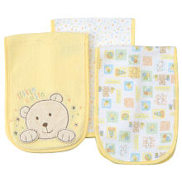

Gerber 3 Pack Terry Burpcloths - Neutral

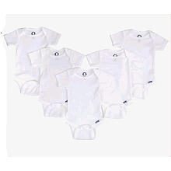

Gerber 5 Pack Onesie - White (3-6 Months)

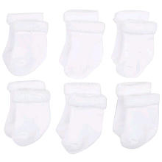

Gerber 6 Pack Sock - White (3-6 Months)

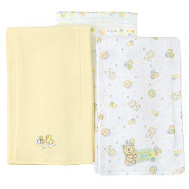

Gerber 3 Pack Interlock Burpcloth Set - Neutral

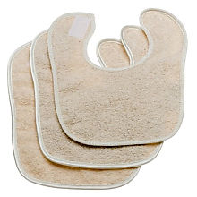

Bumkins 3-Pack Organic Cotton Everyday Bibs - Natural

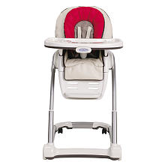

Graco Blossom 4-in-1 Highchair Seating System - Bombay
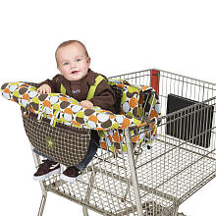

Jeep Shopping Cart & High Chair Cover

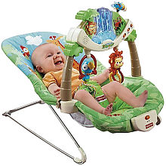

Fisher-Price Rainforest Bouncer

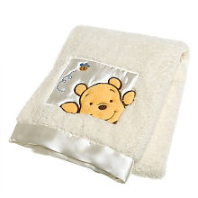

Kids Line Soft & Fuzzy Pooh Fluffy Blanket
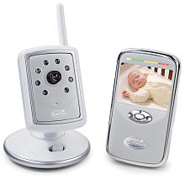

Summer Infant Slim & Secure Handheld Video Monitor

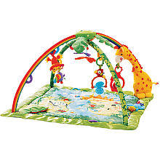

Fisher-Price Rainforest Melodies & Lights Deluxe Gym
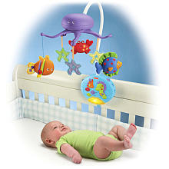

Fisher-Price Ocean Wonders Deep Blue Sea Mobile

