Pregnancy and Labor and Delivery
Unit 3

A. Explain the characteristics of pregnancy
 Identify the early signs and symptoms of pregnancy
Identify common discomforts occurring during pregnancy
Identify potential pregnancy complications (RH factor, toxemia/pre-eclampsia, miscarriage, stillbirth,
premature, low birth weight

B. Explain the processes occurring during prenatal development
Outline the stages occurring during prenatal development (zygote, embryo, fetus)
 Define and discuss prenatal terminology (umbilical cord, placenta, amniotic fluid, amniotic sac, uterus,
lightening, lanugo, vernix, quickening
 Identify the prenatal development occurring during each trimester and month

C. List the sequential events in the childbirth process
 Define childbirth terms (show, crowning, episiotomy, labor, dilation, effacement
 Describe the 3 stages of labor
Discuss delivery options
Describe possible complications that may occur during childbirth

Pregnancy, Labor and Delivery

A. Explain the Characteristics of Pregnancy

- REVIEW: An O__________________ releases an O_______________(egg) during O____________________ (menstrual cycle). The fimbrae bring the egg into the F________________________ T_______________________. If a S______________________ is present in the fallopian tube, then F_____________________ can take place. Fertilization must take place in the F_______________________ T__________________. Only one S_______________ may penetrate the O________________. If more than one ovum is present, they may both be F___________________________ and this will cause multiple births. A fertilized ovum will implant itself in the U__________________________ wall and Endometrium l_____________________________ and begin to develop.

2. What are 3 common signs and symptoms of pregnancy?

B. Explain the processes occurring during prenatal development

3. What is pre-natal development and how long is it?

4. Prenatal Development is divided up into 3 trimesters. Explain each one and the related terms.
A. First Trimester:

- Zygote

- Embryo

- Fetus

*This trimester is the greatest time of risk and vulnerability for __________________________________to the developing fetus. Be careful with medication, environment, and lifestyle choices.

B. Second Trimester:

- Quickening

- Lanugo

*This trimester is physically the ___________________________________________on the Mom.

C. Third Trimester:

- Vernix

- Lightening

*This trimester is physically the most ________________________________________________ on the Mom.

5. Explain the parts of the “house” that the fetus lives in during prenatal development
- Uterus/Womb

- Amniotic Sac

- Amniotic Fluid

- Placenta

- Umbilical Cord

6. A pregnant Mom should gain _________________________ lbs over the course of the entire pregnancy.
Explain 3 basic nutrition guidelines for the Mom to follow throughout pregnancy.

*Assignment
Plan an appropriate 1 day menu for a pregnant woman. Write it in the chart below. Cut out pictures or draw foods that will represent a well-rounded meal for Breakfast, Lunch, and Dinner and place them in the space provided. Follow MyPlate.
BREAKFAST | LUNCH | DINNER

Why is this a healthy meal for pregnancy? How does it follow mypyramid and other nutrition guidelines?

7. Identify potential pregnancy complications and danger signs.
Pregnancy  Complication | Symptoms, Signs, Cause, Effects, etc…
Gestational
Diabetes

Low Birth
Weight

Placenta Previa

Premature

Preterm Labor

Rh Factor

Stillbirth

Spontaneous
Abortion/
Miscarriage

Toxemia/
Pre-Eclampsia

*ASSIGNMENT TEXTBOOK QUESTIONS
Using the textbook,in the Preparing for Birth chapter, answer the following questions.

Professional Care:
- At the initial pre-natal exam, what are routine exams that are done?

- Why is a doctor’s care important throughout the pregnancy?

- How often does a pregnant person receive a checkup?

- A mother’s body is the baby’s environment during a time of important development. Thus, a mother’s characteristics and health practices greatly affect the health of the baby. In the following list, mark a plus sign in front of maternal traits or health practices that help an unborn baby’s health. Mark a minus sign front of those practices that are harmful.

Sleeps well into the night and  takes naps during the day | Has high-pressured job that  causes various stress reactions | Mom has a different Rh factor  than the baby
Has not had rubella or the  vaccination | Is very underweight | Has dental check-ups
Relaxes in a hot tub | Makes poor meal choices | Exercises by walking or  swimming
Avoids even over the counter  drugs | Smokes moderately | Is anemic – low iron
Happy and content with life in  general | Eats foods high in vitamins and  Minerals (calcium, folic acid,  iron) | Is over age 36 years of age

Choose 2 health practices above and explain why this helps or harms the unborn child:
1.

2.

Personal and Emotional Care:
1. What causes emotional changes during pregnancy?

2. How can a spouse and couple deal with the mood swings and postpartum depression of the pregnant wife?

3. Give 3 guidelines for personal prenatal care such as: rest, exercise, hygiene

4. Give 3 guidelines for choice of clothes and shoes during pregnancy

Postnatal Needs
1. Provide advice for meeting the new Mom’s needs for: rest, exercise, nutrition, and Medical Checkups
Rest

Exercise

Nutrition

Medical Checkups

2. What are “baby blues” or postpartum depression? What should a new Mom and Dad do about them?

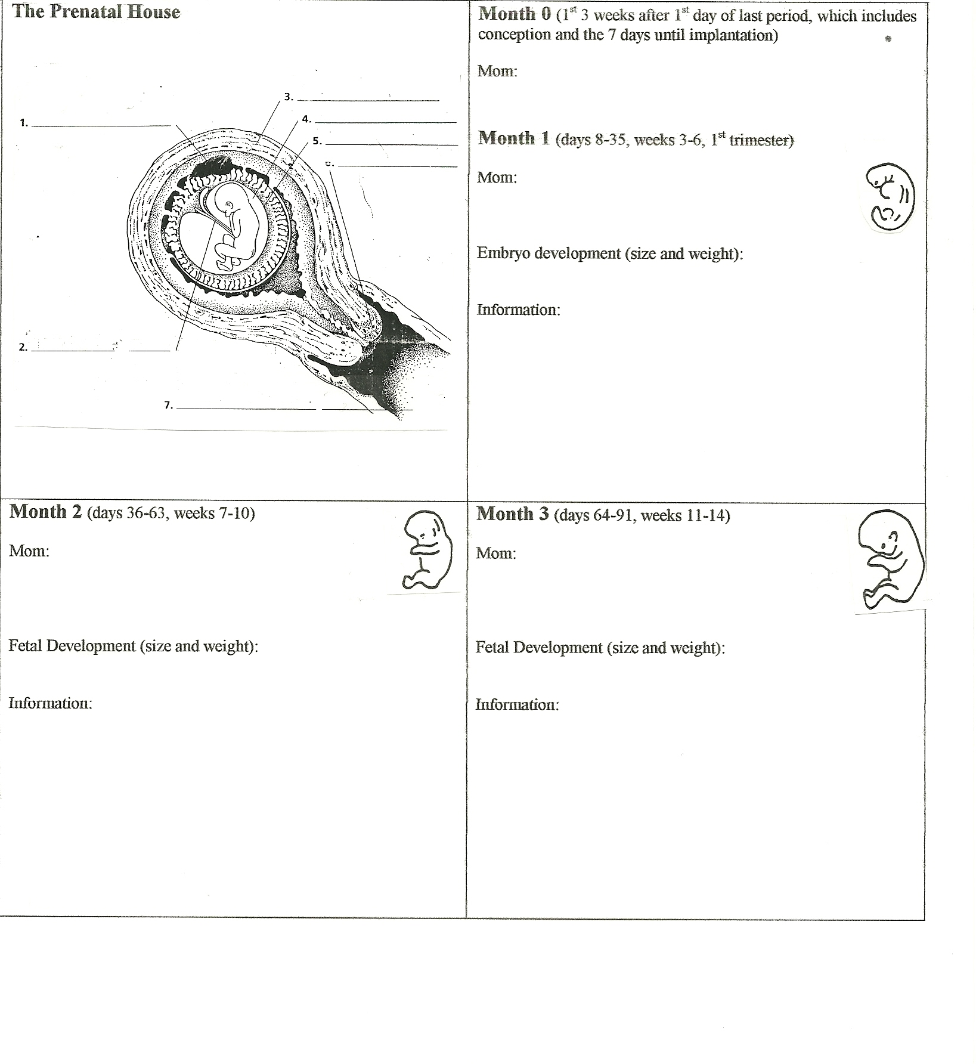
MONTH AT A TIME pg 1
Use the resources around the room to complete this prenatal development information.
Explain what is happening to the Mom, the Baby, and basic prenatal information.

MONTH AT A TIME pg2
Use the resources around the room to complete this prenatal development information.
Explain what is happening to the Mom, the Baby, and basic prenatal information.

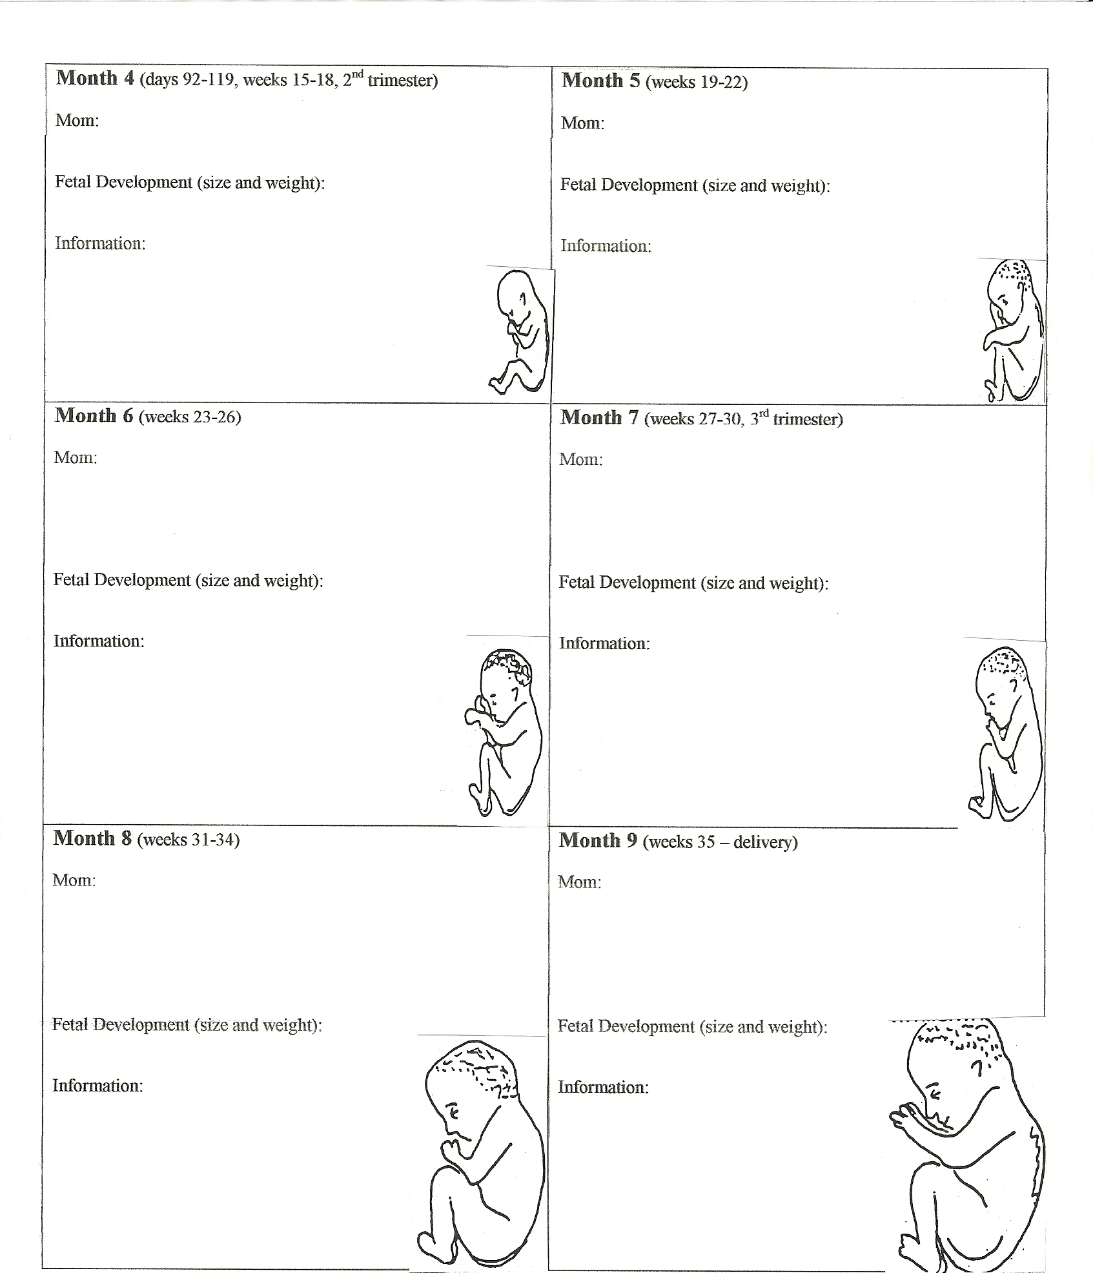
FATHERHOOD QUESTIONS
Answer the following questions based on your experiences with your Dad or another father figure in your life.
Think about the kind of father you want to be or to have for your own children.

- Describe your most positive, memorable, one-on-one activity with your father or father figure.

- Describe your most positive, memorable, family activity which included your father or father figure.

- Name 3 one-on-one activities you consider important for a father to do with his children.
A.

B.

C.

- What types of family activities do you consider important for a father to participate in.

- Describe the communication patterns that are most familiar between you and your father or father figure.

- How do you think a father should communicate with his children?

- As a child, what ways did your father, or father figure, tell you that he loved you and accepted you?

- What ways do you think a father should demonstrate his love and acceptance for his children?

- What role did your father, or father figure, have in caring for your physical, emotional, moral, educational, and social needs?

Compare this to what your Mom did.

- What role should fathers have in caring for the physical, emotional, moral, educational, and social needs of their children?

- IF YOU ARE A MALE: What will you do to be a bigger and more active part of your children’s lives? IF YOU ARE A FEMALE: How will you help your husband to be a bigger and more active part of you children’s lives?

Labor and Delivery

Labor is:

Dilation:

Effacement:

The average length of labor for a first baby is _____________________ hours.

1. Identify possible signs that indicate the beginning stages of labor.

- Lightening:

- The Show:

- Water Breaking:

- Contractions:

- Braxton Hicks contractions:

Inducing Labor:

2. Labor is divided into 3 stages.
Describe the 3 stages (length, events, contractions...) of Labor and Delivery.

- First Stage:

Early labor:

Active Labor:

Transition:

This is the _____________________________________ stage of labor.
Purpose of contractions during the 1st stage of labor: _________________________________________________

Epidural:

External/Internal Monitoring:

Birthing Positions:

- Second Stage:

Crowning:

Forceps:

Vacuum Extractor:

Fontanelles:

Episiotomy:

Purpose of contractions during the2nd stage of labor: _________________________________________________

- Third Stage

Purpose of contractions during the 3rd stage of labor: _________________________________________________

- Who are these people?
Obstetrician | OBGYN
Mid-Wife | Labor and Delivery Nurse

- Explain delivery options and why these might be used.

- Explain choices and types of Anesthesia
Natural | Epidural

6. Describe possible complications that may occur during childbirth: (umbilical cord, stress, heart rate...)

- Explain possible ways a baby can be positioned for birth.
Normal

Breech

Posterior

Transverse

Fetus doesn’t
drop into position

When are cesarean deliveries used?

8. What is an average birth weight of a full term healthy baby?

9. What is a new Mom’s primary physical need after childbirth?

DESCRIBE (or draw) the 3 STAGES of LABOR in a way that you will remember them

1st Stage

2nd Stage

3rd Stage

Apgar Rating:

Colustrum:

Sitz Bath:

Problems of Premature Infants:

Add in 2 Extra Credit Pregnancy Interview

