UNIT 2 Reproduction, Genetics/ Heredity, and Birth Defects

1. Which of the following is produced from two separate egg cells being fertilized?
A. Triplets
B. Siamese twins
C. Fraternal twins
D. Identical twins

2. How many chromosomes are contained in each mature sperm cell?
A. 16 C. 32
B. 23 D. 46

3. Fertilization usually takes place in the:
A. Uterus
B. Fallopian tube
C. Cervix
D. Vagina

4. What is the opening to the uterus called?
A. The vagina
B. The fallopian tube
C. The ovary
D. The cervix

5. The fetus grows inside the:
A. Uterus / womb
B. Cervix
C. Fallopian tube
D. Vagina

6. The passageway from the uterus to the outside of the body used for sperm, menstrual fluid, and delivery of the baby is:
A. Fallopian tube
B. Vagina
C. Ovary
D. Esophagus

7. The female reproductive sex cell is the:
A. Cervix
B. Ovary
C. Fimbrae
D. Ovum

8. The passageway carrying the sperm away from the epididymis:
A. Vas Deferens
B. Scrotum
C. Urethra
D. Seminal Vesicle

9. This produces sperm and the hormone testosterone.
A. Scrotum
B. Epididymis
C. Testicle
D. Semen

10. Mixture of sperm cells and gland secretion fluids
A. Semen
B. Seminal Fluid
C. Testosterone
D. Estrogen

11. The passageway to transport the egg away from the ovary and towards the uterus is
A. Fimbrae
B. Fallopian tube
C. Vas deferens
D. Vagina

12. The process of releasing a ripened ovum from the follicle within the ovary.
A. Conception
B. Ovulation
C. Endometrium
D. Menstruation

13. A test done by inserting a needle through the abdomen wall and into the uterus to withdraw some amniotic fluid is:
A. Vasectomy
B. Amniocentesis
C. Ultrasound
D. Chorion villi biopsy

14. The birth defect that is characterized by the baby’s inability to digest protein is:
A. Down Syndrome
B. PKU
C. Cleft-lip and cleft palate
D. Cerebral palsy

15. Birth defects in which the trait for the defect is carried by the female, but shows up in the male, are known as:
A. Blood Disorder
B. Congenital malformation
C. Sex-linked defects
D. Chromosomal error

16. A recessive (weaker) gene will produce a trait only when it is:
A. Transmitted by father
B. Transmitted by mother
C. Transmitted by either parent
D. Transmitted by both parents

17. Fetal alcohol syndrome:
A. Occurs when the mother smokes during pregnancy
B. Causes damage to the fetus as soon as the mother takes a drink
C. Is more common in baby girls than in baby boys
D. Can cause mental retardation and physical abnormalities in the fetus.

18. The following statement describes the birth defect Down syndrome:
A. It was previously known as cystic fibrosis
B. Chromosome 21 occurs as a triplet rather than as a pair (it has 3 rather than 2).
C. It does not cause any mental or physical defects
D. It can be treated at birth so the child suffers no long-term effects

19. Passing on genetic characteristics from one generation to another is known as:
A. Sequence
B. Tradition
C. Heredity
D. Nurturing

20. Which is NOT a birth defect caused by lifestyle and environment?
A. PKU
B. Fetal Alcohol Syndrome
C. Genital Herpes
D. Rubella

21. Stonger genes where the genetic characteristics need to only show up in one parent is known as:
A. Recessive
B. Dominant
C. Infertile
D. Chromosomes

22. The birth defect often characterized by a split in the tissue between the upper lip and nose, or a split in the roof of the mouth is:
A. Cerebral Palsy
B. Down syndrome
C. Cleft palate/cleft lip
D. Club hand/foot

23. Pregnant women are advised against smoking because the nicotine can:
A. Stimulate the expectant mother’s appetite and cause overeating
B. Cause Muscular Dystrophy
C. Affect the expectant mother’s emotional health
D. Decrease the fetal heart rate, slow the fetal growth, and cause low birth weight in babies.

24. Which of the following risk of chromosomal birth defect increases if the mother is over the age of 35?
A. Rh Disease
B. Down Syndrome
C. PKU
D. Sickle cell anemia

25. A pattern of physical and mental birth defects caused by excessive or steady alcohol consumption during pregnancy is:
A. Fetal alcohol syndrome
B. Rh alcohol disorder
C. Rubella
D. Toxemia

26. Weaker genes that do not show themselves as frequently are known as:
A. Dominant
B. Recessive
C. Infertile
D. Chromosomes
27. The chromosome combination that determines that a baby will be a boy is:
A. XX
B. XY
C. YY
D. YZ
28. Which of the following characteristic is determined more strongly by environment influences and choices than heredity?
A. Weight
B. Height
C. Skin color
D. Blood Type

29. Which of the following carries the inherited traits that are passed on from parent to child?
A. A gene
B. fallopian tubes
C. sex(x)-linked birth defects
D. testicles

30. The optimum age range for a woman to have a healthy baby us
A. 15-25 C. 25-40
B. 20-35 D. 15-40

31. The birth defect characterized by the hand or foot and ankle being twisted is:
A. Cerebral Palsy
B. Fetal Alcohol Syndrome
C. Club hand/foot
D. Congenital rubella syndrome

32. During which trimester(s) can medicine/drug have the greatest effect on the developing baby?
A. 1^{st trimester} C. 3^{rd trimester}
B. 2^{nd trimester} D. There is no effect

33. The prenatal period of greatest vulnerability to birth defects is:
A. There is no effect C. 2nd trimester
B. 1st trimester D. 3rd trimester

34. Identical twins are:
A. Twins that develop from two separate eggs, each fertilized by different sperm.
B. Twins that remained connected together and did not fully divide during prenatal development.
C. Twins that develop from a single fertilized egg that completely divided during prenatal development.
D. The opposite sex (one is a boy and one is a girl)

35. The medical test which utilizes sound waves to produce a video image of the fetus is known as:
A. Genetic counseling
B. Amniocentesis
C. APGAR
D. Ultrasound

36. Which of the following is not an environmental hazard during pregnancy?
- smoking
- hemophilia
- Alcohol
- X-ray

37. How much alcohol can a pregnant woman drink without risking harm to the developing fetus?
- 1 glass or bottle a day
- There is no limit to it
- It is still unknown so the best advice is none – not a drop
- 1 glass or bottle a week

38. What is false about fraternal twins:
- They will look like siblings, but not exactly alike.
- The same egg is divided into 2 separate eggs.
- They could be the same sex.
- They could be opposite sex.

39. When are genetic / heredity traits, such as height, determined?
- At birth
- Over the course of ones’ life.
- Over the course of prenatal development.
- At conception

40. Which gender (parent’s) sex cell determines the gender of the unborn child?
- Male / sperm
- Female / ovum
- Whichever sex-cell is stronger
41. ____ A. cervix
42. ____ B. uterus
43. ____ C. vagina
44. ____ D. fallopian tubes
45. ____ E. ovary

- The parents flip a coin and go from there.

41-45: Match the correct Letter to the number on the diagram.

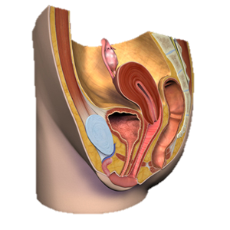
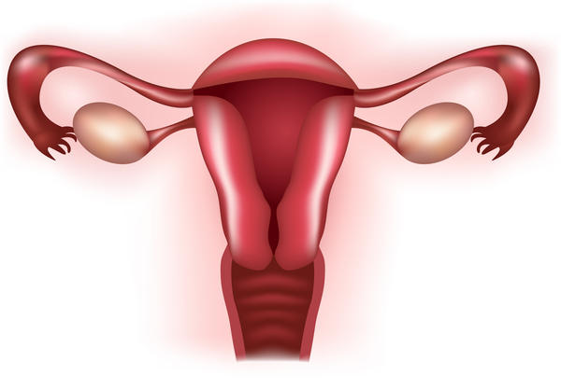
45
41
42
43
44
43
45
44

46-49: Match the correct Letter to the number on the diagram

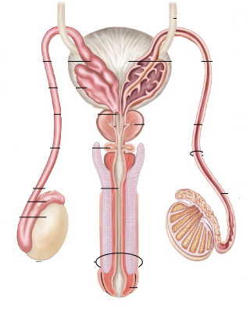
49
47
46
48
49
46. ___ A. bladder
47. ___ B. penis
48. ___ C. testicle 49. ____ D. prostate gland
E. vas deferens

