Lamb Burgers
1 lb. ground lamb
1 diced pepper (use what you have: jalepeno, bell pepper, etc.)
1 Tbsp.fresh thyme
1Tbsp. fresh oregano
Can substitute other herbs (basil, parsley, savory, cilantro, etc.)
1 clove minced garlic
1 splash hot sauce
1 minced shallot (or 1-2 Tbsp. minced onion)
salt and pepper
Mix together and form 4 patties. Grill for 3-4 minutes per side. Add cheese if desired.

Lamb meatballs
1/4-1 1/2 lbs ground lamb
1 egg, lightly beaten
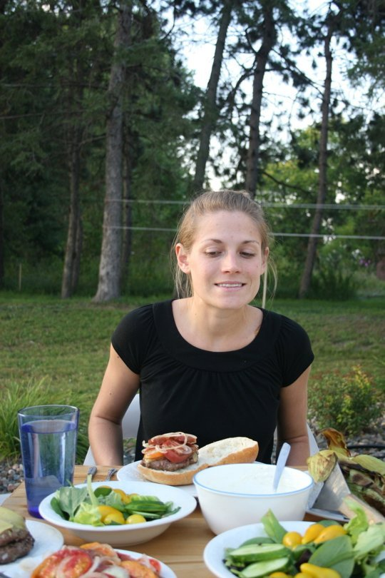
1/4 cup finely chopped onion
3 minced garlic cloves
1/2 cup breadcrumbs
1/4 teaspoon salt
1/4 teaspoon pepper
1 teaspoon lemon zest
2 tablespoons chopped fresh parsley
1/4 cup plain low-fat yogurt

Preheat oven to 350 degrees.
In a large bowl, combine all ingredients and mix very well. (Easiest to mix with clean hands). Form by hand into 1 1 1/2 inch balls and place in a baking pan about 2 inches apart. Bake @ 350 for about 25 minutes or until done.

Lemon Yogurt Sauce
1 cup Yogurt
2 Tbsp fresh mint leaves finely chopped
1 ½ tsp lemon juice
½ tsp sugar
½ tsp lemon zest

Tomato Sauce
1 tablespoon olive oil
3 cloves garlic, finely chopped
1/2 cup onion, chopped
2 cups diced tomatoes
1/2 teaspoon cinnamon
2 Tbsp chopped fresh mint
Salt and freshly ground black pepper to taste. Saute garlic and onions in oil. Add to tomatoes. Season with cinnamon, mint, salt and pepper.
Lamb Phyllo Bites

1 lb ground lamb
2 eggs
Garlic
Cumin
1 cup fetta cheese (crumbled) Mix and fold into triangles using phylo dough. Bake until golden brown.
*Butter strips of phylo while making and folding.
Irish Lamb Stew

2 Tbsp. oil
1-1/2lb. trimmed lamb shoulder, cut into 3/4-inch cubes
2 Tbsp. flour
1 large onion, coarsely chopped
1-1/2 cups apple juice
1 cup beef broth
1 envelope Italian Dressing Mix
3 medium potatoes, cut into 1-inch chunks
½ lb. carrots (about 4), cut into 1-inch chunks
½ lb. parsnips (about 2 medium), cut into 1-inch chunks

HEAT 1 Tbsp. of the oil in large heavy saucepan or Dutch oven on medium-high heat. Coat meat with flour. Add in batches to saucepan; cook until evenly browned, stirring occasionally and adding remaining 1 Tbsp. oil as needed. Remove meat from saucepan; set aside. Add onions to saucepan; cook and stir 2 min.
Stir juice, broth and dressing mix into onions in saucepan. Return meat to pan. Bring to boil, stirring occasionally. Reduce heat to low; cover. Simmer 30 min.
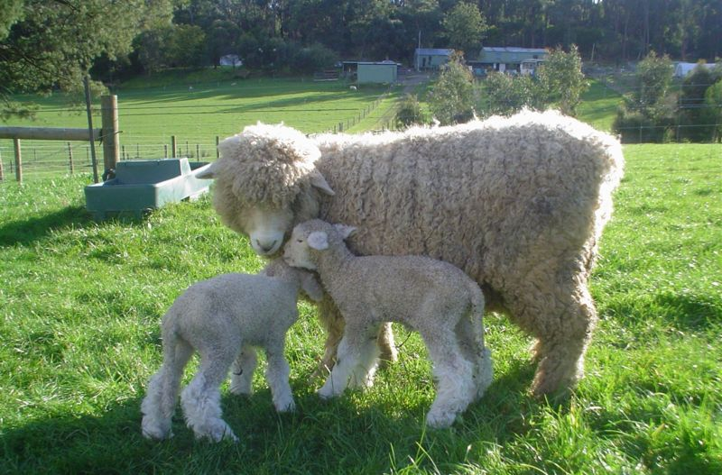
ADD potatoes, carrots and parsnips; stir. Cover. Simmer 30 min. Uncover; simmer 15 min. or until meat is cooked through, vegetables are tender and sauce is thickened, stirring occasionally.

Mantu (dumplings) Wontons
1 lb. ground or minced lamb (salt and pepper)
1 medium onion, grated
2 tsp chopped oregano
1 tsp cumin
Won Ton wrappers

Yogurt Sauce
¾ cup yogurt
¼ tbsp dried mint
2 mashed garlic gloves
water

Place 1 tsp meat mixture in center of
Wrapper and bring to a point. Seal with moistened fingers with water. Fry in oil (turning).
Mix yogurt, mint, garlic and enough water for mixture.
Serve: Spoonful of yogurt mixture and place wonton on top.
Good with a tomato sauce on top.

Cubed Lamb Curry

1 apple, diced
1 onion,
diced
4 Tbsp butter
Garlic powder to taste
1-2 Tbsp curry
1 tsp ground ginger
¼ tsp pepper
2 cups chicken bouillon
½ cup craisins
3 cups cubed cooked lamb

Sauté apples and onion in butter. Sprinkle with all seasonings until soft. Add cornstarch. Gradually stir in chicken stock; add lamb and raisins. Simmer 30 minutes.
Add coconut flakes, salted almonds, bacon bits, pineapple chunks before serving. Serve over rice.
Sheep Products
Meat is the most important product which we get from sheep. Lamb is the meat we get from sheep that are less than one year old. Mutton is the meat from sheep over 1 year of age.
Sheep meat is a major world product for many countries.

World meat consumption
Pork | 40 percent
Beef | 32 percent
Poultry | 22 percent
Lamb and mutton | 6 percent
Wool is the product for which sheep are best known. Wool is used in knitwear clothing, socks, suits, and clothing. It is also used in upholstery, carpets, pool table covers, and tennis balls.

Additional uses for wool include caskets (United Kingdom), oil spill cleanup, reinforcement for bricks, and insulated boxes.

Approximately 90 percent of the world's sheep produce wool. One sheep produces anywhere from 2 to 30 pounds of wool annually. The wool from one sheep is called a fleece, from many sheep, a clip. The amount of wool that a sheep produces depends upon its breed, genetics, nutrition, and shearing interval. Lambs produce less wool than mature animals. Due to their larger size, rams usually produce more wool than ewes of the same breed or type.

Color - In the commercial market, white wool is more valuable than colored wool because it can be dyed any color. Even the wool from sheep with white faces is more valuable than the wool from sheep with dark or moddled faces because the fleeces from non-white face sheep may contain colored wool or hairs which cannot be dyed. In contrast, naturally colored wools are often favored in the niche markets.

Lanolin is a product from raw wool that is used in oils, cosmetics, lubricants, and hair conditioners.

Skins are removed from the sheep and made into soft leather and chamois.

Persian lambskin is a commercial product from new lambs and used to make fine coats and skirts and edging accessories.

Dairy products of cheese include Feta, Roquefort, Ricotta, and Romano. Sheep milk is also used in yogurt, butter, and ice cream.

Science and medicine are contributed to from the sheep industry for
Study of disease and surgical techniques. Sheep blood is an ideal medium for culturing bacteria. Wound dressing are make from wool proteins and are even used for bone graft implants.

Landscape management has been controlled by sheep herds for centuries. They control unwanted vegetation and noxious weeds and invasive plants.

