Apparel Design & Production 1 Syllabus (Former Clothing 1)
2016 – 2017 for 9th – 12th Grade
Instructor – S. Wilde (435)-336-5656 ext. 8114, swilde@nsummit.org
Course Description – This course introduces students to basic apparel design & construction skills. These skills prepare students for the exciting global apparel industry & entrepreneurial opportunities. Students will sew apparel & accessory projects. This course will strengthen comprehension of concepts & standards outlined in Sciences, Technology, Engineering & Math (STEM) education. Student FCCLA introduction, leadership & competitive events will be integrated into this course. CIP Code: 20.0113, Credits .50, Skill Certificate Test: 350, CTE Pathway:
Fashion Design, Manufacturing & Merchandising
STRAND 1: Students will identify careers & products in the apparel design & production
Industry.
Standard 1: Identify soft goods in the apparel design & production industry. Soft goods: products
made with textiles & fabrics: Clothing bags, men’s furnishings, linens, home
furnishings.
a. Identify design & career opportunities in the apparel design & production industry
(designer, textile designer, fabrication & pattern drafting).
STRAND 2: Students will be able to recognize basic sewing equipment.
Standard 1: Identify sewing machine parts & their functions, safety & maintenance.
a. Identify the stitch plate, feed dogs, presser foot, bobbin case, spool pin, upper thread
tension, presser foot lever/lifter, thread take-up lever (should be in the highest position
when starting to sew), foot pedal, hand-wheel (turns toward you), stitch length control &
stitch width control.
b. Demonstrate how to thread the sewing machine, replace a needle & how to turn the
hand-wheel when sewing.
c. Identify basic problems encountered when sewing: thread jam, dull/broken needle &
incorrect stitch formation. (If the thread take-up lever is not threaded it will cause loops on
the wrong side of the fabric. Most sewing machine problems result from improper
threading, poor quality thread).
d. Identify what a correct stitch looks like & how it is formed (sewing machine forms a stitch
when the upper & bobbin threads interlock).
e. Explain solutions to common sewing machine malfunctions (skipped stitches, threaded
wrong, bad needle, wrong needle being used, lint removal, noisy sewing machine, needs
to be oiled, puckered seams, check tension, snagged fabric.
f. Identify needle types (universal, sharp & stretch)
g. Follow the machine manual to clean the machine & remove the lint regularly.
h. Identify safe sewing procedures (keep fingers a safe distance from needle, foot pedal
placement.
Standard 2: Identify sewing tools, their functions & safety procedures. Identify: seam ripper,
straight pins, shear/scissors, rotary cutter & mat, seam gauge, tape measure, iron,
pressing cloth, marking tools & transparent ruler.
a. List sewing tool safety precautions, procedures & maintenance.
Standard 3: Introduce the serger and its function.
a. Discuss the advantages of the serger (cuts excess fabric, sews & edge finishes).
b. Practice operating the serger.
c. Discuss safety & maintenance of a serger (always leave the presser foot down, do not
serge over pins, zippers, or excessive bulk).
STRAND 3: Students will identify & analyze the characteristics & care of specific textiles.
Standard 1: Identify basic fibers, the characteristics, use & care of each textile. Fiber content
establishes many of the characteristics of a specific fabric, so it is important to know
what a textile is made of.
a. Identify natural fibers & their characteristics (cotton, linen, silk, wool).
- Characteristics: comes from plant & animals, moisture absorbent, more expensive
- Cotton: absorbent, comfortable, durable, wrinkles, shrinks easy to launder, plant source.
- Linen: absorbent natural luster, quick drying, wrinkles, frays, little stretch, plant source-flax.
- Silk: animal source-silk worm cocoon, absorbent, natural luster insulating, strong, resilient, dyes well, expensive, degrades & yellows from age & sunlight.
- Wool: animal source-fur, absorbent, strong, elastic, shrinks when laundered improperly, wrinkle resistant, warm.
b. Identify manmade fibers & their characteristics (nylon, polyester, acrylic, rayon, spandex,
acetate).
- Characteristics: made from chemical compounds, heat sensitive/will melt, less absorbent to not at all absorbent, less expensive.
- Nylon: strong, elastic, water repellent, colorfast, frays easily
- Polyester: good shape retention, easy to launder, wrinkle resistant, colorfast, blends well with other fibers, retains oily stains.
- Acrylic: resembles wool, soft, warm, nonabsorbent, pills, heat sensitive, can shrink or stretch.
- Rayon: soft & comfortable, drapes beautifully, blends well with other fibers, shrinks, poor shape retention, wrinkles, dyes well.
- Spandex: very elastic, adds stretch when blended with other fibers, requires stretch stitching techniques & shrinks.
- Acetate: high luster, drapes well, loses shape & wrinkles.
c. Identify iron temperature settings according to fiber content. High heat: cotton & linen,
low heat: nylon & spandex.
d. Identify advantages of blended fibers used in fabrics.
- Blended fibers: take the best characteristics of two or more fibers & creates a better fiber.
e. Identify various stain removal techniques (grass, blood, chocolate, make-up, ballpoint
pen, etc. Stains set by heat & time).
- Grass: rub detergent into area, let stand, launder.
- Blood: soak in cold water for at least 30 min. pre-treat if stain is still there, launder.
- Chocolate: scrape off remaining, soak in cold water. Pre-treat any remaining stains, launder.
- Make-up: rub detergent into are or use a pre-wash stain remover, launder.
- Ballpoint pen: spray with hairspray, let sit, blot stain with paper towel, or rub detergent into spot, launder.
f. Select correct laundering procedure for pre-wash & clothing care base on clothing care
labels & end of the bolt when fabric is purchased.
Standard 2: Discuss how selection of a fabric affects project construction.
a. Identify the terminology of woven fabrics (warp/lengthwise, weft/crosswise, bias, selvage,
straight of grain/lengthwise & cut/raw edge).
- Grain: is determined by the position of the yarns & fibers in the fabric.
- Warp/lengthwise grain: is the grain-line that is parallel from the selvage.
- Weft/crosswise grain: is the grain-line that runs from selvage to selvage.
- Bias: is the 45-degree angle, it has a lot of stretch.
- Selvage: tightly woven finished edge of fabric formed by the crosswise yarns.
- Straight of grain/lengthwise: Lengthwise fabric threads are commonly referred to as straight of grain on commercial patterns. It runs parallel to the selvage.
- Cut/raw edge: usually runs across the fabric from selvage to selvage. It is the cut length of fabric that is bought.
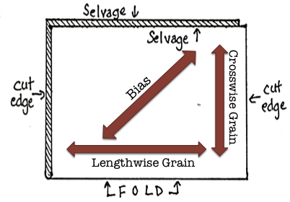
b. Identify the characteristics of woven, knit (looping yarns) & non-woven/felted fabrics.
- Woven: warp & weft yarns are interlaced at a 90-degree angle, limited elasticity.
- Knit: made by looping yarns together medium to high elasticity.
- Non-woven/felted: fibers are pressed together with heat, moisture & pressure.
c. Identify correct fabric for project.
d. Identify specific fabrics (denim, flannel, canvas, calico, satin, rip-stop nylon, vinyl, leather,
2-way stretch, 4-way stretch, rib knit, single knit, polar fleece, sweatshirt fleece, felt,
neoprene).
- Denim: twill weave made of single hard-twisted yarns with colored warp & white or un-dyed fill.
- Flannel: woven fabric made of cotton where the surface has been slightly brushed creating a soft napped fabric.
- Canvas: extremely durable plain-woven fabric.
- Calico: traditionally referred to as a plain-weave cotton cloth that originated in Calicut, India. Today it is most often applied to a cotton or cotton/polyester fabric that is roller printed with small-scale design, usually floral.
- Satin: recognized by its smooth, lustrous surface, satin is woven with long, floating yarns in the warp. Silk, polyester, acetate & rayon are common fabrications.
- Rip-stop Nylon: nylon fabric made with a special reinforcing technique that makes it resistant to tearing & ripping.
- Vinyl: non-woven plastic fabric.
- Leather: skin of an animal that has been tanned & treated.
- 2-Way Stretch: stretches from selvage to selvage.
- 4-Way Stretch: stretches both along the lengthwise & crosswise grain.
- Rib knit: double knit fabric where rib wales alternate on the face & back of fabric.
- Single Knit: plain stitches on the face of the fabric & purl stitches on the back. It can be made from a variety of fibers, wool, cotton, silk, nylon or blends. It can be made lightweight to heavy.
- Polar fleece: a soft napped insulating fabric made from polyester.
- Sweatshirt fleece: type of jersey fabric, plain knit stitches on the front & purl knit stitches on the back, its stretch factor makes it popular.
- Felt: is a non-woven fabric that comes in varying qualities. Wool felt is made by using heat, moisture & agitation. Felt can also be made by pounding & compressing cotton,
polyester or rayon fibers.
Neoprene: soft flexible & durable synthetic sponge rubber that is water resistant &
Stretchable.
STRAND 4: Students will use pattern envelope & guide sheet/instruction for pre-
Construction skills at the introductory level.
Standard 1: Identify the information found on a commercial pattern envelope & guide sheet.
a. Identify important information on the pattern envelope.
- Body measurements (help to make sure you have selected the right pattern size for the body.)
- Suggested fabrics (fabric weight, design & feel affect the way garment look & fit.)
  - (also tells what fabrics are appropriate for the garment being made.)
- Notions (supplies needed to complete the garment.)
  - Elastic, thread, buttons, bias tape, zippers, trims, etc.
- Yardage requirements (a chart on the pattern envelops tells how much fabric is needed to make the garment.)
- Finished garment measurements (gives a finished length of the garment from top to bottom or the width of the pant leg at the bottom.)
- A visual picture of the finished garment front & back (if alterations are wanted.)
b. Identify important information found on the guide sheet.
- Pattern pieces (sketches of each pattern piece used in the garment & their number for an easier reference.)
- Layout diagram (shows how the pieces are to be laid out so they can be cut out)
- Sewing instructions (provide step-by-step sequence for constructing the garment.)
- General directions (show symbols & terms found on guide sheet & pattern pieces.)
- Seam allowances (will be identified in the general directions it will list the standard 5/8” & any other seam allowances that will be used & where.)
c. Determine pattern size based on body measurements & finished garment measurements.
- Pattern size is almost never the same as ready-to-wear sizing.
- Choose a pattern size closest to your body measurements.
- Take into account any ease added for body movement.
- When choosing a dress, blouse, jacket or shirt, use the bust/chest measurement to determine size of pattern.
- When choosing pants or skirt use the waist & hip measurement.
  - For females the hip measurement is best, waists can be altered more easily.
  - For males use the waist measurement they have no hips.
Standard 2: Prepare pattern for layout & cutting.
a. Identify pattern tissue terminology/symbols (Straight of grain arrows, place on fold line,
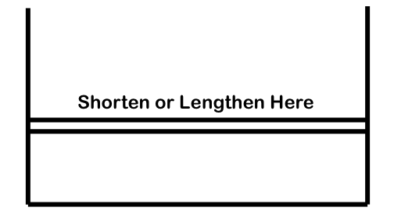
pattern markings, buttons & buttonholes, notches, sizing lines, adjustment lines.

Symbol | Description | Purpose | Where Located
Straight of Grain arrow | Solid line with an arrow point at one or both ends | Use the arrow to orient the pattern on the fabric for cutting. The arrow usually indicates the lengthwise grain-line, parallel to the selvage. | On all pattern pieces
Place on Fold line | Rectangular bracket with arrow tips pointing toward the folded edge. | For cutting efficiency, pattern pieces are produced as “half” pieces & laid out on doubled fabric. The on-the-fold edge is never cut. The pattern piece must be placed along a folded edge to create a full piece. | At center front and or center back
**Pattern Markings  Dots, squares & triangles | Solid circles, squares, or triangles of varying sizes; they sometimes appear as unfilled shapes with different outline styles. | Use them to match patterns at seam-lines and for details with in the garment. | They appear most often on collar, neck, and shoulder points
**Buttons and Buttonholes  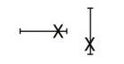 | Buttonholes are marked as horizontal or vertical I-bars. Buttons are noted with an X. | Placements and spacing of buttons and buttonholes. | Either illustrated on the pattern piece or provided as a separate overlay pattern piece
**Notches  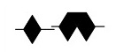 | One diamond, a pair of diamonds, or a triple set of diamonds, usually half inside/half outside the cutting line. Some patterns use a half-diamond (triangle pointed into the seam allowance). | Used for matching seam-lines during constructions. One diamond usually indicates the garment front. A pair of diamonds usually denotes the back. A triple set of diamonds indicates a seam reference other than the front or back. | On most pattern pieces, in a variety of spots, including center back, sleeves, arms eye, side, waist, and shoulder seams
Sizing lines  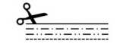 | The line style is different for each size included in multi-size patterns. | Indicates where you cut both the pattern tissue and the garment fabric. | On all pattern pieces
Hem lines | A solid line running at the bottom of pants, skirts, dresses & blouses. | Indicates where the hem is placed in the garment. | Indicates the depth of the hem. Hems should not be any deeper than 2 inches.
Bust and hip indicators | Circle with enclosed cross. | These handy pattern notes give finished measurement s of garment all around at hip & bust. | Bust symbol is generally located at point of bust. Hip symbol is located at hipline (about 7” down from waist.
Lengthen/shorten guide  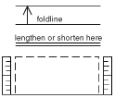 | Double solid line running across pattern piece. Or single line with dotted rectangle above it & mini-rulers at either end. | Recommended area in which to lengthen or shorten pattern piece. | Below knee on pants, below elbow on sleeve, between bust & waist on tops, below hip on skirts & pants.
Cutting line  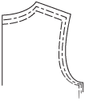 | Outermost line on pattern, often accompanied by scissor icon. Solid line on sing-sized patterns. Line pattern different for each size included on multi-sized patterns. | Where you cut both pattern tissue & garment fabric. | On all pattern pieces. Cut edges of pattern will sometimes be uneven because matching points correspond to where seam-lines meet.
Seam-line  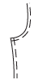 | Dashed or broken line on single-sized patterns, often accompanied by presser-foot icon. | Where you sew garment pieces together. Corresponding seam-lines (sleeve, arms-eye) will always have same seam allowance. | Rarely noted on multi-sized patterns.
** Dart symbols  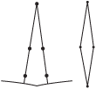 | Darts are either open or closed. Sides can be straight or slightly curved. Little dots in various increments aid in matching dart seam-lines. | Open dart is long V-shaped, extending to cutting line. Closed (double-ended/fisheye) dart is elongated oval or diamond shape & generally found within pattern (not necessarily at cutting or sewing line). | Bust, waist, hip & occasionally at shoulder & arms-eye.
**Pleats, tucks & gathers  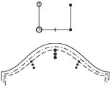 | Pleats & Tucks -Spacing denoted by series of straight lines extending from cutting line. Line length reflects how “deep” stitching line is. Small dots, generally at interior end of line, note end of stitching.  Gathers – Two dotted spaced lines indicate two rows of gathers. | Tucks & Pleats - Symbols indicating pleats & tucks are very similar. Only difference is that pleats are folded in place & tucks are sewn in place.  For gathers, fabric is simply eased between two points on both stitching lines using a basting stitch. | Tucks & Pleats. Bodice, skirts & pants, common at waist & shoulders.  Gathers – on sleeves, cuffs & waistlines. They add fullness as well as a smooth curved shape.

** Indicates which markings should be marked onto the fabric from the pattern or by cutting
out & around such as a notch.
b. Complete necessary pattern alterations (length or width).
- Pattern Alteration Basics:
a. Use the pattern adjustment lines on the pattern pieces which, indicate the
correct area to make an adjustment.

b. You must make the same length adjustments to adjacent pattern pieces (such
as front & back & both arms or legs).
c. If you are adding length or width to the pattern, cut along the length adjustment
line & place tissue paper or pattern paper under the pattern. Tape the pattern
to the paper that fills the gap for the addition.
d. Remember that each front or back pattern piece actually represents a quarter
of the body.
e. After you make an alteration, “true” the cutting line (redraw the line to smooth
any uneven jogs created by your alteration). Use a ruler or a curve to guide the
drawing of the new line.
f. If you are making multiple alterations, adjust the length first.
- Length:
a. Use the printed length adjustment lines on the pattern to lengthen or shorten.
b. If there are two adjustment lines within the body area, divide the total
adjustment between the two lines.
c. If you are making a dress, determine if you need to make your adjustment in
the back-waist length or in the waist-to-hem length & use the appropriate
adjustment line.
d. To shorten – make a pleat in the pattern tissue at the adjustment line, half the
desired amount. True the cutting lines & the dart markings (if applicable.) For
straight styles, you can cut away the excess pattern tissue at the hem, following
the shape of the pattern, however, leave enough for a hem or last minute
length change.
e. To lengthen – cut along the adjustment line & spread the pattern tissue the
desired amount. Be sure to spread evenly & tape a piece of tissue paper in the
opening. True the cutting lines. For straight styles, you can add length at the
hem by taping tissue paper to the lower edge & drawing a new cutting line.
Keep the original hem shape & extend the cutting lines on the side to the new
bottom edge.
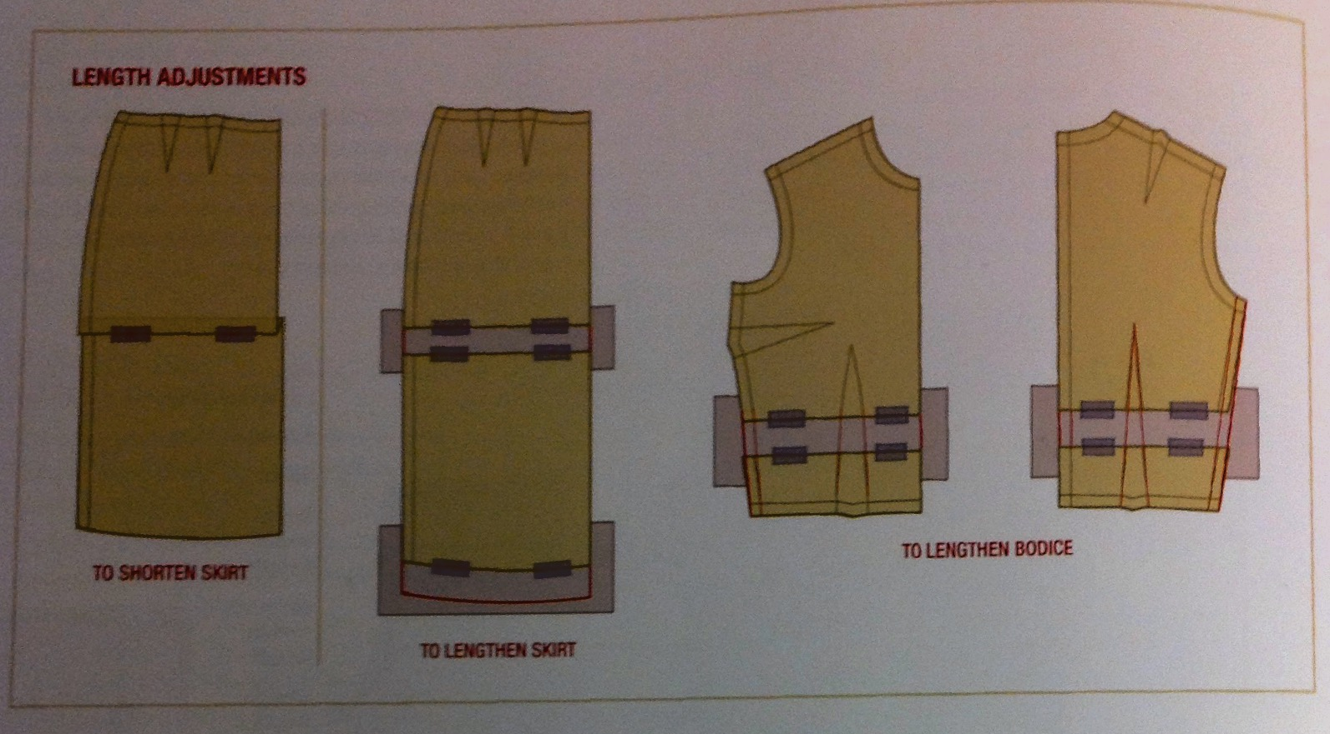

- Width:
a. Simple adjustments of girth, at the waist, hip or around the torso can be made
at side seams or in the middle of a pattern piece. If the adjustment is larger
than 2 inches you may need to make a more involved alteration.

b. For tops with sleeves, adjustments at the side seams require that the sleeves
be altered too.
c. For pants, to adjust pants at the hip, simply add or subtract near the side seam,
as shown. Use a curved ruler as a guide when you redraw the cutting line.
d. For pants, to adjust at the waist, at the side seam gradually add or subtract &
straightening as it nears the waist.
e. Bodices: Blouse, tops & jackets can be made wider or narrower by tucking or adding vertically from the shoulder seam-line to the hem. This alteration can accommodate an increase or decrease up to 2 inches. On the pattern front & back, draw a line parallel to the grain-line from the mid-point of arms eye.

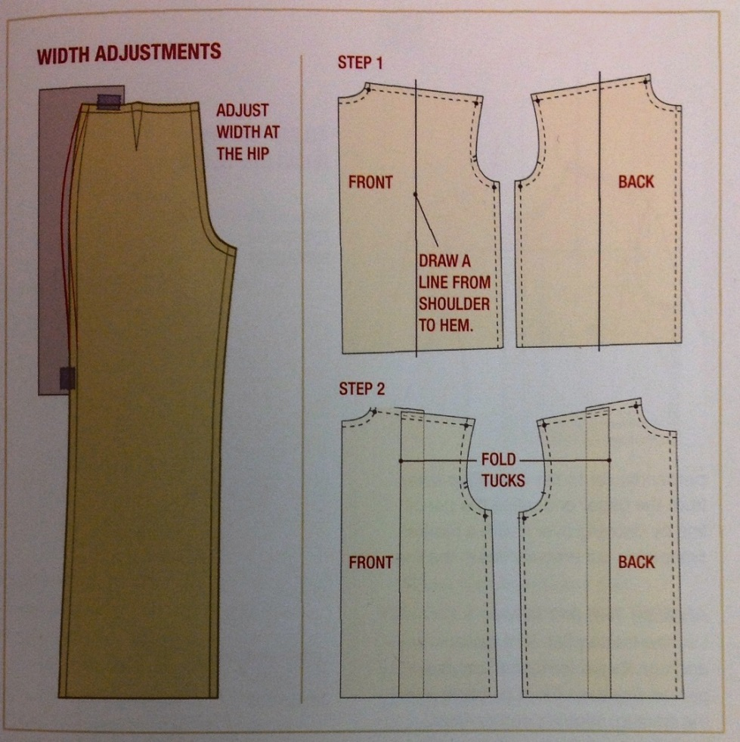

Standard 3: Demonstrate correct placement of pattern pieces on the fabric.
a. Press & straighten grain, if necessary. A fabric does not hang or lie properly if the fabric is
off grain.
- Pre-shrink the fabric first.
- Then hold the fabric at its opposite corners & stretching it away from the center.
- Then press the fabric
- Avoid buying fabric printed off grain, use only for patchwork or smaller projects.

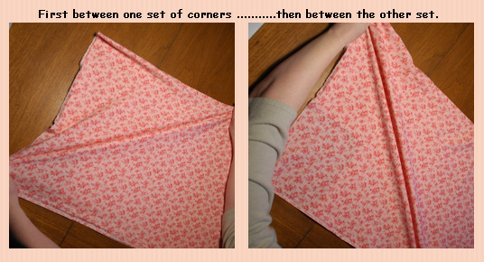
b. Check for directional print & nap layout.
- Directional print: pattern on the fabric that goes all the same direction. Has a definite top & bottom to the pattern.
- Nap: fabric that has a different feel if it is smoothed one way versus the opposite direction; these fabrics will also have a color change from one direction to another. Examples are: corduroy, velvet, velveteen, etc.
- Thus pattern pieces must be laid out all going the same direction.
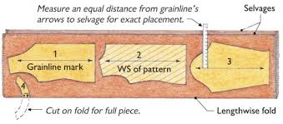
c. Choose correct layout from the pattern guide sheet. The fabric is usually folded
lengthwise for cutting. The pattern instructions provide suggested layouts for different
fabric widths & are intended to make the most economical use of fabric.
- Fabrics with asymmetrical prints or weaves should be cut out in a single layer.
- When cutting singly, flip over some pattern pieces for their second cutting to create both a left & right half.
- A crosswise layout is often needed for wide pieces & sometimes a layout show a double fold, in which both selvages are brought to the center.
- Fold fabrics with right sides out to view the designs on the fabric.
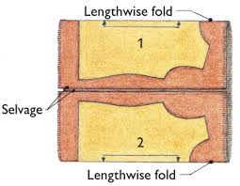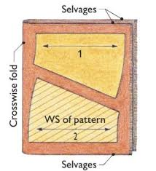

Standard 4: Correctly position, pin & cut out the fabric pieces.
a. Check straight of grain arrows & place on the fold pattern symbols. The grain-line on
each pattern piece should be aligned with the lengthwise grain of the fabric, unless
indicated otherwise.
b. Use correct spacing & positioning of pins (pin perpendicular to pattern edges, inside-
cutting line). Make sure pin points do not cross the cutting line. Place pins closer together
on curves to secure the fabric.
c. Select & use appropriate cutting tools. Use shears to cut out fabric. Right-handed sewers
hold down pattern with left hand & left-handed sewers, the opposite. Hold shears
perpendicular to the cutting surface. Keep shear blade in contact with table surface, slide
it along as you cut.
d. Cut notches. Snip about ¼” long, into the seam allowance at the notch position. This
method works best on garments with 5/8” seam allowance & fabric that doesn’t ravel
easily. You can also mirror image the notch outside of the cutting line.
e. Keep the fabric as flat as possible when cutting pattern pieces out. If necessary, move
around the pattern piece to cut it, rather than moving the pattern piece.
Standard 5: Transfer pattern markings before removing pattern pieces from fabric. Transfer fit-
related & construction markings (Buttons, Button holes, Darts, Dots, Gathers,
Notches, Pleats, Squares, Triangles, Tucks)
a. Select & use appropriate marking tools for fabric marks on the wrong side of the fabric.
- Marking pens/pencils
- Chalk
- Tracing paper with tracing wheel
- Tailor tacks
STRAND 5: Students will utilize construction techniques at the introductory level using
basic construction skills.
Standard 1: Explain & be able to demonstrate the following construction terms:
a. Basting Stitch: Set the machine for the longest stitch possible, no backstitching, baste
within the seam allowance, close to but not on the seam-line.
b. Back Stitch: Stitching a short distance forward then back to reinforce stitching in a seam
at the beginning & end of every seam.
c. Pivot: Stitch to the corner marking. Leave the needle in the fabric & lift the presser foot.
Pivot the fabric, lower the presser foot, & continue sewing.
d. Trimming: Means to cut off part of the seam allowance to reduce bulk. Trim away 3/8 of
an inch of fabric along the full length of the seam. This will leave a ¼ inch seam
allowance. Corners of garment pieces are trimmed by cutting diagonally across the
corner. Be careful not to cut through the stitching.
e. Reinforce Stitch: Smaller length stitching that makes a seam stronger (12-14 stitches
per inch) or using a #1 stitch length. Reinforcement stitching is used in places like
crotches & corners. A second row of stitching to make a seam stronger is used in the
armholes underneath the seam.
f. Top Stitching: Is a row of evenly spaced straight stitches, visible on the right side of the
garment, typically aligned parallel to an edge or a seam. It has two functions: to anchor
layers of fabric together & to accent an edge as a finishing detail. Is usually done using a
slightly longer stitch or heavier thread.
g. Right Sides Together (RST): Fabrics are placed right sides together when sewing a
seam allowance.

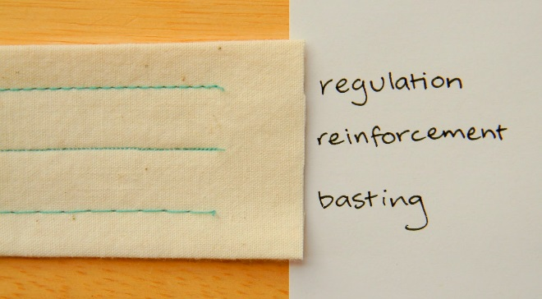

Standard 2: Examine & select correct thread for apparel design & accessory projects.
a. Seam allowance is the area between the cut edge of the fabric to the stitching line.
b. Standard thread is “All Purpose “.
c. Quality thread prevents stitching problems.
Standard 3: Identify & construct standard seam allowances & seam finishes.
a. Standard seam allowance for a commercial pattern is 5/8 inch.
b. Identify ¼” (approximately the edge of the presser foot), 3/8”, ½”, 5/8” & ¾” seam
allowances.
c. A seam finish is applied to the raw fabric edges, used to prevent raveling/fraying,
improves product quality & durability.
d. Identify terms:
- Clean finish: turn under ¼” toward the wrong side & stitch down.
- Zigzagged finish: Zigzag stitch on the outer edge of fabric.
- Serged: Use an overcast/serger to finish the outer edge of fabric.
Standard 4: Press garment correctly.
a. Press as you sew (never sew over a seam that hasn’t been pressed).
b. Pressing is an up & down motion, ironing is a sliding motion.
c. Use correct temperature for fabric/fiber content.
d. Use steam/moisture if appropriate.
e. Use pressing cloth to prevent scorching or shine marks.
REQUIRED PERFORMANCE OBJECTIVES:
- Complete FCCLA Step One.
- With the completion of apparel – (Apron) & personal accessory (Phone case) projects, students will demonstrate competency in sewing machine use, care & safety.
- Create a fabric file, Identify fiber content from: (denim, flannel, canvas, calico, satin, rip-stop nylon, vinyl, leather, 2-way stretch, 4-way stretch, rib knit, single knit, polar fleece, sweatshirt fleece, felt & neoprene). They will identify care, fabrication (woven, knit, or non-woven) & intended use of fabrics.
- Construct an apparel project using the correct pattern size based on body measurements & finished garment measurements. Projects will be a pair of Pajama bottoms – made from flannel & a basic T-shirt – made from knit & sewn on serger.
- Student will use the iron to press their projects as they are being completed to produce a professional quality project.
- Complete all of the following skills as part of the course. A minimum of 8 skills must be included as part of an apparel or personal item project.
  - Serge seam finish – T-shirt
  - Zigzag seam finish – Pajama bottoms
  - Clean finish seam finish – Sample
  - Construct seam allowance as indicated on the guide sheet – Pajama bottoms
  - Casing (1/4” wider than elastic or drawstring) – Pajama bottoms
  - Patch pocket with mitered corners & reinforced top triangle corners with top stitching – Apron
  - Buttonhole – Phone case
  - Attach a button with hand needle & thread with shank – Phone case
  - Construct a machine stitched hem – Apron, Pajama bottoms & T-shirt
  - Hand stitching using a hemstitch – Phone case

SKILLS CETIFICATE TEST POINTS BY STRAND
Test Name | Test Number | STRAND 1 | STRAND 2 | STRAND 3 | STRAND 4 | STRAND 5 | Total Points | Total Questions
Apparel Design 1 | 350 | 2 | 19 | 17 | 17 | 16 | 71 | 71

FCCLA Integration into Apparel Design & Production 1:
STAR EVENTS: Advocacy, Career Investigation, Chapter Service Project Display, Chapter Service Project Manual. Environmental Ambassador, Illustrated Talk, Job
Interview, Fashion Construction, Recycle Redesign.
National Program: Career Connection, Leadership Service in Action.
GRADING SCALE
- A 93 A- 90 B+ 87 B 83 B- 80 C+ 77 C 73 C- 70 D+ 67 D 63 D- 60 F less than 60 Students/Parents may check their grades through power school.
- I am available to meet privately with students 30 min. before & after school begins & ends.
- Make-up work for excused absences will follow school policy.
CLASSROOM RULES
- Students are expected to act as well behaved young adults & will be treated as such.
- Students need to come prepared with paper & pen/pencil. If not, 15 points will be docked.
- Promptness is imperative. Class begins at tardy bell, with students seated & ready to work. Tardy & absences will follow school policy.
- The teacher not the bell will dismiss class.
- Respect must be shown to all members of the class & the teacher.
- Profanity will NOT be tolerated. Such language will result in student being removed from
class.
- All distracters (Cell phones, headphones, I-pods, food/drink) are to be left in lockers. If brought they’ll be taken away. (I-pads must be put away unless using them in class)
- All dress codes will be observed.
- Students need to respect teacher’s right to teach & students’ right to learn, raise your hand to speak.
- Classroom Assignments - Need to have Name, Assignment Title, & put in assignment box.
- Labs are days we will be working on an activity. On lab days students are responsible for cleaning up & putting everything away at the cleanup bell. I will give no excuses for tardiness. Student must be working on lab days. If students don’t have supplies to work with points will be deducted.
- For a fire, earthquake, or other emergency - stop what you are doing & remain calm, teacher will give instructions. Make sure to turn off lights & last person will shut the door. Exit classroom to assigned area. Practices will occur during the year, be prepared. Upon
admittance back, roll will be taken again. If you have questions, always ask.
CLASSROOM REQUIREMENTS
- Pay $10.00 lab fee.
- Provide fabric for Phone Case – 2 fat quarters different patterns but matching & complete Phone case.

- Provide fabric for Apron - 1 yd. cotton blend + a matching 1/3 yd. for pockets & straps & complete Apron.
- Proved fabric for Pajama bottoms – 2 ¼ – 2 ¾ yd. of a flannel (no stripes or plaids – length of fabric depends on height of student) & complete Pajama bottoms.
- Provide fabric for T – Shirt – 1 ½ yd. knit & complete T-Shirt.
- Provide a 3 ring binder for portfolio or use one of mine – Portfolio of samples is required.
- Provide a recipe file box or use one of mine – Fabric File is required.
- Create a career a 2 page typed report on a career in the Apparel & Design Production Area.
- Complete a 2 page typed report on a particular textile or fabric.
- Complete required performance objectives.
- Take state competency skills test.
Before signing this disclosure statement make sure you have read all of the above. Keep this part for your records and return the last page signed. Please contact Ms. Wilde if you have any questions.

Thank You,
Susan A. Wilde

This Paper is required to be signed by student and Parent. It is worth 20 points, if it is returned, (this paper only) by ________________ it will receive an additional 10 extra credit points

Dear Parent & Student,
Please read the Previous Syllabus & Disclosure Statement carefully & return the signed statement below indicating that you understand the policies as outlined. Keep the informational portion of this disclosure for further reference. The areas that students will be tested on are outlined in this disclosure. Student should use this to help them with their end of level tests.

There is a $10.00 lab fee for this class, the lab fee helps with cost of sewing machine repairs & equipment that is purchased for this class, I provide scissors, needles, pins, interfacing, thread & most other equipment they will use. I appreciate your cooperation with this. The fee is due by _______________; I will send home a receipt when this has been paid. Thank you, I would be happy to answer any questions that you might have. The policies in this disclosure have been reviewed & approved by the administration of North Summit High School & Susan Wilde, High School Teacher

_____ I have paid the $10.00 lab fee required for this course

_____ I have read & understand the guidelines listed in this Syllabus/Disclosure Statement.

_____ I am willing to abide by the terms of this disclosure.

______________________ ________________________ ___________________ ________
Student Name (Print) Student Signature Name of Class Grade

________________________ _______________________ _______________ ____________
Parent/Guardian (Print) Parent/Guardian Signature Home Phone # Date

North Summit High School programs are open to all students without regard to race, color, national origin, sex, or disabilities.

