This scarf is great to make for yourself or for a gift, and it comes from your "green" studio when you use eco-friendly soy wax. This is a great first project to explore soy batik; the wax acts as a resist on the scarf, making painting almost foolproof. Using textile paints instead of dyes simplifies the process enough to complete in an afternoon. Make it contemporary, classic, or wild, depending on your choice of colors and wax patterns.

Notes:
- Always use natural-bristle brushes with wax. The wax will not come out of the brushes, so mark them for this use.
- An old crockpot, double boiler, or electrical skillet can be used instead of the melting pot.
- Soy wax will not clog your drains.
- CAUTION: Do not leave melted wax unattended. Always unplug any electrical tools when you are done using them.

To Make a Silk Batik Scarf:
In a well-ventilated area, prepare a work surface that is large enough to accommodate the scarf when laid flat. Cover the surface with a plastic drop cloth topped with an old sheet.
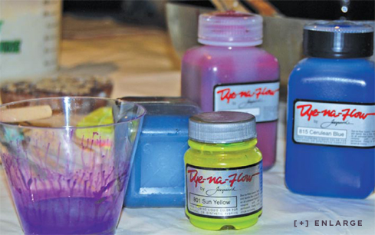
Pre-wash the scarf using gentle detergent and let it dry. Press to remove wrinkles. Pin the scarf to the cloth on your worktable.
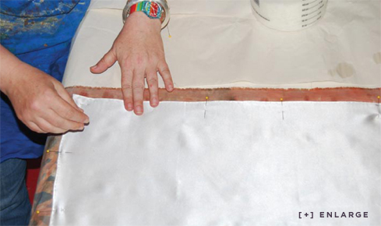
Melt the wax in an old electric skillet or crock-pot, or in the top of a double boiler. Soy wax melts at 150° fahrenheit; do not overheat it.
Dip a natural-bristle brush into the melted wax and apply it to the scarf in oval rings or the design of your choice, keeping in mind that the areas painted with wax will resist the paint and remain white. Some designs should appear to run off the edge of the scarf. Hold a cup or small bowl under the brush as you move from one area to the next to prevent wax from randomly dripping onto your scarf. The wax will harden almost immediately.
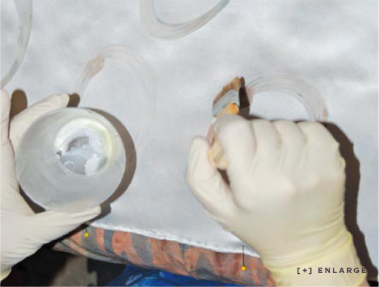

Paint a ring inside the wax ovals with the chartreuse textile paint. The wax will stop the paint from bleeding beyond the oval.
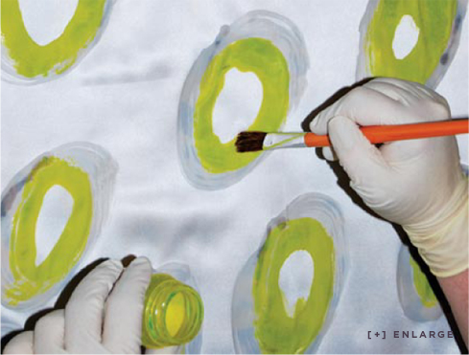
Paint inside the chartreuse ring using a clean brush and violet paint. Let the paint dry.
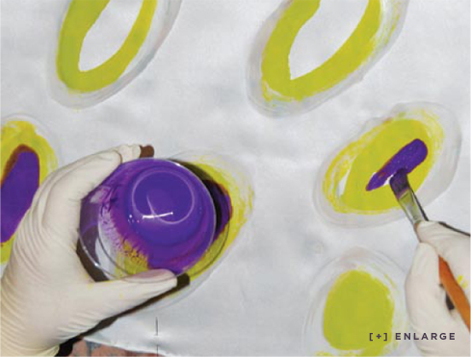
Cover the dry painted areas with melted wax.
Paint the entire scarf with the midnight textile paint.
Unpin the scarf and remove it from your worktable. Hang it on a clothesline to let the paint dry.
Layer newspapers on your worktable, lay down the scarf, and cover with another layer of newspapers.
To heat set the paints and remove the wax, press through the newspapers using a hot, dry iron. The wax will melt into the paper. note: Iron wax in a well-ventilated area only.
Remove the scarf from the layers of newspaper.
To remove the remaining wax, machine wash the scarf in hot water. Line dry, and press for a crisp finish.
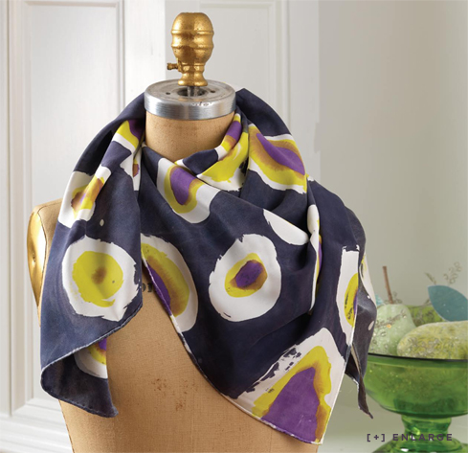

Shopping list:
Hemmed silk scarf
Soy wax
Dye-na-Flow® paints - 3 colors such as chartreuse, violet, midnight
Melting Pot
1" & 2" Natural-Bristle brushes
Two 3/4" brushes (for paint)
Pins
Plastic Drop Cloth
Old Sheet
Cup or Small Bowl
Old Newspapers
Gentle Detergent

