Assignment: example
Take a clothing or outdoor product item and identify the materials and textiles used to create it.
When you are finished, your group will teach each other about the materials.
TECH SHEET
Designer(s) Name: | Sally Sews
Class Period: | 1st
Style Name: | Women’s blouse with ruffled sleeve
Description: | Striped Shirt with set in sleeve and ruffle hem. Jewel neckline
Sewing skills needed:  List at least 3 | Sleeve construction  Ruffle  Hem  Neck facing
Fabrics: | Woven cotton
Trims/Notions: | None
Use pics of your product, show videos or graphics that will teach other students about your product.

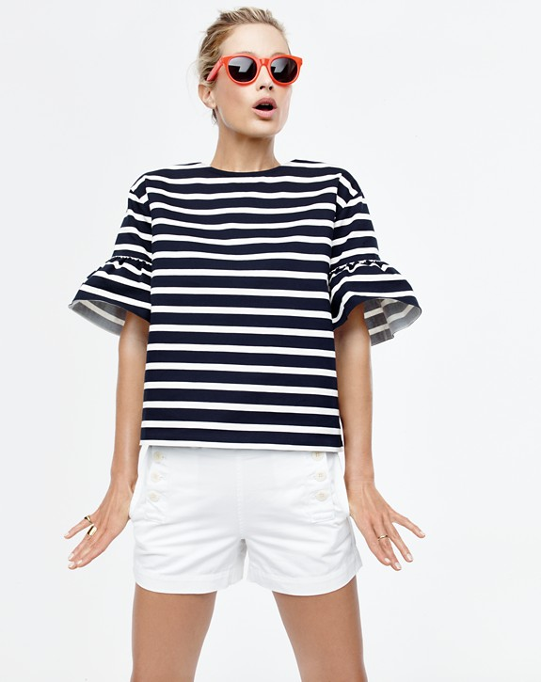

Teaching Notes and Resources to share with classmates:

Sleeve Construction: students can explain show tutorials or videos of the process.
Ruffle:
Hem:
Neck Facing:

Cotton:
https://thefabricofourlives.com/ show video clip

Types of cotton: students should include information here
Benefits of Cotton: students should include information here
Environmental facts: students should include information here
Care tips: students should include information here

