Name:_____________________________________________ Period:__________
Safety and Sanitation Remediation
Today’s Skills:
I can identify safety and sanitation rules and the guidelines necessary to maintain a safe working environment.
Hazards (Biological, Physical, Chemical)
Create a set of flash cards for each hazard; draw the hazard on one side and labeling the hazard on the other.

FIFO
Create a set of flash cards for FIFO.

FATTOM  Label the Feathers of TOM TURKEY with the conditions bacteria needs to grow.  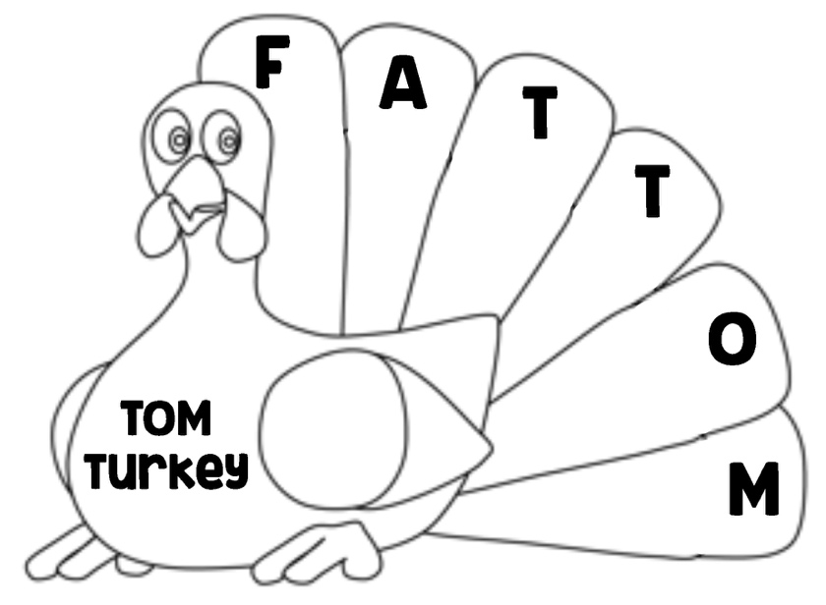 | Food Preparation  How to thaw food & how not to thaw food.  Draw the correct answer:  The safest way to thaw! Plan ahead needs 2-3 days. A safe way, but cook immediately  Uses lots of water but still safe. DON’T ever thaw here!
Food Safety Temperatures  Fill in the blanks.  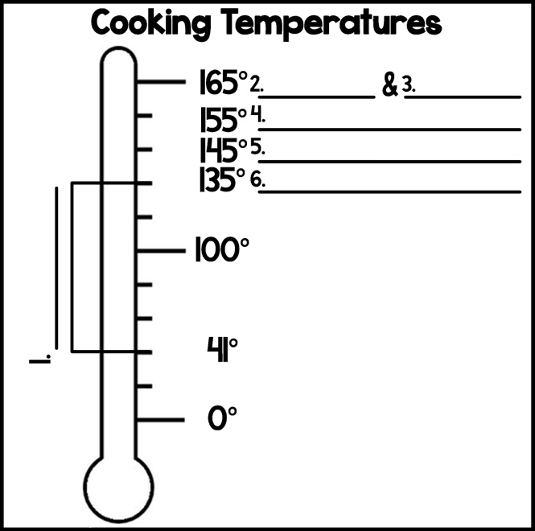 | Safety & Sanitation Questions  Fill in Blanks.  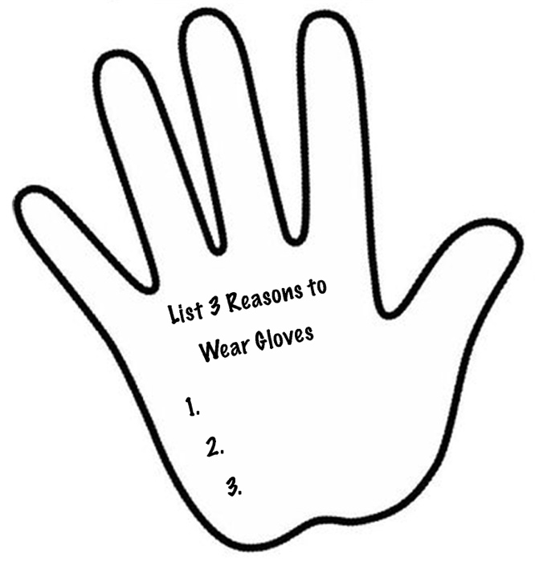

Safety & Sanitation Questions Continued
Draw a line from the method to tell me if it is a safe or unsafe way of putting out a grease fire.

Baking Soda  Sugar  Smoother  Salt  Flour  Fire Extinguisher  Water  Lid | NOT Safe, DO NOT DO THIS!  SAFE Method

