CUSTOMER SERVICE AND MANAGEMENT

IMPORTANCE OF CUSTOMER SERVICE
- Make or break an establishment
•
- Understand customer needs
- -
- -
- -

IDENTIFY FRONT OF THE HOUSE JOB AND DUTIES
HOST/HOSTESS

- Responsible to the customer
•
- Take reservations
- Supervises service to customers
•
SERVER
•
•
•
•
•
•
Handles customer needs
Checks tables
Correct problems

Knows appropriate table setting
•
•
CASHIER

- Responsible for cash drawer
•
•
BUS PERSON:
DINING ROOM MANAGER:

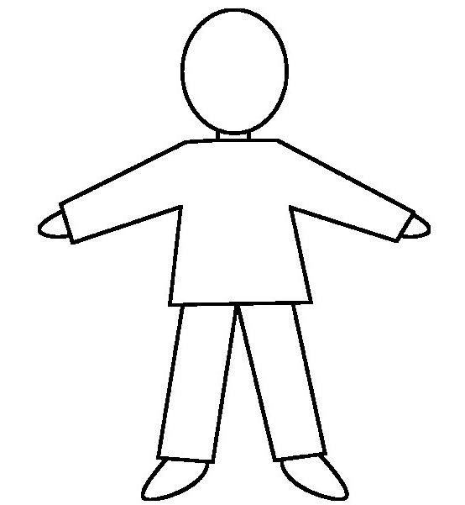
NON-VERBAL:
VERBAL:
ATTITUDE:

- Positive
•
•
•
•
PERSONAL APPEAL:
UNDERSTAND ORDER OF FRONT OF THE HOUSE SERVICE
CHARACTERISTICS NEEDED TO BE A SKILLED EMPLOYEE

3. SELL THE MENU
4. SERVE THE ORDER
1. GREET CUSTOMERS
2. TAKE BEVERAGE ORDERS
6. PROCESSING PAYMENT
5. ALCOHOL SERVICE

MAIN TYPES OF DINING ENVIRONMENTS

QUICK SERVICE:
CASUAL DINING:
TRADITIONAL OR FINE DINING:
AMERICAN SERVICE:
FRENCH SERVICE:
RUSSIAN SERVICE:
ENGLISH SERVICE:

DINING EQUIPMENT AND HOW THEY ARE USED
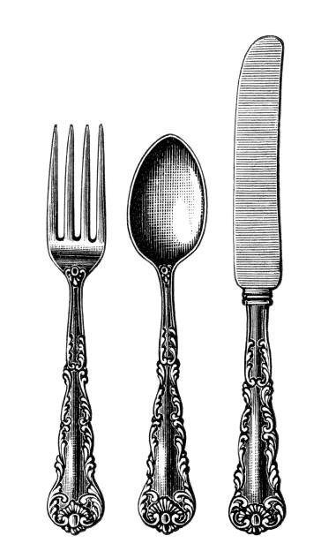
FORKS
KNIVES
SPOONS

DRINKING GLASSES
DINNERWARE
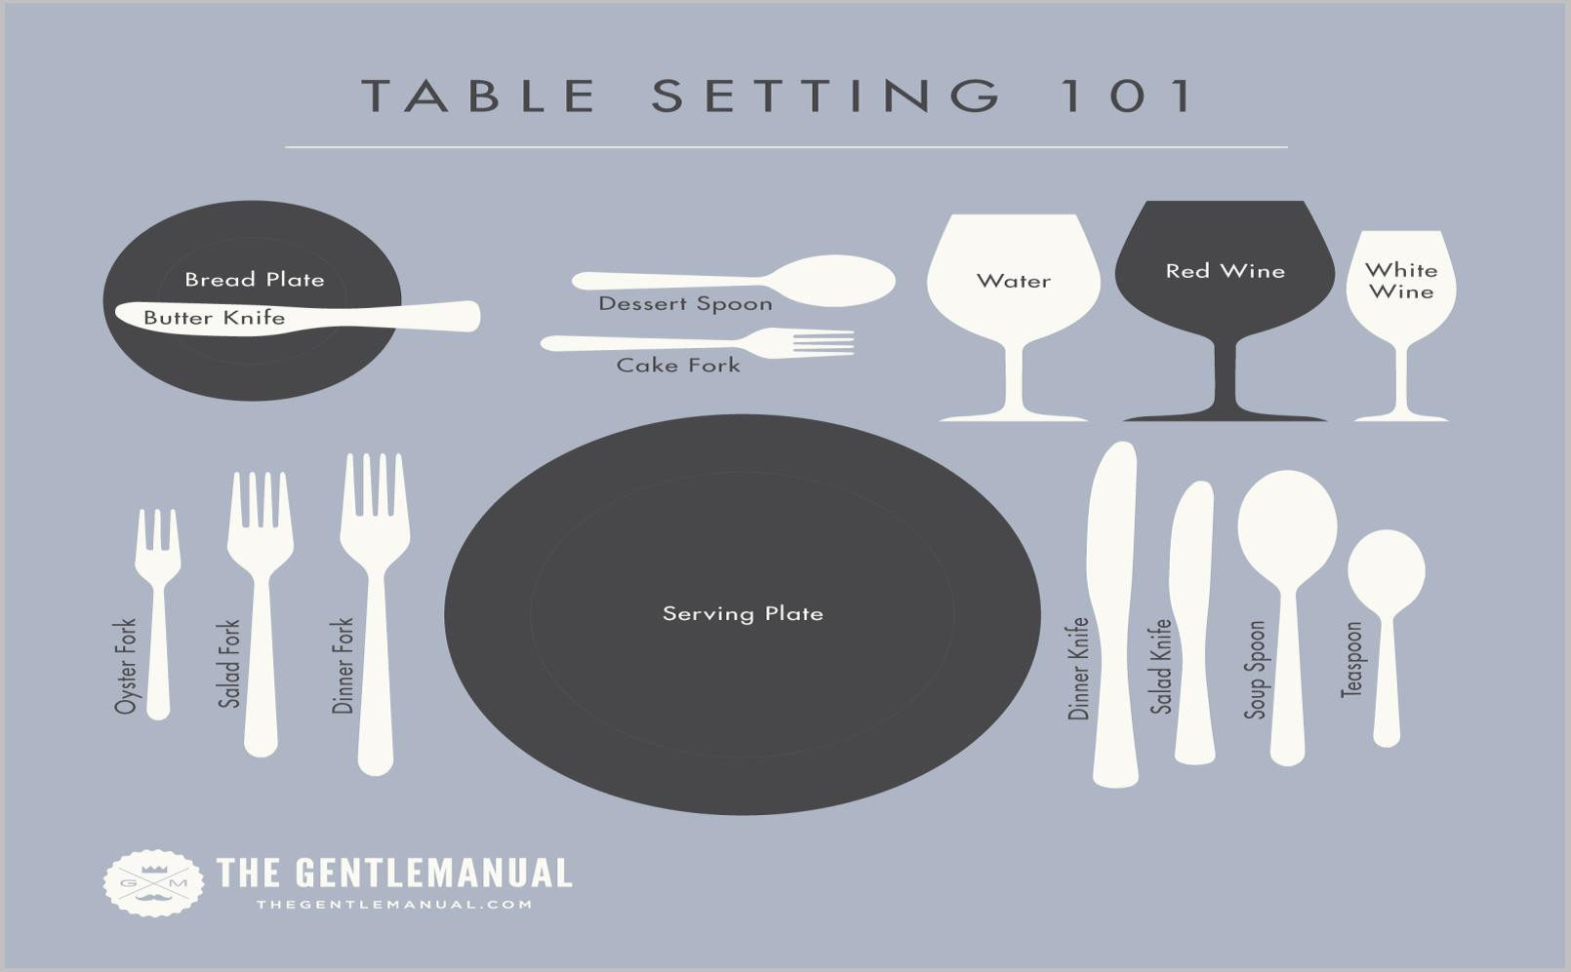

15 QUALITIES AND DUTIES OF AN EFFECTIVE MANAGER

