Kitchen #: ___________

Nutrition in Culinary

You work for Blend-tec. You have been asked to create a smoothie that will meet the needs of people with various food allergies or intolerances. You need to make the smoothie for the focus groups that will be trying the smoothies, so make 1 batch and divide it into a cup for each group. Sample cups will be provided in each focus group. The requirements for your smoothie are below:

The allergy or intolerance that you have to avoid: NUTS

You must include the following in your smoothie, you can have more if you want:
2 fruit components
1 vegetable component
1 dairy/dairy substitute

In the space below write your recipe and how it avoids the allergies and intolerances that you:

Once every group is done, fill in the chart below with your group. List the allergy or intolerance, describe the flavor and then rank your favorite smoothie 1 being the highest 8 being the lowest:
 | Kitchen 1 | Kitchen 2 | Kitchen 3 | Kitchen 4 | Kitchen 5 | Kitchen 6 | Kitchen 7 | Kitchen 8
Allergy or Intolerance
Describe Flavor
Ranking

Kitchen #: ___________

Nutrition in Culinary

You work for Blend-tec. You have been asked to create a smoothie that will meet the needs of people with various food allergies or intolerances. You need to make the smoothie for the focus groups that will be trying the smoothies, so make 1 batch and divide it into a cup for each group. Sample cups will be provided in each focus group. The requirements for your smoothie are below:

The allergy or intolerance that you have to avoid: Dairy

You must include the following in your smoothie, you can have more if you want:
2 fruit components
1 vegetable component
1 dairy/dairy substitute

In the space below write your recipe and how it avoids the allergies and intolerances that you:

Once every group is done, fill in the chart below with your group. List the allergy or intolerance, describe the flavor and then rank your favorite smoothie 1 being the highest 8 being the lowest:
 | Kitchen 1 | Kitchen 2 | Kitchen 3 | Kitchen 4 | Kitchen 5 | Kitchen 6 | Kitchen 7 | Kitchen 8
Allergy or Intolerance
Describe Flavor
Ranking

After you have ranked each group’s smoothies, look over the wed med article to compare and contrast food allergies and food intolerances using the ven diagram below. Make sure that you include common foods, symptoms and treatment.
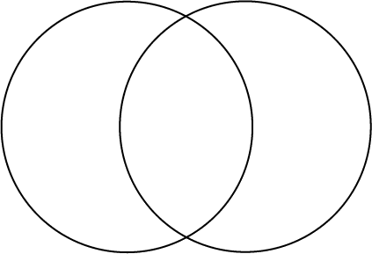
Food Allergy
Food Intolerance

