Kitchen #: ___________

Nutrition: Allergies and Intolerances

You work for Blend-tec. You have been asked to create a smoothie that will meet the needs of people with various food allergies or intolerances. You need to make the smoothie for the focus groups that will be trying the smoothies, so you will need to first make enough for 30 sample cups for the focus group to try. Then you will give one cup to each member of the class so that they can sample the different smoothies and vote on their favorite. The best group will receive a prize. The requirements for your smoothie are below:

The allergy or intolerance that you have to avoid: NUTS

You must include the following in your smoothie, you can have more if you want:
2 fruit components
1 vegetable component
1 dairy/dairy substitute

In the space below write your recipe and how it avoids the allergies and intolerances that you were given:

Once every group is done, fill in the chart below with your group and rank your favorite smoothies:
 | Kitchen 1 | Kitchen 2 | Kitchen 3 | Kitchen 4 | Kitchen 5 | Kitchen 6
Allergy/Intolerance:
Describe Flavor:
Ranking:

Kitchen #: ___________

Nutrition: Allergies and Intolerances

You work for Blend-tec. You have been asked to create a smoothie that will meet the needs of people with various food allergies or intolerances. You need to make the smoothie for the focus groups that will be trying the smoothies, so you will need to first make enough for 30 sample cups for the focus group to try. Then you will give one cup to each member of the class so that they can sample the different smoothies and vote on their favorite. The best group will receive a prize. The requirements for your smoothie are below:

The allergy or intolerance that you have to avoid: DAIRY

You must include the following in your smoothie, you can have more if you want:
2 fruit components
1 vegetable component
1 dairy/dairy substitute

In the space below write your recipe and how it avoids the allergies and intolerances that you given:

Once every group is done, fill in the chart below with your group and rank your favorite smoothies:
 | Kitchen 1 | Kitchen 2 | Kitchen 3 | Kitchen 4 | Kitchen 5 | Kitchen 6
Allergy/Intolerance:
Describe Flavor:
Ranking:

After you have ranked each group’s smoothies, go to this website: goo.gl/Lq9X4v to compare and contrast food allergies and food intolerances using the ven diagram below. Make sure that you include common foods, symptoms and treatment.
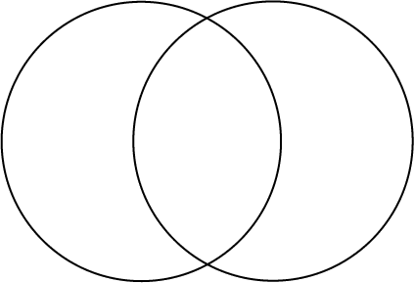
Food Allergy
Food Intolerance

