Strand 5 – Nutritional Guidelines

From the MyPlate Video (what is written on the note pad)
What is the tip for fruits and vegetables?
What is the tip for grains?

What is the tip for protein?
What is the tip for diary?

What should you avoid?

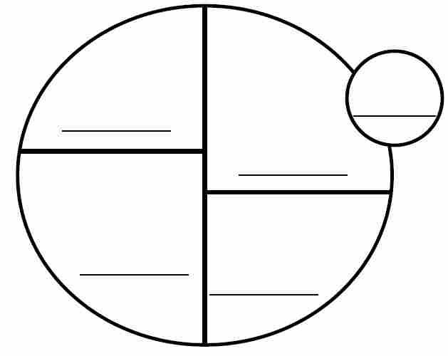
On the plate to the left fill in the correct names of each group

Carbohydrates
1
2
3

Protein
1
2

Lipids (Fat)
1
2

Vitamins
1
2

Minerals
1
2
3
4

Water
1

Difference between Allergies and Intolerances
Allergies | Intolerances

Go to choosemyplate.gov, scroll down to choose a food group to explore. Read the information about the food group and then take the quiz about the food group. Repeat for all 5 food groups. Record your scores below.

Dairy _____ Fruits_____ Vegetables_____ Protein _____ Grains _____

Now create a healthy menu for 1 day using the information you have gained. You don’t have to have all 5 food groups each meal, but if you are missing one add it to the snack chart.

Breakfast
Fruit
Vegetable
Protein
Grain
Dairy

Lunch
Fruit
Vegetable
Protein
Grain
Dairy

Dinner
Fruit
Vegetable
Protein
Grain
Dairy

Snacks
Fruit
Vegetable
Protein
Grain
Dairy

