Name:_______________________________________ Period:_________________
Salads, Dressings and Garnishes

Appetizer: | Accompaniment: | Main Dish:
Intermezzo: | Dessert: | 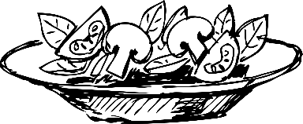

When possible, purchase greens ______________________________.

1. | 2.

Match type of dressing with | Dress greens just before | Starch salads should be dressed and refrigerated to allow the flavors to _____________ and __________________.

Vinaigrette:

Mayonnaise Based Dressing:

Cooked Dressings:

Garnishes:________________________________________________________

