Name:____________________________________________________ Period:______
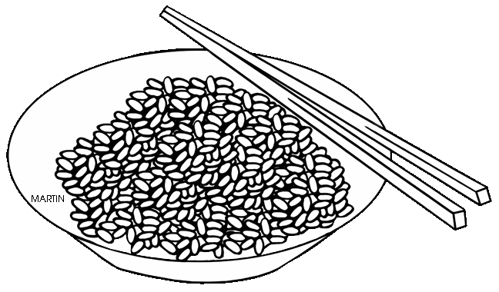
Grains, Legumes, Potatoes

Types Rice
Long Grain
Medium Grain
Short Grain
Whole Grain
Converted

Rice Storage
White Rice
Brown Rice

After Cooking

Cooking Techniques
Before Cooking
Yield
Boiling
Steaming
Braising or Pilaf
Risotto
Baked

Pasta Ingredients
Flour

Liquid

How is pasta named? ____________________________

How does the shape determine what sauce to use?

Cooking Pasta
Technique

Al Dente
Undercooking

Yield

Types of Grains
Quinoa
Millet
Barley, Farro, Spelt
Corn

Hominy

How to receive, store and handle potatoes
Choosing potatoes
Storage
Before Use
After Cutting

Types of Potatoes
Starchy | Example  Use
Waxy | Example  Use
All-Purpose | Example  Use
What are the four types of Legumes?
1
2
3
4

Tips for Storing and Cooking Legumes
Purchasing
Prep for Dry Beans
Effects of Acid on Beans
Storage
