Purchase CDA books at http://www.cdacouncil.org

Click on the “Buy CDA Materials” link (Top, right of screen)

Click on “CDA Books/Applications” link (Left side of screen)

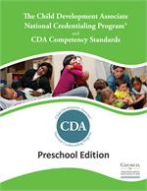
Preschool CDA "2.0" Competency Standards Book (replaces the application packet)
Price: $25.00

The book gives Candidates working with Preschoolers, ages 3-5, everything they will need to
prepare and apply for the CDA Credential. It replaces the current “application packets.”

