2012-2013

Layton High School CDA TRACKING WORKSHEET

- Hours of Education Hours Completed (Refer to CDA pg. 11, Table 2)
- The CDA requires 120 total education hours to be completed. These hours encompass at least 10 hours from each subject area.
- The education requirements will be met through the completion of the Child Development Pathway courses (Child Development, ECE 1, ECE 2, and ECE 3) with a C or better.

Competency Area | Class Day # | Title of Training | # of minutes |  | Total # of hours
Safe, Healthy, Learning Environment | CD 22  CD 23  CD 24,28,31  CD 38  ECE 1 6  ECE 1 10  ECE 1 22  ECE 1 32-38  ECE 2  ECE 2  ECE 2  ECE 2 | Infant emotions  Health and Safety  Child Clothing Safe & appropriate  (3 days x 10min)  Coping with challenging situations  Center Tour and policies and procedures test and review  Play (indoor and outdoor)  Food and Nutrition Experience  Equipment and toys (ch 9)  Environment (ch 8)  Health and safety (ch 10 and 12)  CDA Goal #1  (3 days x 15 min)  Policies and procedures test and review  First Aid and CPR Training  Food Handlers Permit  TOTAL # of MINUTES | 70  75  30  75  85  75  70  80  45  45  180  -----  830 |  | 13.83 hrs.
Physical & Intellectual | CD 21  CD  24,28,31  CD  26,30,33,40,43  CD  26,30,33  CD Daily  CD Daily  ECE 1 9  ECE 1 10, 11,12,13,14,15  ECE 2 | Newborn cognitive development  Motor skills  (3 days X 10 min)  Language and literacy  (5 days x 15 min)  Cognitive Development  (3 days x 35 min)  Music / Songs and Literacy / books  (44 days x 10 min)  DAP Learning Activities  (44 days x 10 min)  Storytelling  Play, Art, music, math, science, literacy  (6 days X 75 min)  CDA Goal #2 (3 days x 15)  TOTAL # OF MINUTES | 30  30  75  105  440  440  65  450  45  1680 |  | 28 hrs.
Social & Emotional | CD 1  CD 2  CD 4  CD 5  CD 25,29,32  CD 21  CD  35,36,37  CD 43  ECE 1 7  ECE 2 | Value and influence children  Rights of children  Bonding and nurturing children  Develop and strengthen self-concept in children  Emotional and social development  (35 min x 3 days)  Newborn emotional and social development  Positive Guidance  (80 min x 3 days)  Children’s book write and analysis  Discipline  CDA Goal #3 (2 days x 15 min)  TOTAL MINUTES | 75  40  75  75  105  35  210  15  75  30  735 |  | 12.25 hrs.
Families | CD 3  ECE 1 32-38  ECE 2  ECE 2  ECE 3  ECE 3  Other relatable courses. | Parenting roles and responsibilities  Parent Involvement (ch 31)  CDA Goal #4  Child report to the family  Parent Child Survey and child Data collection  Weekly Parent letters and daily greeting parents  With proof of transcripts  TOTAL # of MINUTES | 70  60  30  60  50  270+ |  | 4.5 hrs.+
Program Management | CD 19  CD 39  ECE 1 4  ECE 1 5  ECE 1 23 – 31  ECE 1  ECE 1  ECE 1 32-38  ECE 2 | Lesson Planning  Child Abuse  DAP  Curriculum  Writing an 18 Lesson Plan Theme book  (6 days x 80 minutes)  Writing 5 single activity lesson plans  (5 lessons x 10 min)  Writing 2 complete lesson plans  Childcare programs (ch 2)  CDA Goal #5 (3 days x 15)  TOTAL # of MINUTES | 70  85  75  75  480  50  50  20  45  950 |  | 15.83 hrs
Professionalism | CD  ECE 1  ECE 1  ECE 1 1, 38, 43  ECE 1 32-38  ECE 1 3  ECE 2  ECE 4 | Evaluating group teaching experience  Evaluating group teaching experiences  (4 days x 10 min)  Evaluating support experiences  (14 days x 10 min)  Quality childcare worker  Career in Child Care (ch 32)  Observation information  CDA Goal #6 (3 days x 15 min)  Internship / job shadow in center  (42 days x 90 min)  TOTAL # OF MINUTES | 10  40  140  45  20  80  45  345+  725+ |  | 12+hrs
Observing & Recording | Child Development  Class day minutes  Development and theories 15  Child Observation 85  ECE 1  Class day minutes  Unit 2 Observe Quality teacher characteristics (15 min x 6) 90  Unit 3 Observe Quality teacher characteristics (15 min x 3) 45  Unit 4 child observation 90  Community Experience Observe the teacher and the children 90  ECE 2  Class day minutes  Individual Child observation (12 days x 20) 240  ECE 3  Class day minutes  42 days x 5 min 210 |  | Total Minutes Total # of hours  100 1.66  315 5.25  240 4  210 3.5  865  14.41
Child Development | CD 6  CD 24,29,32  CD 26,30,33  CD 24,25,26  CD 28,29,30  CD 31,32,33  ECE 1 2  ECE 1 10, 11,12,13,14,15  ECE 2  ECE 3 | Theories of Development  Erickson Emotional Theory  (3 days X 30 min)  Piaget Cognitive Theory  (3 days x 30 min)  Infant milestones  (3 days x 15 min)  Toddler milestones  (3 days x 15 min)  Preschool milestones  (3 days x 15 min)  Ages and stages of development  Play, Art, music, math, science, literacy  (6 days x 15min)  Ages and Stages review and lesson planning  Lesson planning (7x15)  TOTAL # OF MINUTES | 60  90  90  45  45  45  80  90  75  105  725 | 12.08 hrs.
Total # of Training Hours Completed
Minutes:__6961.65_____

Hours: (Total minutes ÷ 60)____116.19____

CDA LAB EXPERIENCE HOURS (480 hours total required)
Class | Total Minutes | Total # of hours
Child Development  Class day minutes  Teach/support (2 x 80) 160 | 160 | 2.66
ECE 1A  Class day minutes  Read to kids 20  Unit 2 support (6 days x 85min) 510  Unit 3 support and teach (3 days x 85min) 255  Unit 4 support and teach (2 days x 85min) 170  Community Exp. (3 days x 70min) 210 | 1,165 | 19.41 hours
ECE 1B  Class day minutes  Support (22 days x 90) 1980 | 1,980 | 33
ECE 2 (1 semester or multiple semesters)  Class day minutes  Teach and support 44 days x 90 3960 | 3,960+ | 66+
Summer Job or Internship
In order to count for lab experience hours, the setting needs to include at least a group of 5 children between the ages of 3-5 years old.

Paid Employment in the Center  After school, before school, during lunch, assemblies, and late start, etc… | 165 days x 2.5 hours+ | 412.5 hrs+
Total # of Minutes | ____7265+
Total # of Hours  (Total minutes ÷ 60) | _____121.00+______

  - Verification Signature _________________________ Date ____________

Required Experience Hours to complete CDA: 480 total hours with children, ages three to five, in a state-approved child development center (Refer to CDA pg. 10).

CDA LAB/ EXPERIENCE HOURS
(Refer to CDA pg. 10)

In order to count for lab experience hours, the setting needs to include at least a group of 5 children between the ages of 3-5 years old.

Name: __________________________________

Date | Time In | Time Out | Total # of Minutes | Notes and location | Verification
Total # of Minutes ___________
Total # of Hours ___________
(Total minutes ÷ 60)

Verification Signature _________________________ Date ____________

Required Experience Hours to complete CDA: 480 total hours with children, ages three to five, in a state-approved child development center (Refer to CDA pg. 10).

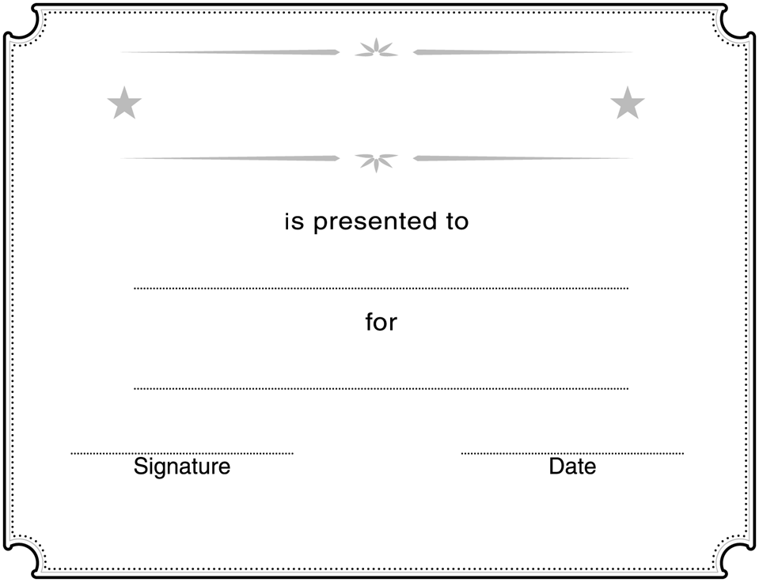

Utah State Office of Education
CDA
Certificate of Competency

Successfully completing the CDA performance levels acknowledged in the Child Development pathway
Training hours:________________________ / 120 total required
Lab / Experience hours:__________________ / 480 total required

