Creating My Kitchen
This assignment give you the opportunity to select actual materials, appliances, etc. for your kitchen. Remember this part as you choose item for your kitchen. There is no budget so you can choose whatever you want.
✓ Page 1:
A title (Creating My Kitchen)
Your name
Your choice of kitchen layout – Examples: Corridor, one-wall, U-shaped, L-shaped, G-shaped kitchen or any of these kitchens with an island or peninsula. You need a picture or drawing and label.
✓ Page 2: style of kitchen –traditional, transitional, contemporary, rustic, arts & crafts, old world. Include a description of items for this style. Go to http://www.kitchens.com/design/kitchen-style.aspx or a similar site. Description of what makes this that style, i.e. type of wood and color of stain for cabinets, flooring material, design details.
✓ Page 3: Countertops –Choose a material and include a picture. Include a description of material and advantages or disadvantages. What does this type of countertop cost per square foot? Include this price range.
✓ Page 4: Sink – Choose a sink. Include a picture and describe style and material it is made of and give any information that would be useful to the homeowner. Can you find a price range? If so, include this figure.
✓ Page 5: Flooring – Include a picture, advantages and disadvantages, care instructions, price range per square foot.
✓ Page 6: Appliances: range/oven and microwave – Find actual appliances for sale online at an appliance store. Include picture, specs, and price.
✓ Page 7: Refrigerator – Same as for #6.
✓ Page 8: Two small appliances of your choice – toaster, mixer, blender, etc. – Same as for #6 and #7

Kitchen Design
For this assignment you will research styles, materials, appliances and supplies to create your dream kitchen! You have no budget so have fun!
Kitchen Layout
Draft and label your kitchen layout below:

Kitchen Layout: _____________________________
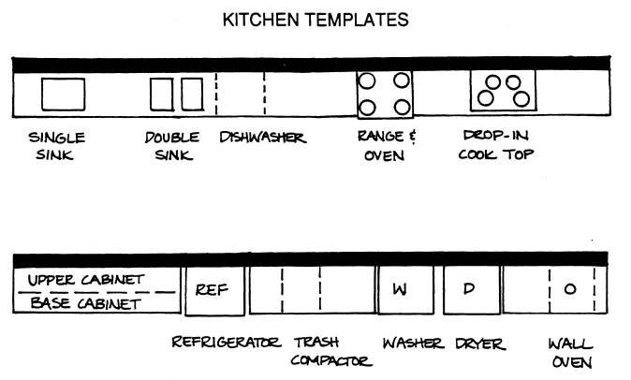
Kitchen Design/ Style
What style of kitchen do you want (traditional, contemporary, rustic, French country)? Using these websites research different styles:
http://www.kitchens.com/design/kitchen-style.aspx
http://photos.hgtv.com/rooms/kitchen

Give a description of your design style:

What are some of the materials used in this style for flooring, cabinets, colors, design details?

Kitchen Interior Finishes
What types of finishes would you like? What are some of the advantages and disadvantages of the materials used? What is the cost for the materials? Complete the chart below on the interior finishes used in your kitchen Print a small picture to include in your chart.
ITEM | DESCRIPTION | PICTURE | ADVANTAGES | DISADVANTAGES | COST
Countertop Material (What type of material will you use, and what is the cost of this material per square foot?)
Type of Flooring (what is the use and care for this type of flooring?/ cost per square foot?)
Type and Color of Cabinets (wood and stain color)

Paint/ Back Splash (will you add a back splash or paint color to your walls?)

Lighting Fixtures (What types of fixtures would you like in your kitchen, recessed can lights, pendant lights, etc.).
Kitchen Appliances
What major appliances would you use in a kitchen, and what you would like? Include descriptions, specs and information from your research. Also, choose two small appliances you would like to have as well: Toaster, Mixer, Waffle Maker, etc.
Complete the chart below on the appliances used in your kitchen. Print a small picture to include in your chart.

ITEM | DESCRIPTION | PICTURE | COLOR | COST | ADDITIONAL INFO
Sink and Faucet
Refrigerator
Range/ Oven
Microwave

Dishwasher
Small Appliance #1

Small Appliance #2

