MAKING APRONS FROM OLD SHIRTS: Whether you're sentimental or frugal, you'll love aprons repurposed from old plaid shirts belonging to a brother, dad, or grandpa. Psst... makes a great Father's Day gift too!

DIRECTIONS: Cut off sleeves and back. Cut around collar but leave it intact. Cut close to seam so that you won't need to hem anything or have any raw edges. 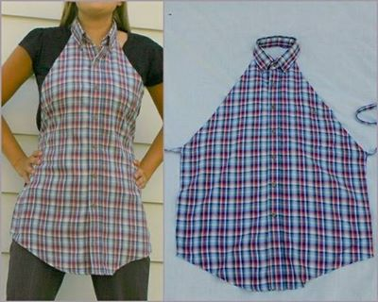

Then use rotary cutter and ruler to make a diagonal cut from armpit to top of shoulder; make sure both sides are even. On raw edge that you just cut, turn a hem under, concealing all raw edges, and sew it down. Do this on both sides.

Final step is to make apron ties. Either use ribbon or cut strips of fabric on bias to make apron interesting. Close all raw edges in and sew straps on to bottom of your diagonal cut. Backstitch several times for reinforcement.

TIPS: (1) Flip the collar up until you are completely done with apron. This keeps you from accidentally stitching it down and it just puts it out of the way. (2) Second, button the shirt all the way down at beginning (helps fabric stay straighter). (3) A plaid shirt is a good starter since you can use the stripes as your guide for keeping it straight.

For more examples and pictorial directions, seehttp://beeinmybonnetco.blogspot.com/2011/11/making-aprons-from-old-shirts.html

