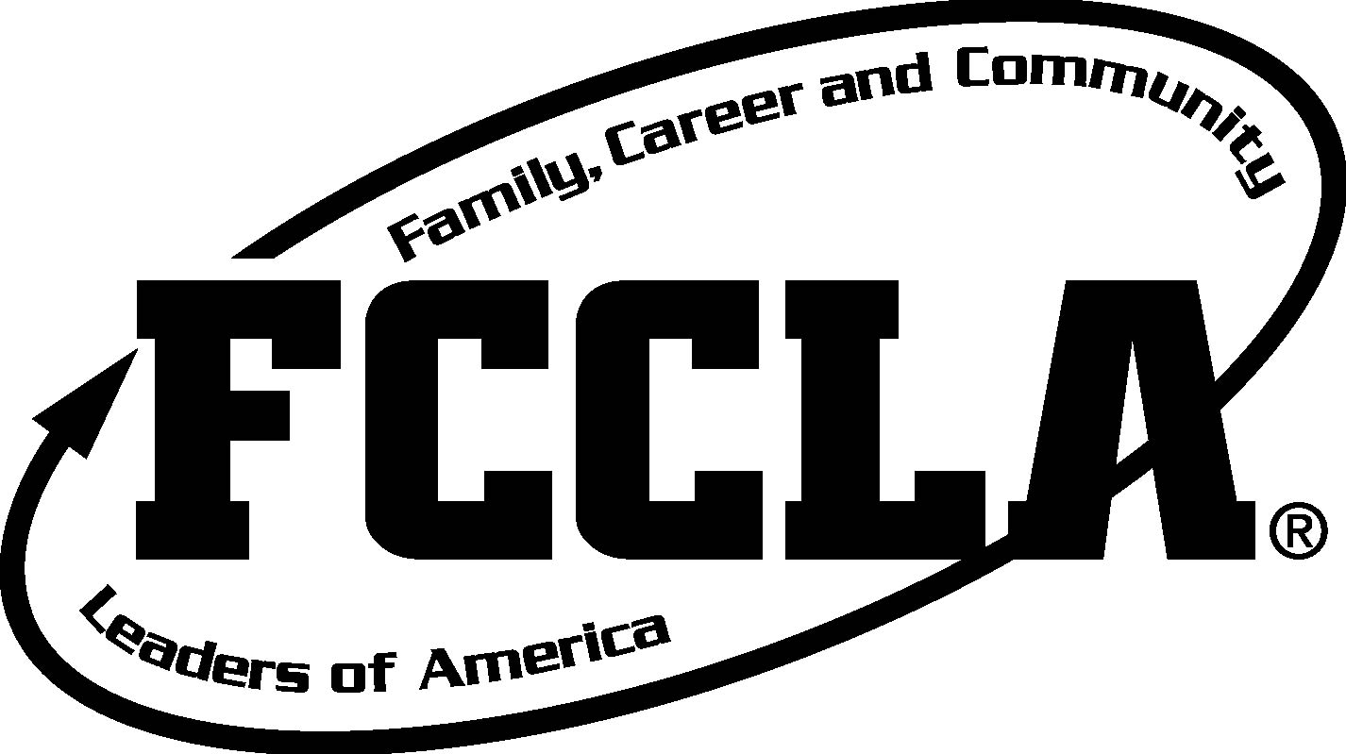

Canyon View FCCLA Scavenger Hunt 2015
TEAM MEMBERS (no more than 4!)
 | Location | Answer
Question 1
Question 2
Question 3
Question 4
Question 5
Question 6
Question 7
Question 8
Question 9

