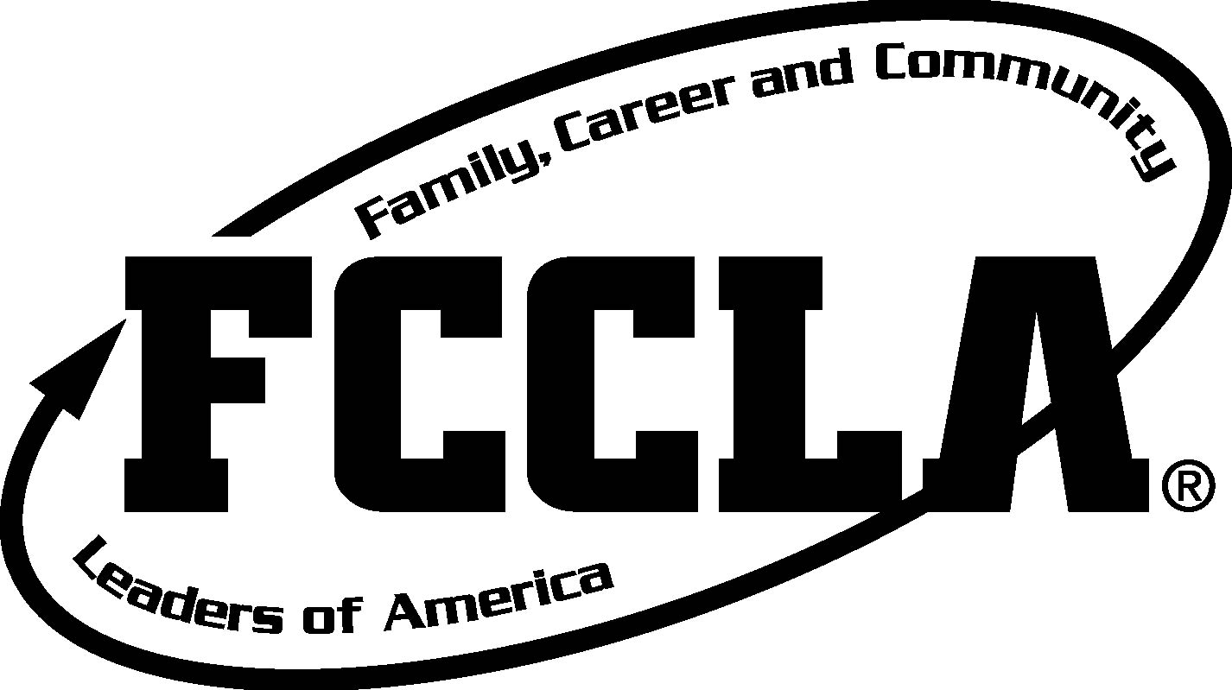

Question #1:
This CVJH science teacher speaks the language from a country where FCCLA sponsors a student exchange….find him and list the country where FCCLA does this international exchange program!

Answer #1:
Teacher : Mr. Pusey
Country: Japan (FCCLA Japanese Exchange)

Question #2:
This geography teacher’s door holds the clue to the location of this year’s National FCCLA Leadership Meeting.

Answer #2:
Teacher : Mrs. Brown
Location of Nationals 2016: San Diego CA

Question #3:
This technology teacher’s LAST name starts with the letter that begins the name of FCCLA’s adult support network.

Answer #3:
Teacher: Aston
FCCLA Adult Network: Alumni & Associates

Question #4:
This Utah History/Art teacher’s door holds the clue for Utah’s FCCLA state theme this year:

Answer #4:
Teacher: Mrs. Wilhelm
Utah Theme: Empower within—the world is yours!

Question #5:
This culinary location of the school is a clue to this year’s FCCLA National Outreach Project.

Answer #5: location is the Cafeteria
National Outreach Project= Lead2Feed

Question #6:
One of the 7 National FCCLA programs is all about the Benjamins. The location in our school where money is collected holds the clue to this National Program name:

Answer #6: Location= Financial Office
FCCLA National Program: Financial Fitness

Question #7:
FCCLA members are all about making healthy choices--for body, mind and spirit. The people in our school to help you with emotional challenges hold the clue to this FCCLA National Program:

Answer #7:
Location= Counseling Office
National Program: Student Body

Question #8:
The competitive part of FCCLA is called what? Look where the “stars” of our new school play are listed.

Answer #8:
Location: Mary Poppins cast list
FCCLA Competition: STAR Events (Students Taking Action with Recognition)

Question #9:
How many years in a row has Canyon View FCCLA won the 4 STAR Chapter award?

Answer #9:
Location: FCCLA bulletin board in room 122
Won the award 2 years in a row

