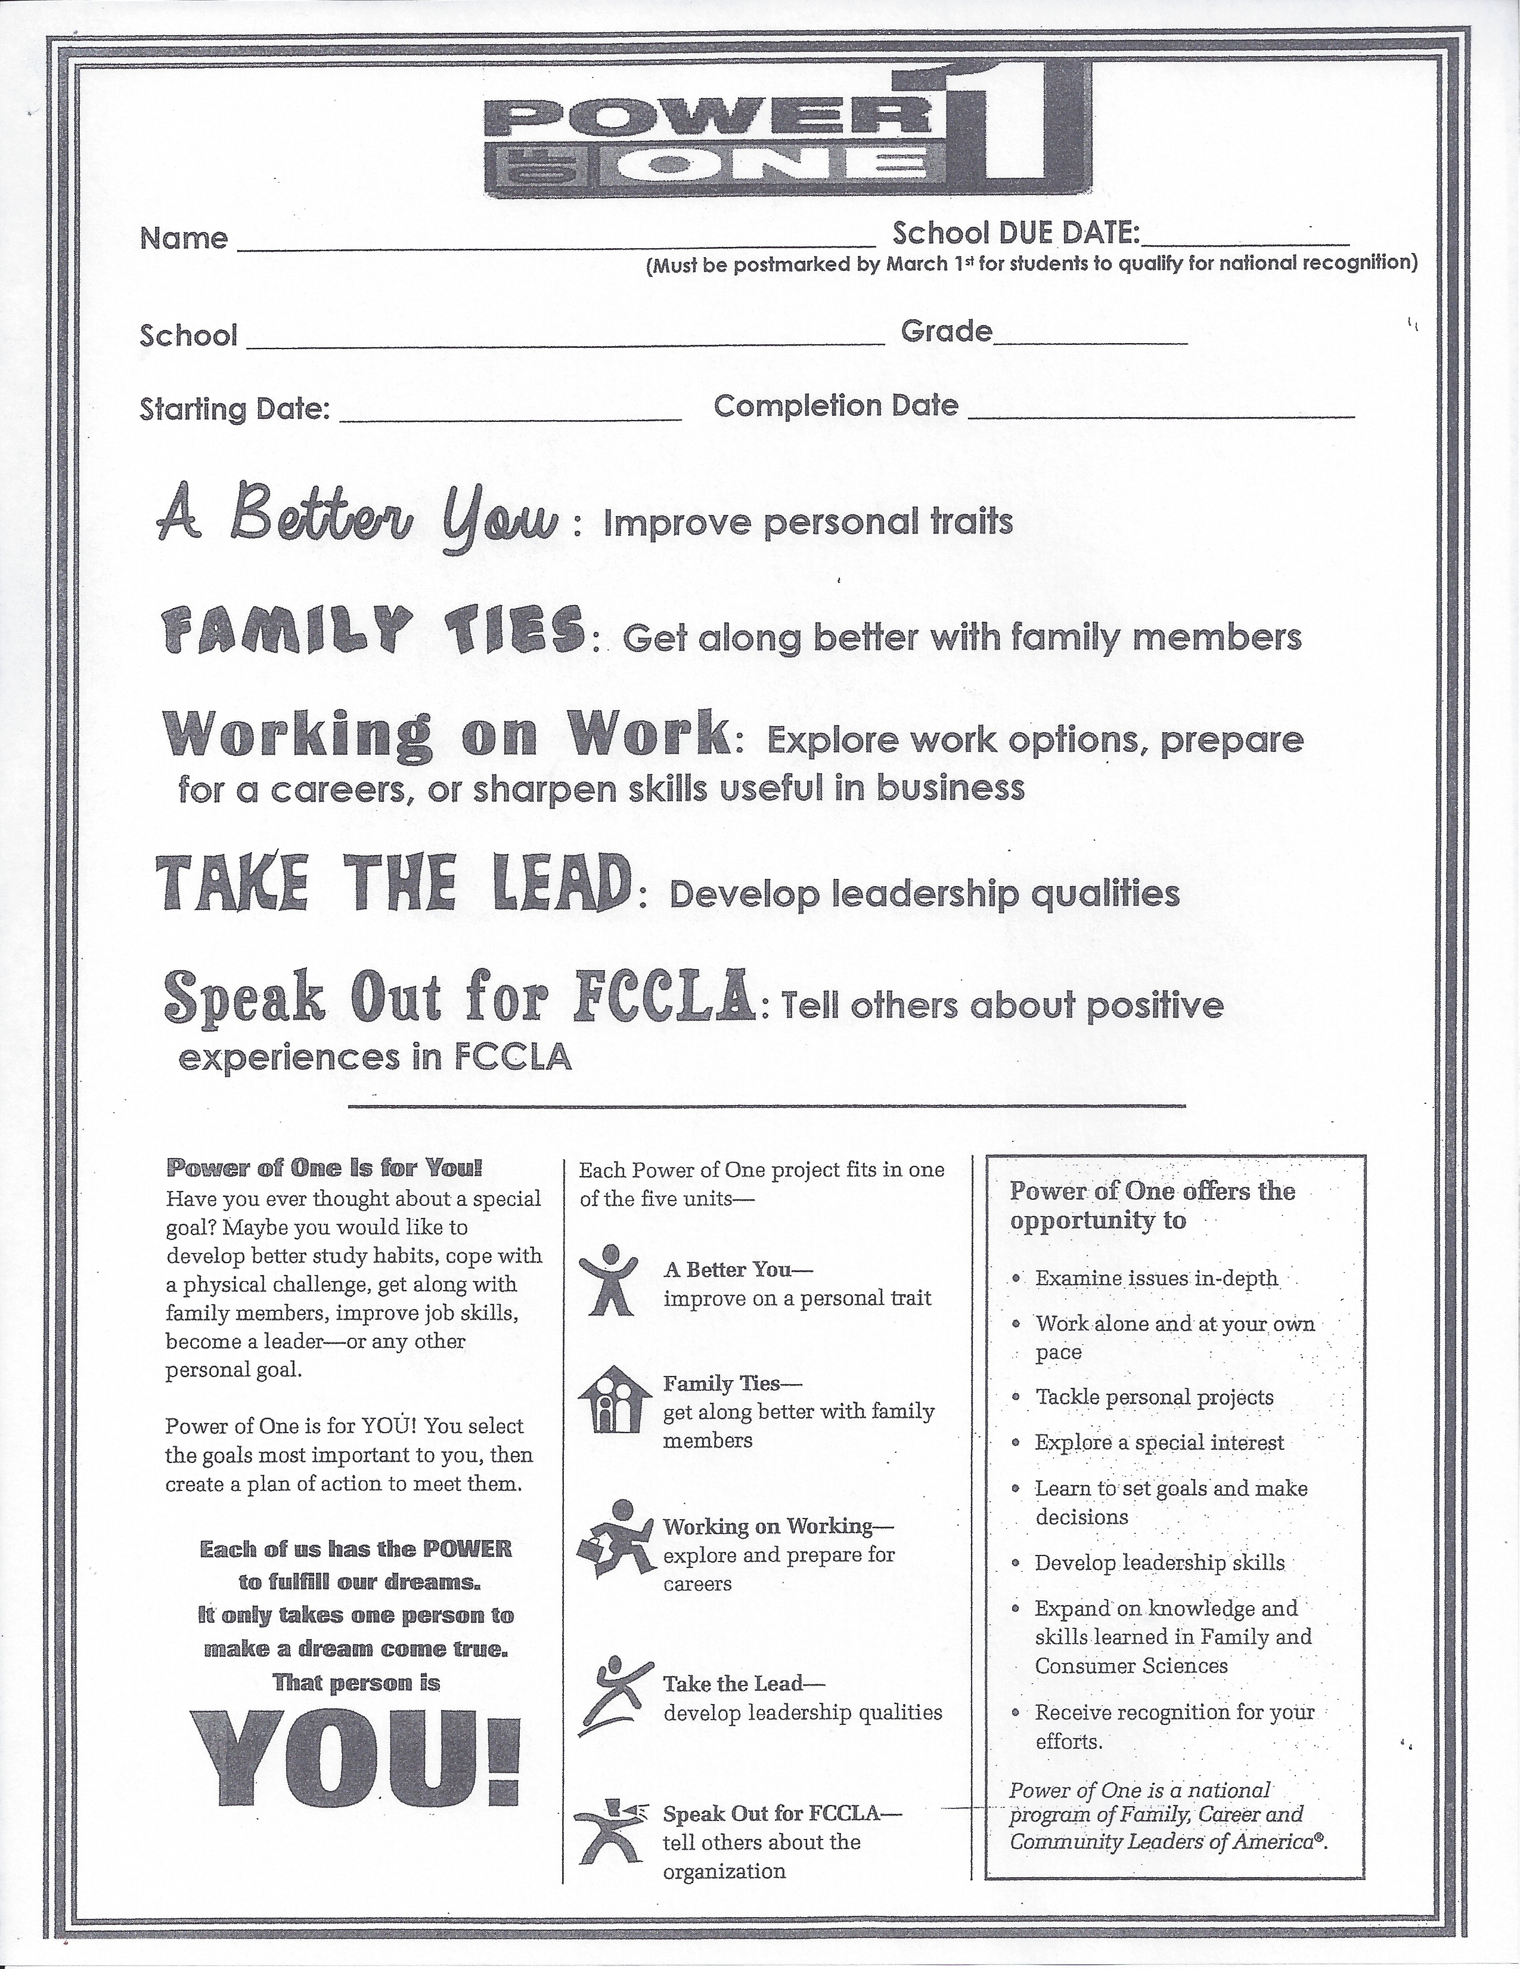
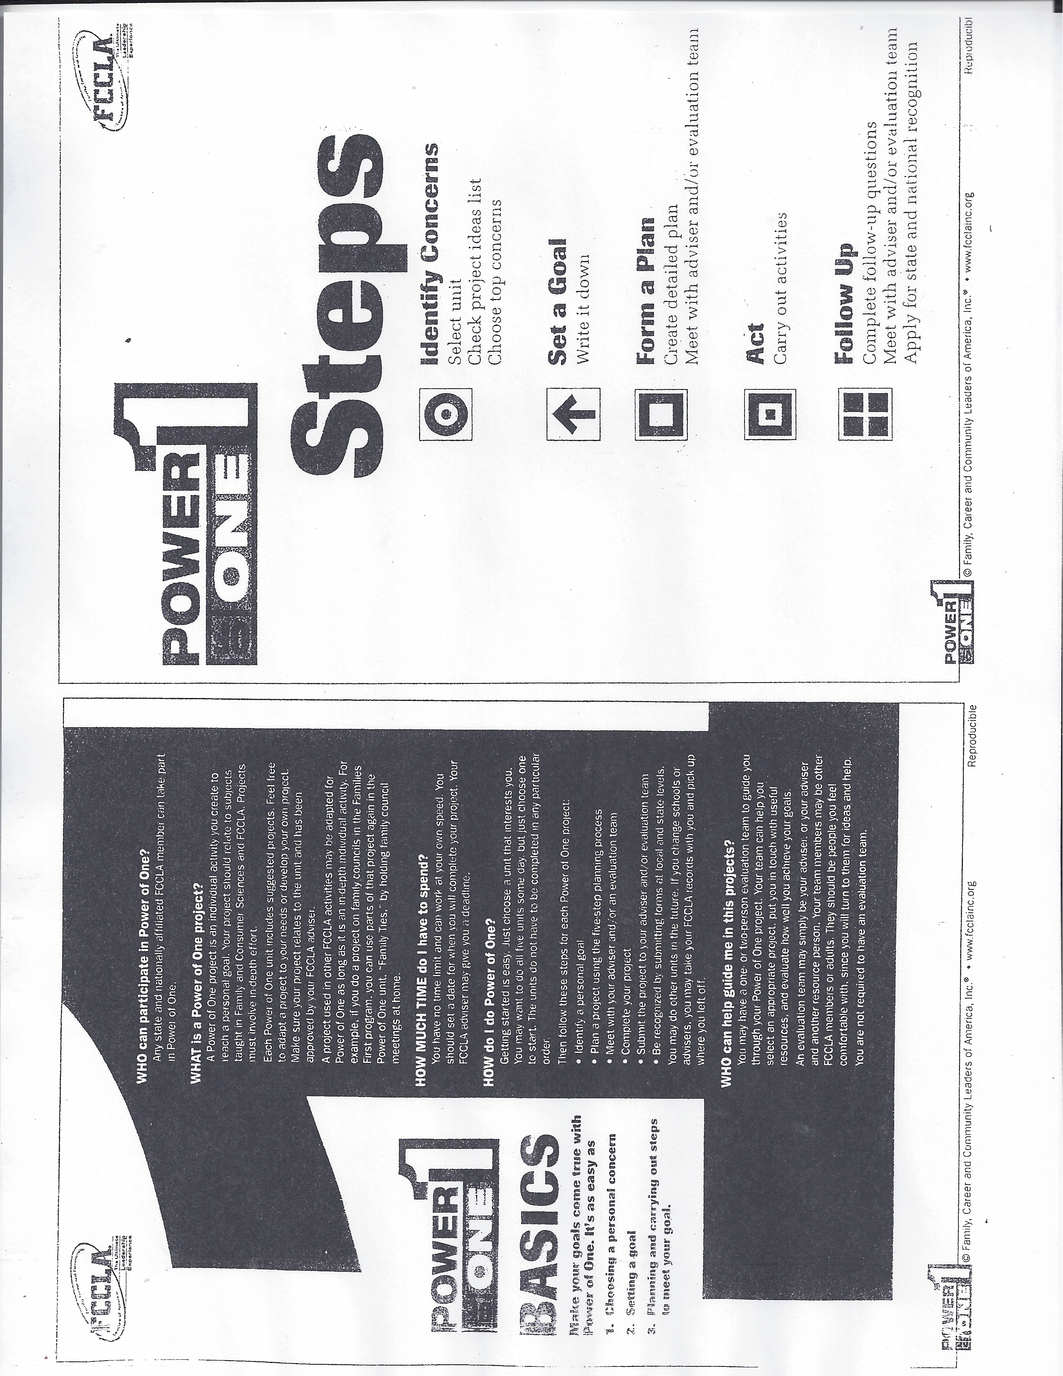
A Better You Improve personal traits

A BETTER YOU Project Idea List
- Achieve better grades- Hand in complete homework on time – study for classes at home
- Clean and organize bedroom or other room in house
- Keep a daily food diary for 2 weeks and evaluate how to improve
- Lose weight by following a balanced eating plan
- Follow an exercise program for a month
- Learn about stress and how to reduce the stress in your life – save money for college or activity or purchase
- Manage my $ money $ better – Set up a budget
- Set up a calendar/planner to help schedule personal time better
- Other

IDENTIFY A CONCERN
Ask yourself:
Which project idea deals with concerns that area most important to me?
Which could be an in-depth project?
Which can be finished in the time available

My top concern is:

SET A GOAL
Here’s what I hope to accomplish:

DATE Project/Goal will be completed_______________________________

MY GOAL IS: (Habit/activity/personal trait to be improved)

FORM A PLAN
Here’s my plan:

WHO:

WHAT:

WHEN:

WHERE:

HOW:

ADVISER GOAL APPROVAL (Make suggestions to make goal more meaningful and attainable)

Adviser Signature______________________________________________________

Date __________________________
ACT
Here’s what I accomplished:

FOLLOW UP
Here’s what I learned:

What were the most successful parts of your project?

What would you change if you repeated the project?

ADVISER GOAL FOLLOW-UP
Did the student: Circle one:
Achieve the original goal? Yes No
Complete all planned activities? Yes No
Devote in-depth effort to the project Yes No
Complete project alone Yes No

Fill out the above form completely Yes No

Answers to all questions must be “yes” for project to be approved for Power of One

Adviser Signature______________________________________________________

Date __________________________
Family Ties Get along better with family member
FAMILY TIES Project Idea List
- Organize and maintain my clothes and closet
- Schedule an hour a day to spend talking with family members
- Volunteer to take care of additional household responsibilities
- Prepare nutritious family meals 2 times a week
- Interview a parent, grandparent or other relative about their life
- Prepare a family tree or genetic journal
- Create a fun activity with family or siblings
- Practice conflict-resolution techniques in the family
- Say only + positive things about my family
- OTHER

IDENTIFY A CONCERN
Ask yourself:
Which project idea deals with concerns that area most important to me?
Which could be an in-depth project?
Which can be finished in the time available

My top concern is:

SET A GOAL
Here’s what I hope to accomplish:

DATE Project/Goal will be completed_______________________________

MY GOAL IS: (Habit/activity/personal trait to be improved)

FORM A PLAN
Here’s my plan:

WHO:

WHAT:

WHEN:

WHERE:

HOW:

ADVISER GOAL APPROVAL (Make suggestions to make goal more meaningful and attainable)

Adviser Signature_____________________________________________________

Date __________________________
ACT
Here’s what I accomplished:

FOLLOW UP
Here’s what I learned:

What were the most successful parts of your project?

What would you change if you repeated the project?

ADVISER GOAL FOLLOW-UP
Did the student: Circle one:
Achieve the original goal? Yes No
Complete all planned activities? Yes No
Devote in-depth effort to the project Yes No
Complete project alone Yes No

Fill out the above form completely Yes No

Answers to all questions must be “yes” for project to be approved for Power of One

Adviser Signature_____________________________________________________

Date __________________________

Working on Work
Explore work options, prepare for a career, or sharpen skills useful in business

WORKING ON WORK Project Idea List
- Obtain a part=time job
- Participate in the Job Interview STAR Event
- Create a portfolio of your accomplishments
- Set and work on goals to improve on the job skills (being on time, using time well/having a positive attitude, etc.)
- Shadow a worker in a career that interest you
- Research colleges and postsecondary school choices
- Create resume’
- Make list of local jobs available in community
- Volunteer at a job site that interests you
- Research a career that interests you
- Other

IDENTIFY A CONCERN
Ask yourself:
Which project idea deals with concerns that area most important to me?
Which could be an in-depth project?
Which can be finished in the time available

My top concern is:

SET A GOAL
Here’s what I hope to accomplish:

DATE Project/Goal will be completed_______________________________

MY GOAL IS: (Habit/activity/personal trait to be improved)

FORM A PLAN
Here’s my plan:

WHO:

WHAT:

WHEN:

WHERE:

HOW:

ADVISER GOAL APPROVAL (Make suggestions to make goal more meaningful and attainable)

Adviser Signature_____________________________________________________

Date __________________________
ACT
Here’s what I accomplished:

FOLLOW UP
Here’s what I learned:

What were the most successful parts of your project?

What would you change if you repeated the project?

ADVISER GOAL FOLLOW-UP
Did the student: Circle one:
Achieve the original goal? Yes No
Complete all planned activities? Yes No
Devote in-depth effort to the project Yes No
Complete project alone Yes No

Fill out the above form completely Yes No

Answers to all questions must be “yes” for project to be approved for Power of One

Adviser Signature_____________________________________________________

Date __________________________

Take the Lead Develop leadership qualities

TAKE THE LEAD Project Idea List
- Work with elderly people, someone who is ill, or at risk/special needs child
- Volunteer for several weeks t a local institution or agency
- Help children learn about safety, nutrition or self-esteem
- Explain FCLA to 4 friends and get them to join
- Actively promote abstinence from smoking, drinking, an drugs
- Campaign for no texting while driving
- Lead a chapter committee or project
- Organize a chapter membership activity
- Serve as a chapter officer and fulfill specific responsibilities
- Run for a state or national office
- Other

IDENTIFY A CONCERN
Ask yourself:
Which project idea deals with concerns that area most important to me?
Which could be an in-depth project?
Which can be finished in the time available

My top concern is:

SET A GOAL
Here’s what I hope to accomplish:

DATE Project/Goal will be completed_______________________________

MY GOAL IS: (Habit/activity/personal trait to be improved)

FORM A PLAN
Here’s my plan:

WHO:

WHAT:

WHEN:

WHERE:

HOW:

ADVISER GOAL APPROVAL (Make suggestions to make goal more meaningful and attainable)

Adviser Signature_____________________________________________________

Date __________________________
ACT
Here’s what I accomplished:

FOLLOW UP
Here’s what I learned:

What were the most successful parts of your project?

What would you change if you repeated the project?

ADVISER GOAL FOLLOW-UP
Did the student: Circle one:
Achieve the original goal? Yes No
Complete all planned activities? Yes No
Devote in-depth effort to the project Yes No
Complete project alone Yes No

Fill out the above form completely Yes No

Answers to all questions must be “yes” for project to be approved for Power of One

Adviser Signature____________________________________________________

Date __________________________

Speak Out for FCCLA
Tell others about positive experiences in FCCLA

SPEAK OUT FOR FCCLA Project Idea List
- Create a pamphlet, poster or power point about FCCLA
- Create a display case promoting your chapter FCCLA
- Organize National FCCLA Week activities
- Appear on a television or radio show and promote FCCLA
- Create an video clip to be shown at your school
- Write an article about your chapter FCCLA and submit it to school or local newspaper
- Write and submit an article with pictures to State FCCLA newsletter or Teen Times
- Write a letter to a state legislator about why FCCLA is important to schools, families, careers and communities
- Other

IDENTIFY A CONCERN
Ask yourself:
Which project idea deals with concerns that area most important to me?
Which could be an in-depth project?
Which can be finished in the time available

My top concern is:

SET A GOAL
Here’s what I hope to accomplish:

DATE Project/Goal will be completed_______________________________

MY GOAL IS: (Habit/activity/personal trait to be improved)

FORM A PLAN
Here’s my plan:

WHO:

WHAT:

WHEN:

WHERE:

HOW:

ADVISER GOAL APPROVAL (Make suggestions to make goal more meaningful and attainable)

Adviser Signature_____________________________________________________

Date __________________________
ACT
Here’s what I accomplished:

FOLLOW UP
Here’s what I learned:

What were the most successful parts of your project?

What would you change if you repeated the project?

ADVISER GOAL FOLLOW-UP
Did the student: Circle one:
Achieve the original goal? Yes No
Complete all planned activities? Yes No
Devote in-depth effort to the project Yes No
Complete project alone Yes No

Fill out the above form completely Yes No

Answers to all questions must be “yes” for project to be approved for Power of One

Adviser Signature_____________________________________________________

Date __________________________

Other 1st and 2nd pages.
I like the two I scanned better,
BUT they are not as clean a copy…

If you use the original two I made,
we need to add the planning process
to bottom of second page.

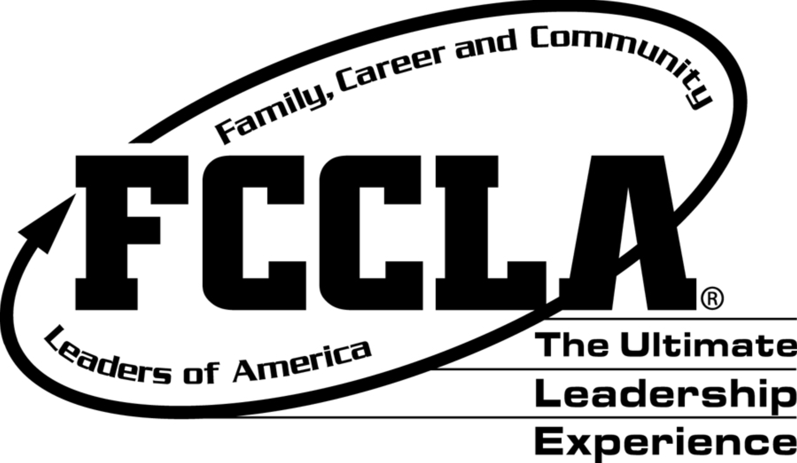
Name _____________________________________ School DUE DATE:______________
(Must be postmarked by March 1st for students to qualify for national recognition)

School ___________________________________________ Grade_____________

Starting Date: _______________________ Completion Date __________________________

A Better You : Improve personal traits

Family Ties: Get along better with family members

Working on Work: Explore work options, prepare for a careers, or sharpen skills useful in business

Take the Lead: Develop leadership qualities

Speak Out for FCCLA: Tell others about positive experiences in FCCLA

POWER of ONE helps YOU find and use your personal POWER!
YOU create a project just for YOU.
YOU set goals that are important to YOU
YOU create a plan of action to
achieve them.

Each of us has the POWER
to fulfill our dreams.
It only takes one person to make a wish come true.

That person is YOU!

WHO can participate in Power of One?
- Any state and nationally affiliated member can take part in Power of One.

What is a Power of One project?
- An individual activity you create to reach a personal goal
- Your goal should relate to subjects taught in Family and Consumer Science
classes and FCCLA activities
- Projects must involve in-depth effort.

How much time do I have to spend?
- You have to set a time limit with your adviser.
- Most goals take between 3 and 6 weeks to accomplish.

How do I do Power of One?
- Identify a personal goal
- Use the 5-Step Planning Process for each goal/area
- Meet with Adviser to go over your goals and have them approved.
- WORK on your GOALS
- Meet with your adviser when you have completed the goals
- Complete the 5-Unit Recognition Application for State and Nationals

