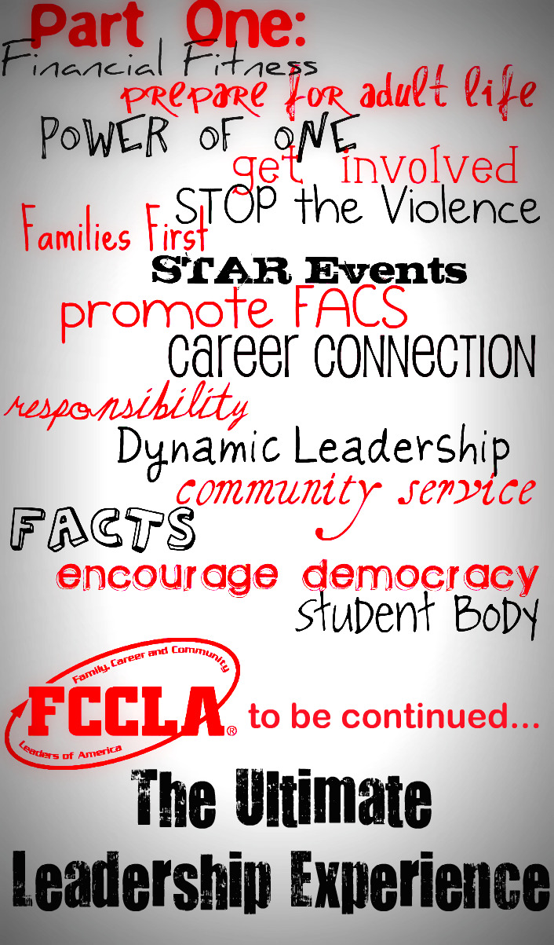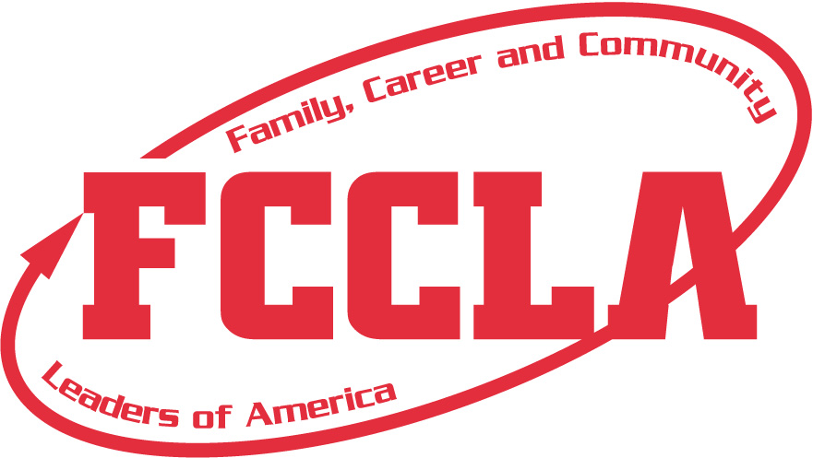

Come join the fun! learn, **compete** & meet people from your local area, district, and even nation.

### FCCLA

WEBSITE: <http://www.fcclainc.org/>

Or

Contact your local FCCLA advisor or national FCCLA

Contact Information

Family, Career and Community Leaders of America

FCCLA is a dynamic national student organization that helps young men and women become leaders and address important personal, family, work and societal issues through family and consumer sciences education.

community

leadership

america

family

F C C L A

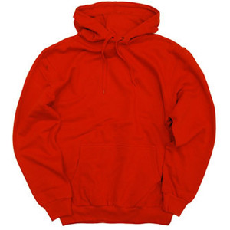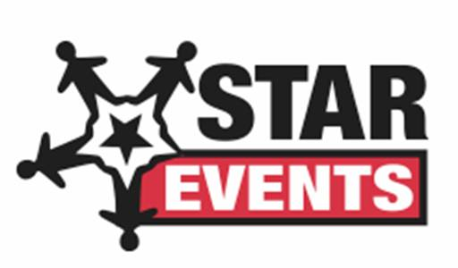

# Goals:

career

of

1. Provide opportunities for personal development & preparation for adult life
2. Strengthen the function of the family as a unit of society
3. Encourage democracy through cooperative action in the home and community
4. Encourage individual and group involvement in helping achieve global cooperation and harmony.
5. Promote great understanding between youth and adults
6. Provide opportunities for making decisions and for assuming responsibilities
7. Prepare for the multiple roles of men and women in today’s society
8. Promote family and consumer sciences and related occupations.

Opportunities:

Run for and **hold responsibilities** on a local, regional, state, and national level.

**Compete in**

on a district, state and national level.

**Learn** about **character development, creative and critical thinking, interpersonal communications, practical knowledge**, and **career preparation**.

Build **relationships**

**Explore** careers