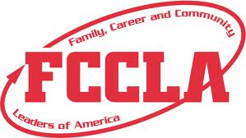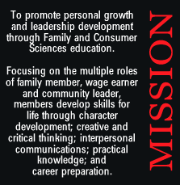

Family, Community and Career Leaders of America

**The goals of FCCLA include:**  
- Providing opportunities for personal development  
  
- Provide opportunities for making decisions and for assuming responsibilities.  
  
- Promote Family and Consumer Sciences and related occupations

**Opportunities Provided Through FCCLA**

* Leadership
* Competition
* Scholarship
* Experience
* Service

To find out more:  
Fcclainc.org OR talk to your school’s advisor!

**Why should I join??**

* Gain Leadership Skills
* Work one-on-one with advisors and teachers
* Compete in a variety in events
* Make a difference through service
* Be a part of something!