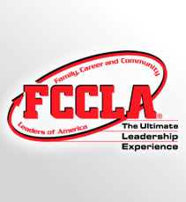

**By: Sarah Fletcher**

Contact Information

FCCLA National Headquarters

1910 Association Dr.

Reston, VA  20191

(703) 476-4900

(800) 234-4425

Fax:  (703) 860-2713

[www.fcclainc.org](http://www.fcclainc.org/)



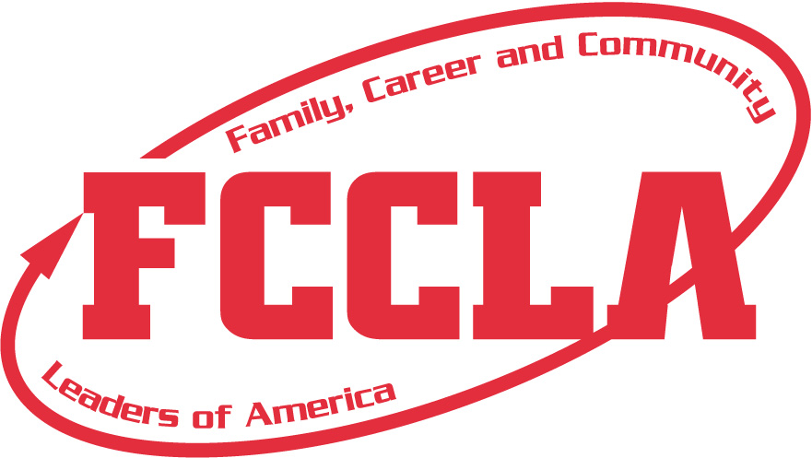

FCCLA is a nonprofit national career and technology student organization for young men and women in family and consumer sciences education in public and private schools.

1. To provide opportunities for personal development and preparation for adult life.

2. To strengthen the function of the family as a unit of society

3. To encourage democracy through cooperative action in the home and community.

4. To encourage individual and group involvement in helping achieve global cooperation and harmony.

5. To promote greater understanding between youth and adults.

6. To provide opportunities for making decision and for assuming responsibilities.

7. To prepare for the multiple roles of men and women in today’s society.

8. To promote family and consumer sciences and related occupations.

### PURPOSE OF FCCLA

### MISSION

Eat right, be fit, and make healthy choices.

Empower youth with attitudes, skills, and resources to recognize, report, and reduce youth violence.

Give yourself the power to make a positive change in your families, careers, and communities, one goal at a time.

Manage your money! Use this program to help you make, save, and spend your money wisely to be financially fit.

Experience another culture and develop independence while living with a Japanese host family.

Discover how you can strengthen family relationships through FCCLA’s national peer education program, Families First.

Put the brakes on impaired driving and traffic crashes. Through peer education help your friends arrive alive and lower the number one cause of death for youth in America.

Ignite the fire of Dynamic Leadership! Try new leadership experiences and investigate exciting topics through interactive participation in various programs.

Take action in your community and discover the difference you can make.

Put yourself in charge of your future! Enhance your job skills and gain valuable on-site work experience.

Learn how to explore career pathways and skills for success in families, careers, and communities.

#### **PROGRAMS**







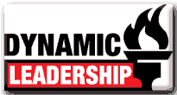

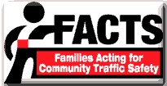

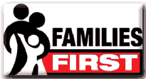







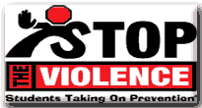

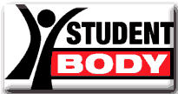

To promote personal growth and leadership development through family and consumer sciences education. Focusing on the multiple roles of family member, wage earner and community leader, members develop skills for life through –

* Character development
* Creative and critical thinking
* Interpersonal communication
* Practical knowledge
* Vocational preparation

You can use secondary headings to organize your text and to make it more scannable for theThis is a good place to briefly, but effectively, summarize the products or services that you offer. Sales copy is typically not included here.