

[](http://www.google.com/url?sa=i&rct=j&q=fccla&source=images&cd=&cad=rja&docid=OBo7Z7MzQ_7ysM&tbnid=-KZoCOsBCr5wEM:&ved=0CAUQjRw&url=http://www.texicoschools.com/www/texico/site/hosting/FCCLA/About.htm&ei=iJ4RUeTSHuSKjALurIHABg&bvm=bv.41934586,d.cGE&psig=AFQjCNGrs7Qv7-KBF0UeBmae60T-fFsgXA&ust=1360194003871124)

Delete text and place photo here.

our goals

**To provide** opportunities for personal development and preparation for adult life

**To strengthen** the function of the family as a unit of society

**To encourage** democracy through cooperative action in the home and community

**To promote** better understanding between youth and adults

**To prepare** for the multiple roles of men and women in today’s society

JOIN FCCLA!

“to promote personal growth and leadership development…”

Natalie Haymore

Riverton High School

12476 S. Silverwolf Way,

Riverton, UT 84065

Phone: 801-256-5800

Fax: 801-256-5880

www.fcclainc.org

[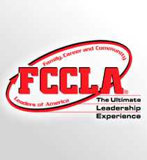](http://www.google.com/url?sa=i&rct=j&q=fccla&source=images&cd=&cad=rja&docid=Asyy-4RI2CntVM&tbnid=8SDfKu-laLyoEM:&ved=0CAUQjRw&url=http://www.fcclainc.org/&ei=NqQRUfKWBKXrigL5g4HgDw&bvm=bv.41934586,d.cGE&psig=AFQjCNHBT5azAXDbcP4Lw7xIAW_7_6qpHw&ust=1360195677366816)

Enter Contact Information Here | 1127 Lombard Blvd. San Francisco, CA 59802 | phone 555.555.5555 | fax 555.555.5555



[](http://www.google.com/url?sa=i&rct=j&q=fccla&source=images&cd=&cad=rja&docid=iUVDtdTpUT1OJM&tbnid=XhKUj0uBf6D_vM:&ved=0CAUQjRw&url=http://www.qisd.net/vnews/display.v/SEC/High%20School%7CQuanah%20FCCLA&ei=KXAUUYL5I6OgiQLao4HQBA&bvm=bv.42080656,d.cGE&psig=AFQjCNEA2cQdprU370hwJW7RrDP444adjg&ust=1360380313364564)

Why join fccla??

* Improve self-esteem
* Strengthen home and family life
* Develop career skills
* Learn to balance career and family responsibilities
* Prepare for community living as a responsible citizen

FCCLA provides many opportunities to get involved in several programs:

- Career connection

- Community service

- Families first

- Japanese Exchange

- Student Body

- And more!

There are also competitive events available to FCCLA members. STAR events are competitions where students can participate in cooperative, individualized, and competitive activities.

**JOIN FCCLA TODAY!!!**

opportunities

**F**AMILY

**C**AREER AND

**C**OMMUNITY

**L**EADERS OF

**A**MERICA

It is a dynamic and effective national student organization that helps young men and women become leaders and address important personal, family, work, and societal issues through family and consumer sciences education. Chapter projects focus on a variety of youth concerns, including teen pregnancy, parenting, family relationships, substance abuse, peer pressure, environment, nutrition and fitness, teen violence, and career exploration. Involvement in FCCLA offers member the opportunity to expand their leadership potential and develop skills for life – planning, goal setting, problem solving, decision-making, and interpersonal communication – necessary in the home and workplace.

FCCLA is a nonprofit national career and technology student organization for young men and women in family and consumer sciences education in public and private schools.

[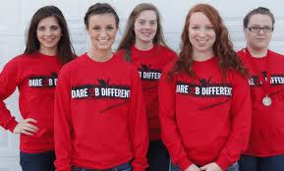](http://www.google.com/url?sa=i&rct=j&q=fccla&source=images&cd=&cad=rja&docid=x9xyVctXdAwL0M&tbnid=5ztfDlDloAZJ1M:&ved=0CAUQjRw&url=http://www.adrianjournal.com/school/attends-fccla-leadership-conference&ei=eKIRUcTDFefdigL1-YGACA&bvm=bv.41934586,d.cGE&psig=AFQjCNHBT5azAXDbcP4Lw7xIAW_7_6qpHw&ust=1360195677366816)

[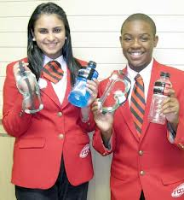](http://www.google.com/url?sa=i&rct=j&q=fccla&source=images&cd=&cad=rja&docid=1qcl96ueEnJLvM&tbnid=2fv3DhqldDVBZM:&ved=0CAUQjRw&url=http://warnerrobinspatriot.com/bookmark/20629915-HCHS-FCCLA-participates-in-leadership-conference&ei=CqMRUZamIoXAigK5gYGACw&bvm=bv.41934586,d.cGE&psig=AFQjCNHBT5azAXDbcP4Lw7xIAW_7_6qpHw&ust=1360195677366816)

[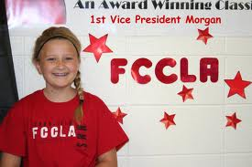](http://www.google.com/url?sa=i&rct=j&q=fccla&source=images&cd=&cad=rja&docid=PeqDIHYECEbBiM&tbnid=xHwFCm5YzT9jEM:&ved=0CAUQjRw&url=http://170.211.34.161/fccla/&ei=zaARUYGiAebziwKY7YCwAw&bvm=bv.41934586,d.cGE&psig=AFQjCNHBT5azAXDbcP4Lw7xIAW_7_6qpHw&ust=1360195677366816)

.

FCCLA

is for you

www.fcclainc.org

What is fccla?

[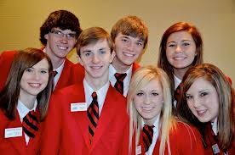](http://www.google.com/url?sa=i&rct=j&q=fccla&source=images&cd=&cad=rja&docid=OzlIsA49nC7gmM&tbnid=E3hmYR_vHaV2UM:&ved=0CAUQjRw&url=http://www2.edutech.nodak.edu/fccla/&ei=ZqMRUbXRLqmCiwKitoGAAw&bvm=bv.41934586,d.cGE&psig=AFQjCNHBT5azAXDbcP4Lw7xIAW_7_6qpHw&ust=1360195677366816)

.