## **Family, Career and Community Leaders of America offers a variety of national programs to guide and motivate students as they develop projects related to the Family and consumer sciences national standards.**

**Career connection**

**Community service**

**Dynamic leadership**

**FACTS**

**Families first**

**Financial fitness**

**Japanese exchange**

**Leaders at work**

**Power of one**

**Star events**

**Stop the violence**

**Student body**

Promote personal growth and leadership development through family and consumer sciences education. Focusing on the multiple roles of family member, wage earner and community leader, members develop skills for life through:

**What is FCCLA?**

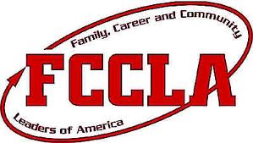**A nonprofit national career and technology student organization for young men and women in family and consumer sciences education in public and private schools.**

We are the Family, Career and Community Leaders of America.

We face the future with warm courage and high hope.

For we have the clear consciousness of seeking old n precious values.

For we are the builders of homes, Homes for America’s future,

Homes where living will be the expression of everything that is good and fair, Homes where truth and love and security and faith will be realities, not dreams

**Opportunities**

* **character development**
* **creative and critical thinking**
* **interpersonal communication**
* **practical knowledge**
* **vocational preparation**

### **Why Join?**



FCCLA helps students develop career skills and learn to balance career and family responsibilities. It is an opportunity to experience the connection between career and technical and academic skills while improving self-esteem as you develop friendships with other FCCLA members. 

**For more information visit:**

http://www.fcclainc.org

# **Purpose of FCCLA**