

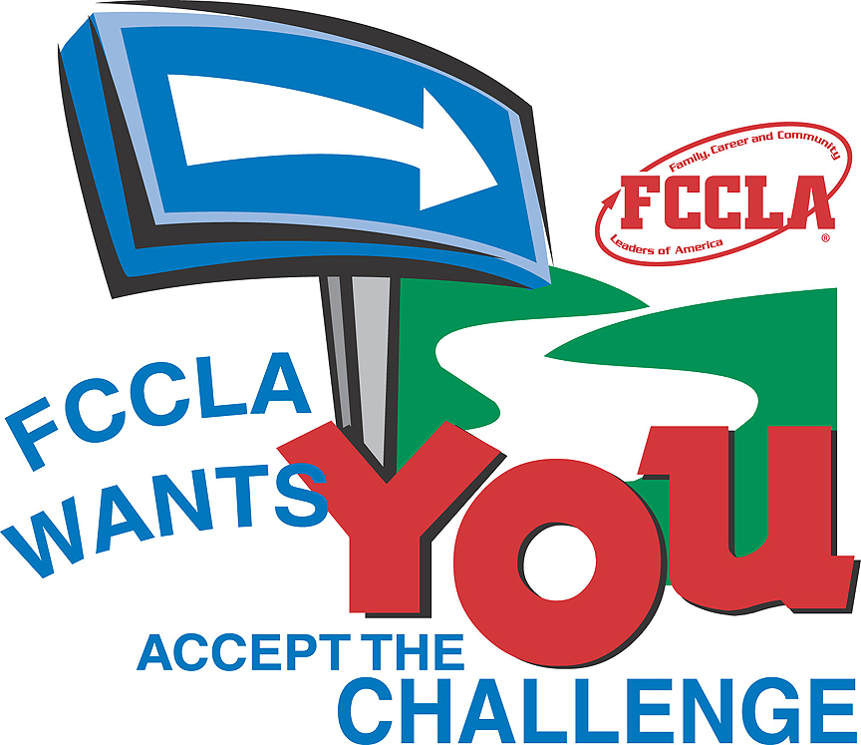

It is a national organization that will help YOU become a LEADER. We will address important personal, family, work, and societal issues. We will help you establish life skills including planning, goal setting, and problem solving, decision-making, and interpersonal communication.

Family

Career

and  
Community

Leaders

of

America

LEADERS OF AMERICA

FCCLA is a NATIONAL student organization that will help YOU become a LEADER, address personal, family, work, and social issues some of those include teen pregnancy,

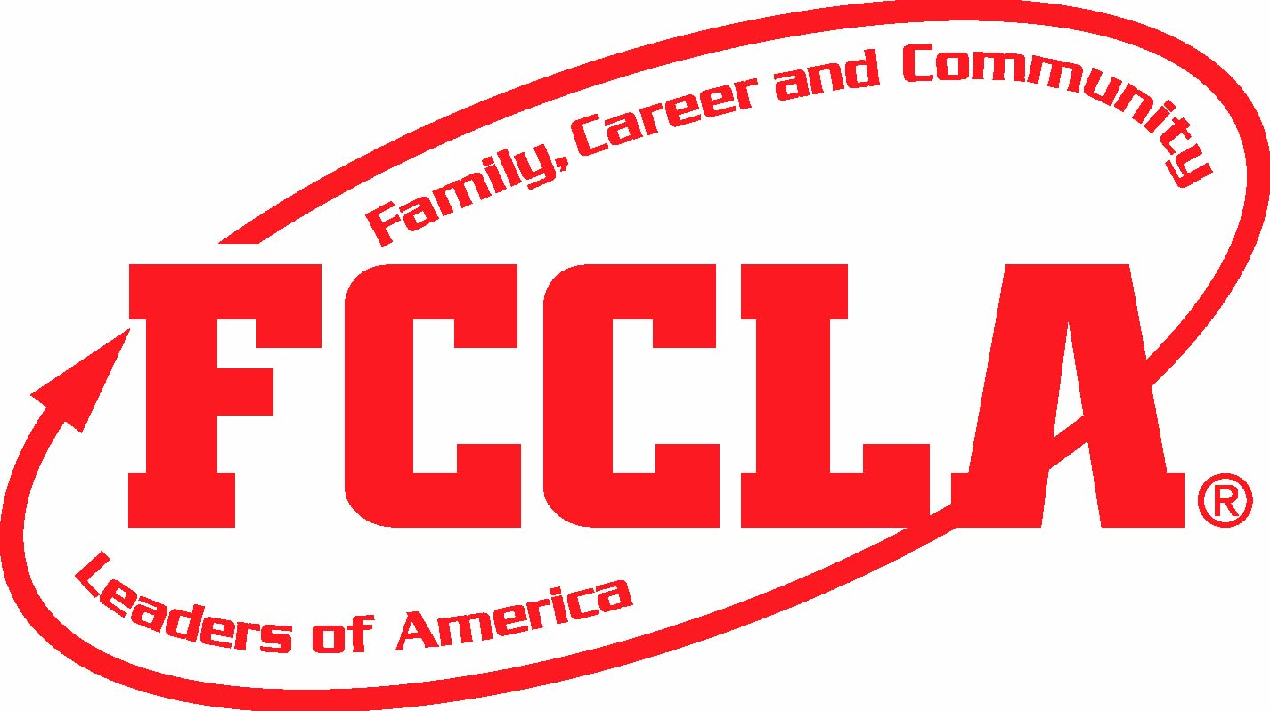

Contact info;

Madi Dunn

4355126852

madidunn@live.com

www.fcclainc.org

FCCLA

THE ULTIMATE LEADERSHIP EXPERIANCE

“We are the Family, Career, and Community Leaders of America. We face the future with warm courage and high hope”

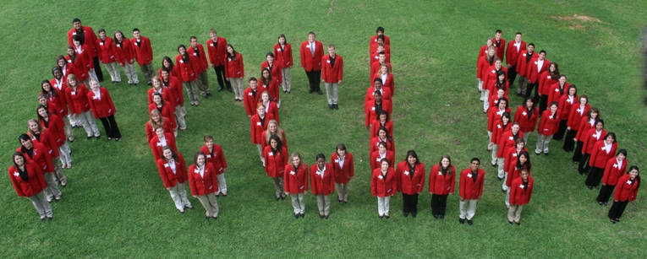

Why join??

1. Strengthen Home and Family Life
2. Develop Career Skills and learn to balance Career and Family responsibilities
3. Prepare for Community Living
4. Improve Self-Esteem
5. Understand yourself and relationship with others
6. Practice and Apply Creative Thinking
7. Experience between skills and learn to balance career and family responsibilities

FCCLA goals:

* Character Development
* Creative and Critical Thinking
* Interpersonal Communication
* Practical knowledge
* Vocational preparation

the OPPORTUNITES are endless:

* Advocacy
* Applied Technology
* Career Investigation
* Chapter Service Project
* Chapter Showcase
* Culinary Arts
* Early Childhood
* Entrepreneurship
* Environmental Ambassador
* Fashion Construction
* Fashion Design
* Focus on Children
* Food Innovations
* Hospitality, Tourism, and Recreation
* Illustrated talk
* Interior Design
* Interpersonal Communications
* Job Interview
* Leadership
* Life Event Planning
* National Programs in Action
* Nutrition and Wellness
* Parliamentary Procedure
* Promote and Publicize FCCLA
* Recycle and Redesign
* Teach and Train

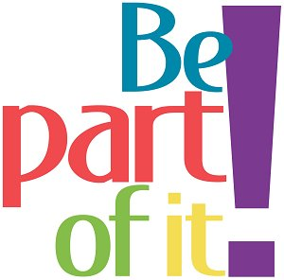

PLACE PHOTO HERE,

OTHERWISE DELETE BOX