

Check this out!

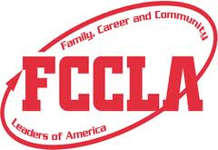

top things to know about fccla

1. FCCLA is the only career and technical student-led organization with the family as its central focus.

2. FCCLA is the career and technical student organization that functions as an integral part of the family and consumer sciences education curriculum and operates within the school system.

3. FCCLA is the **ultimate** leadership experience, focusing on character development, creative and critical thinking, interpersonal communications, practical knowledge, and career preparation.

.

Want to have fun?

Want to have the ultimate leadership expierence?

THEN LEARN MORE ABOUT FCCLA

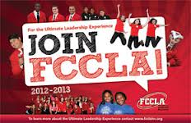

Enter Contact Information Here | 1127 Lombard Blvd. San Francisco, CA 59802 | phone 555.555.5555 | fax 555.555.5555

It’s an opportunity that could change your life.

Are you interested in...

* Career pathways and skills for success
* Community service
* Strengthening families
* Managing your money
* Power of one
* Stopping the violence
* Student body

If so come learn more about the National programs FCCLA offers.

Would you like more information?

contact your fccla

state or national advisor

at http://www.fcclainc.org/



the goals of fccla

FCCLA will help to provide opportunities for personal development and preparation for adult life, strengthen the function of the family as a unit of society, encourage democracy through cooperative action in the home and community, encourage individuals and group involvement in helping achieve global cooperation and harmony, and promote greater understanding between youth and adults

Opportunities offered through fccla

The mission statement of FCCLA is to promote personal growth and leadership development through family and consumer sciences education. Focusing on the multiple roles of family member, wage earner and community leader, members develop skills for life through: character development, creative and critical thinking, interpersonal communication, practice knowledge, vocational preparation.

Why students want you to join

FCCLA is a nonprofit national career and technology student organization for young men and women in family and consumer sciences education in public and private schools. It is a dynamic and effective national student organization that helps young men and women become leaders and address important personal, family, work and societal issues through family and consumer sciences education.

FCCLA helps students: develop career skills and learn to balance career and family responsibilities, strengthening home and family life, prepare for community living as responsible citizens, experience the connection between career and technical and academic skills, improve self-esteem, practice and apply creative an critical thinking, and understand themselves and their relationships with others.

What is FCCLA?

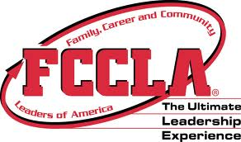

Opportunities

Goals of FCCLA

Definition of FCCLA

HEADER

SUBHEAD HERE

www.website.com

Why join?