FCCLA

**STAR Events**

These are competitive events in which members are recognized for proficiency and achievement in chapter and individual projects, leadership skills, and career preparation.

**The Events include:**

Advocacy, Applied Technology, Career Investigation, Chapter Service Project, Chapter Showcase, Culinary Arts, Early Childhood, Entrepreneurship, Environmental Ambassador, Fashion Construction, Fashion Design, Focus on Children, Food Innovations, Hospitality, Tourism, and Recreation, Illustrated Talk, Interior Design, Interpersonal Communications, Job Interview, Leadership, Life Event Planning, National Programs in Action, Nutrition and Wellness, Parliamentary Procedure, Promote and Publicize FCCLA, Recycle and Redesign, and Teach and Train.

FCCLA is a nonprofit national career and technology student organization for young men and women in family and consumer sciences education in public and private schools

FCCLA National Headquarters

1910 Association Dr.

Reston, VA 20191

Phone | (703) 476-4900

Fax | (703) 860-2713

www.fcclainc.org

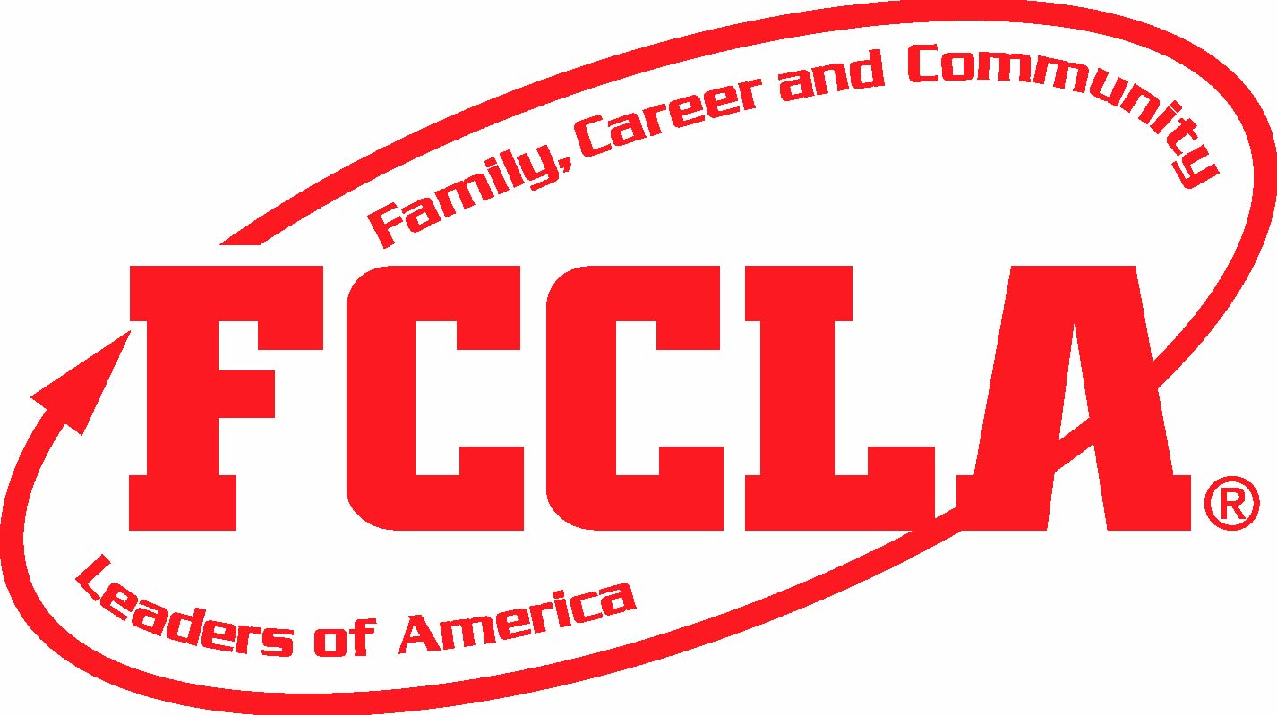



Enter Contact Information Here | 1127 Lombard Blvd. San Francisco, CA 59802 | phone 555.555.5555 | fax 555.555.5555

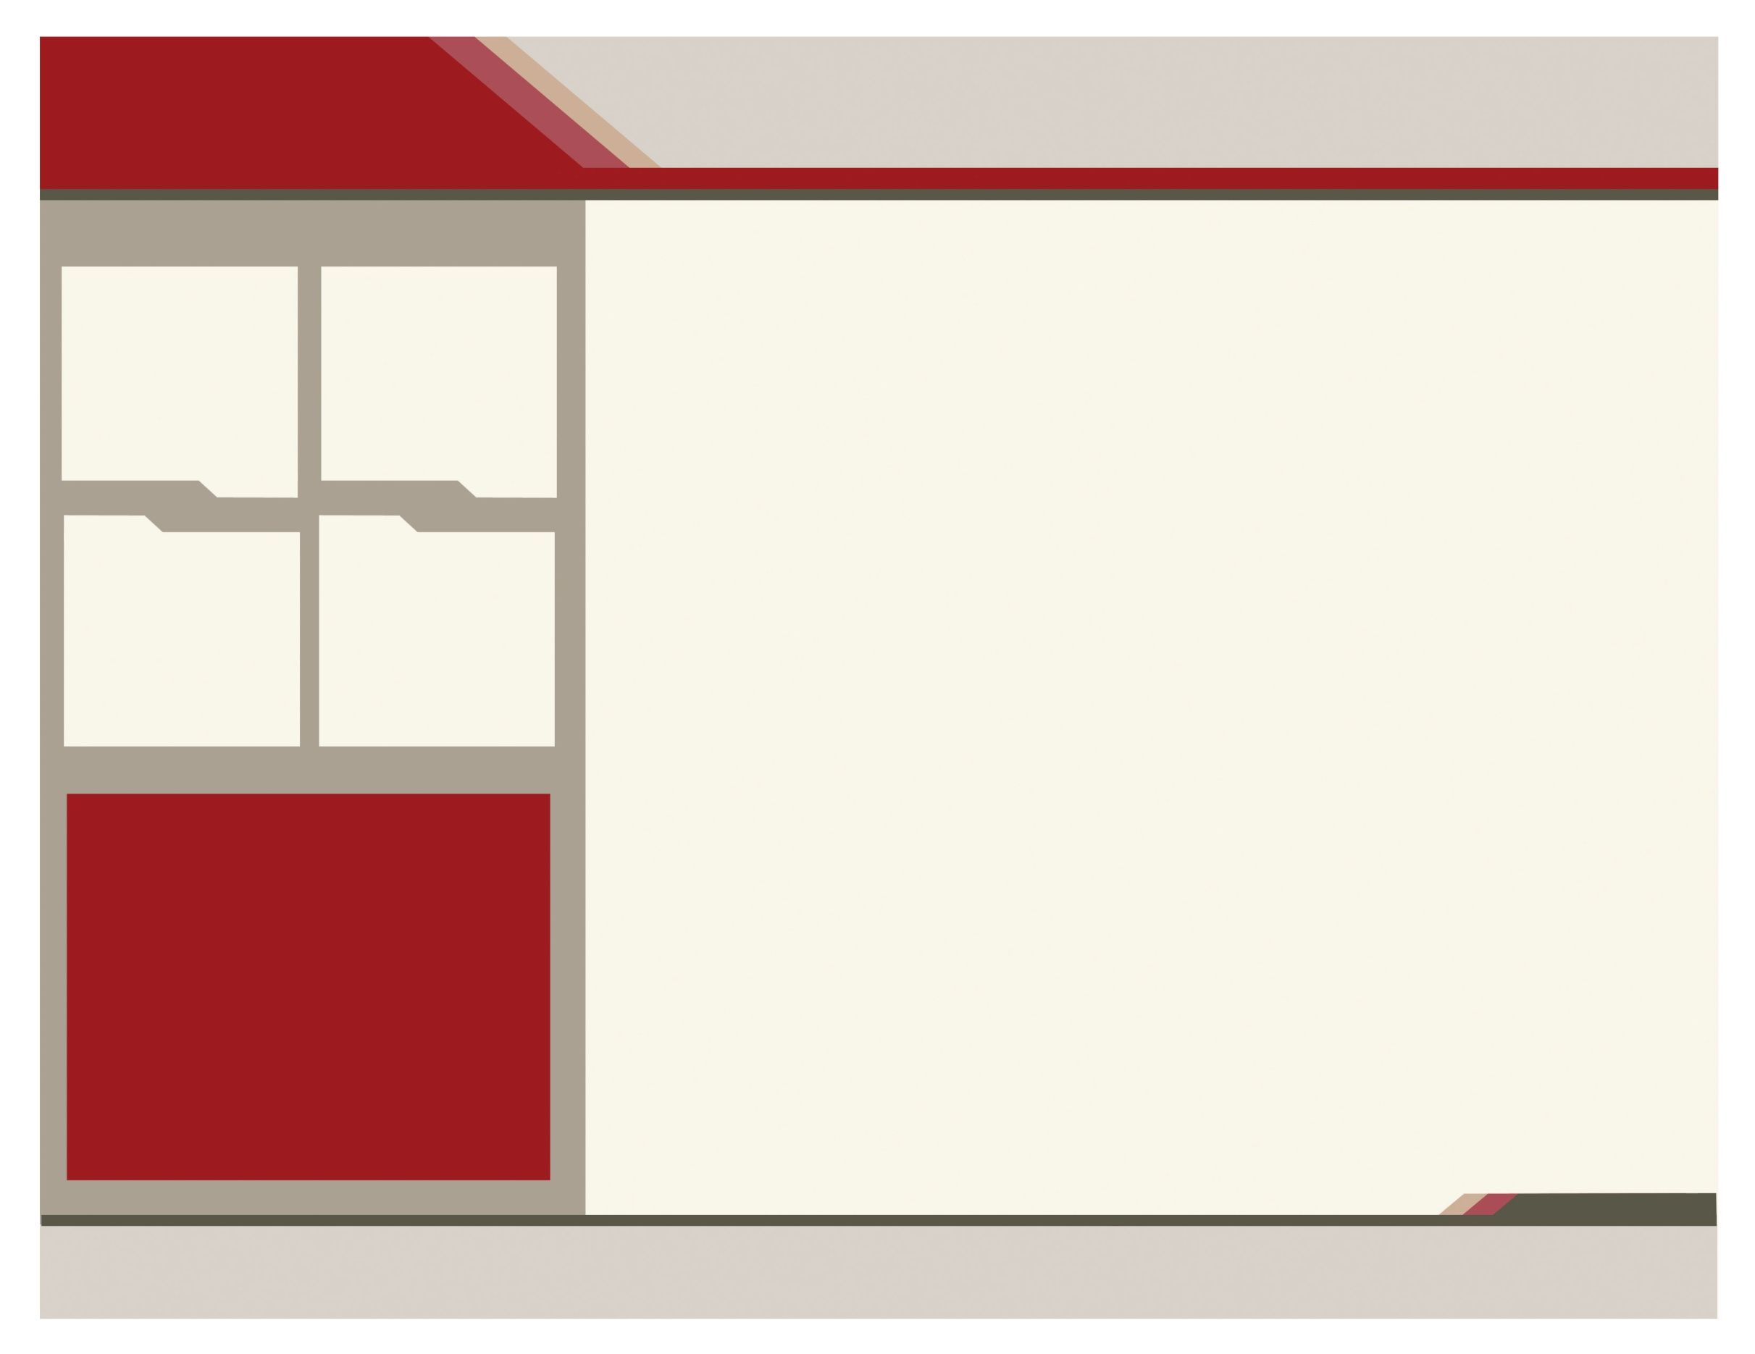

Goals of FCCLA

• to provide opportunities for personal development and preparation for adult life

• to strengthen the function of the family as a basic unit of society

• to encourage democracy through cooperative action in the home and community

• to promote greater understanding between youth and adults

• to provide opportunities for making decisions and for assuming responsibilities.

box or continue brochure text here. Brief   
words or customer testimony. Delete box   
or continue brochure text here.

Students have the opportunity to advance their leadership potential!

Nine national programs to address vital issues affecting our nation!

Family is our central Focus!

FCCLA is a dynamic and effective national student organization that helps young men and women become leaders and address important personal, family, work and societal issues through family and consumer sciences education. Chapter projects focus on a variety of youth concerns, including teen pregnancy, parenting, family relationships, substance abuse, peer pressure, environment, nutrition and fitness teen violence and career exploration. Involvement in FCCLA offers members the opportunity to expand their leadership potential and develop skills for life necessary in the home and workplace.

**Why Would You Want to Join FCCLA?**

FCCLA

Family, Career and community leaders of america

**Japanese Exchange**: Experience another culture and develop independence while living with a Japanese host family.

**Leaders at Work**: Put yourself in charge of your future! Enhance your job skills and gain valuable on-site work experience

And many more opportunities!

**Career Connection**: Learn how to explore career pathways and skills for success in families, careers, and communities.

**Community Service**: Take Action in your community and discover the difference you can make.

**Dynamic Leadership**: Ignite the fire of Dynamic Leadership! Try new leadership experiences and investigate exciting topics through interactive participation in various programs.

**Families Acting for Community Traffic Safety**: Put the brakes on impaired driving and traffic crashes. Through peer education help your friends arrive alive and lower the number one cause of death for youth in America.

**Families First**: Discover how you can strengthen family relationships through FCCLA’s national peer education program, Families First.

**Financial Fitness**: Manage your money! Use this program to help you make, save, and spend your money wisely to be financially fit.

www.fcclainc.org

**opportunities offered through FCCLA**

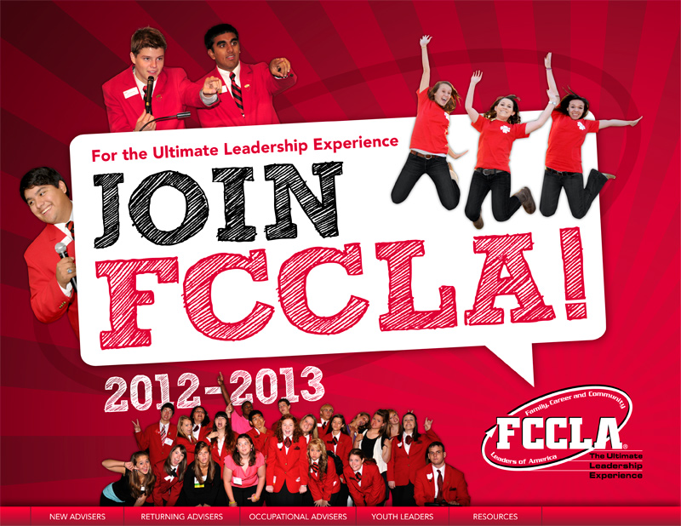

Has national membership of nearly 220,000 young men and women!