

A LEADERSHIP EXPERIENCE UNLIKE ANY OTHER.

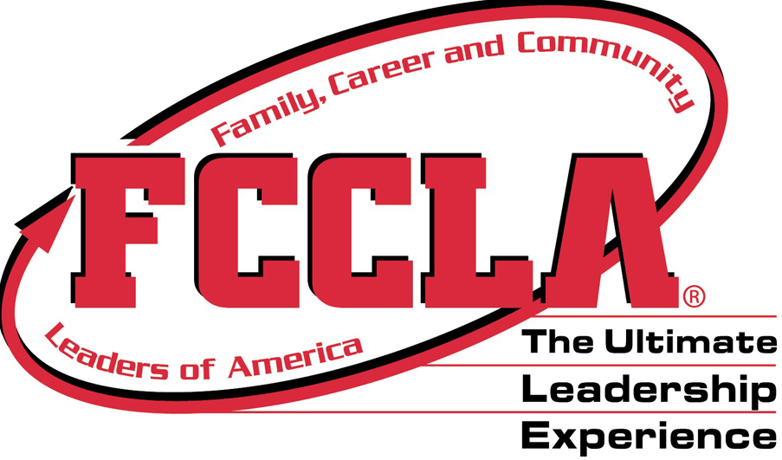

FCCLA National Headquarters

1910 Association Dr.

Reston, VA  20191

(703) 476-4900

(800) 234-4425

Fax:  (703) 860-2713

[www.fcclainc.org](http://www.fcclainc.org/)



Jessica Tolbert

FACS Instructor

What is FCCLA?

FCCLA is a nonprofit national career and technology student organization for young men and women in family and consumer sciences education in public and private schools.

It helps young men and women become leaders and address important personal, family, work and societal issues through family and consumer sciences education.

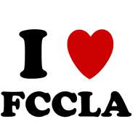

* FCCLA is the only career and technical student led organization with the family as its central focus.
* It functions as an integral part of Family and Consumer Sciences Education curriculum.
* Has a national membership of 220,000 young men and women with 7,000 local chapters.
* Supports charities… raised $220,000 for the Feed the Children organization and $650,000 for the American Cancer Society.
* STAR events are the competitive events where students can learn cooperative action and leadership skills through projects that they present at district, state, and national level.

Did You Know?

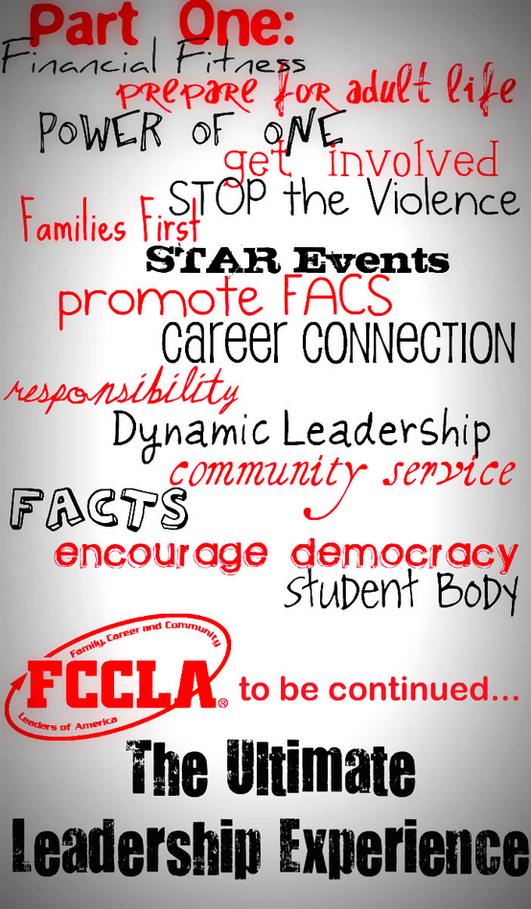

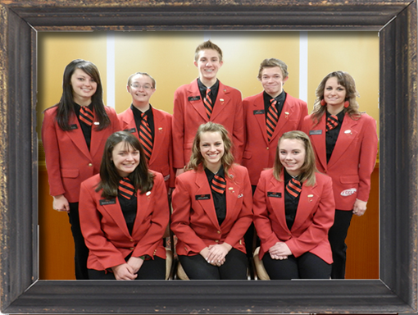

ORWISE DELETE BOX

How can FCCLA help You?

* Develop career skills
* Learn to balance career and family responsibilities
* Strengthen home and family life
* Prepare for community living as responsible citizens
* Experience the connection between career, technical and academic skills
* Improve self-esteem
* Practice and apply creative and critical thinking

What is the mission of FCCLA?

To promote personal growth and leadership development through family and consumer sciences education. Focusing on the multiple roles of the family member, wage earner and community leader, members develop skills for life through—

* Character Development
* Creative and Critical Thinking
* Interpersonal communication
* Practical knowledge
* Vocational preparation

WHY?

“If I had not joined FCCLA, I would not be the confident, professional, unique, job-ready young lady I am today. I have gained so much experience through my FCCLA career that I feel more than prepared to have a successful life.”

Jessie Pratt

Current Vice-President of Finance