 

For More Information Visit:

FCCLA

Family, Career and Community Leaders of America

Deanna Wheeler

FCCLA Brochure

www.fcclainc.org

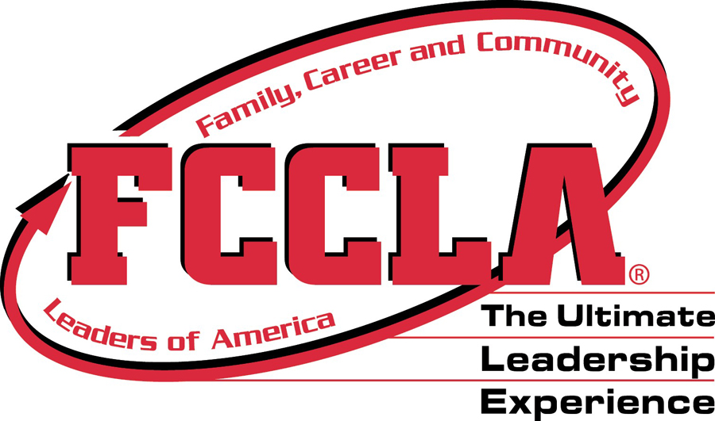E PHOTO HERE, OTHERWISE DELETE BOX

FCCLA gives opportunity for Learning, Service, Leadership, Scholarship, Competition, and Friendship.

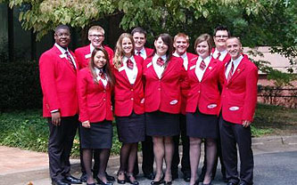

Why Join FCCLA?

* Star Events
* Power of One
* Career Connection
* Community Service
* Dynamic Leadership
* Families First
* Financial Fitness
* Leaders at Work
* Stop the Violence
* Student body

Service, Learning, and Leadership!

National programs like:

FCCLA is a nonprofit national career and technology student organization for young men and women in family and consumer sciences education in public and private schools.

**What is FCCLA?**

Goals of FCCLA:

* To provide opportunities for personal development and preparation for adult life
* The strengthen the function of the family as a unit of society
* To encourage democracy through cooperative action in the home and community
* To encourage individual and group involvement in helping achieve global cooperation and harmony
* To promote greater understanding between youth and adults
* To provide opportunities for making decisions and for assuming responsibilities
* To prepare for the multiple roles of men and women in today’s society
* To promote family and consumer sciences and related occupations

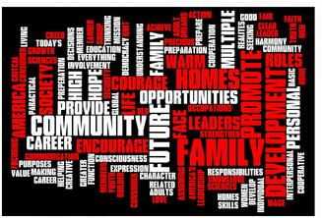

Opportunities offered through FCCLA