Name ______________________________ Period ___________

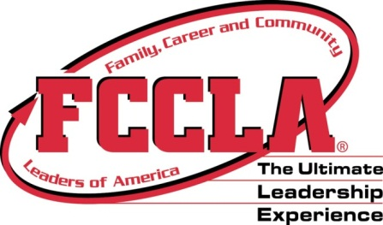
UTAH FCCLA WEB QUEST

STATE WEBSITE: www.utahfccla.org
NATIONAL WEBSITE: www.fcclainc.org

- Home Page, click on the “2012-2013 State Officers” link under the picture How many FCCLA State Officers are there in Utah?

- Who is the NATIONAL Vice President of National Programs, what school does she go to and what is her email address?

- What is the Utah FCCLA Theme for 2011-2012?

- What are two of the four goals the Utah FCCLA State Officers have set for the state.

- Under the “Adviser” section in the FCCLA Organizational Tree” Who is the Utah FCCLA State Adviser and what is ONE of her responsibilities?

- Under the “Adviser” section in the FCCLA Organizational Tree” Who is the Utah FCCLA State Officer Assistant and what is ONE of her responsibilities?

- Home page: FCCLA Executive Council & Advisory Board Who is the Utah FCCLA State Officer from Area 5, what school does she go to and who is her adviser?
- Home page, “STAR Events”, “STAR Events Manual”, Page 49
STAR Events (Students ________________ Action with _________________________) are competitive events in which members are recognized for ______________________ and _______________________ in chapter and individual _______________________, leadership _______________________, and _________________________ preparation.
Family, ______________________ and _________________________ Leaders of America’s (FCCLA) STAR Events offer individual skill development and application of learning through the following activities:
■ ____________________________—teams work to accomplish specific goals
■ ____________________________—an individual member works alone to accomplish specific goals
■ ____________________________—individual or team performance is measured by an established set of criteria.

- Home page How many gold winners did Utah have at the FCCLA National Leadership Conference in Orlando, Florida?

- Home page, “Year at-a-glance Calendar” When is National FCCLA Week?

- Home page, “Year at-a-glance Calendar” When AND where is the 2013 National Conference being held this year?

- National Website, “Membership”, “Join FCCLA” Who is eligible to be a member of FCCLA?

Bonus Question: What is the “tagline” for FCCLA?

