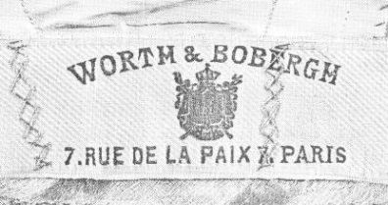
Who was the Father of Haute Couture?
Charles Frederick Worth
What did he do to become known as the “Originator of Fashion”
He created the Designer name as we know it. Established the pattern of regular seasoned fashion shows (1825-1895-Napolean III)
Who is Christian Dior? He reestablished Paris as a fashion capitol after WW2
Decade of Influence? 1940-1950s
What was happening in the world during this time? WW2 had just ended, no more restriction on fabrics, women wanted to look pretty again
What was the name of his Design? The New Look

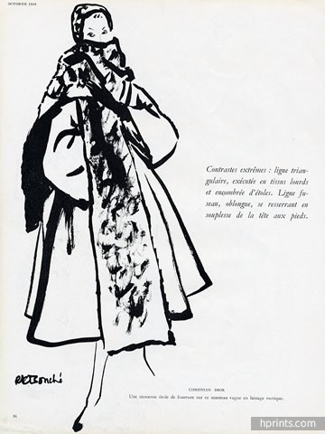

What influence did Coco Chanel have on Fashion? Little black dress, relaxed fashions
, short skirts, casual look, simple suits and dresses
When were her decades of Influence? 1920-1940
What was happening around the world during this time? Women’s right to vote,
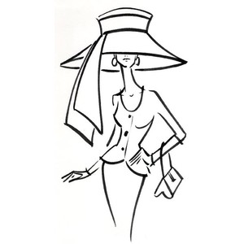
WW1 had ended, industrial revolution
