LEVEL 1
Label each kitchen tool
A.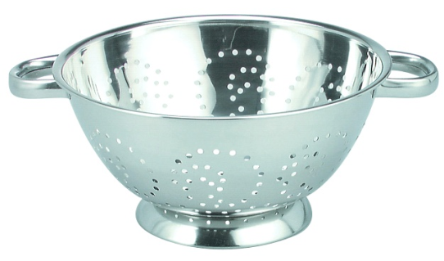 | B.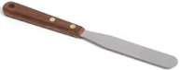 | C. | D.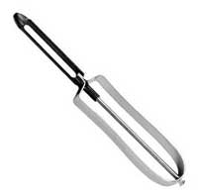
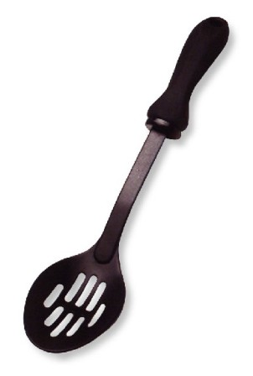  E. 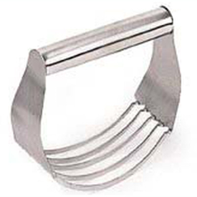 | F. | G. 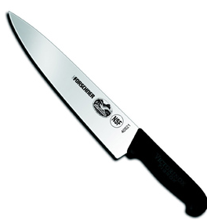 | H.
 | K. 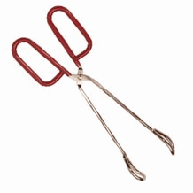 | L. | M. 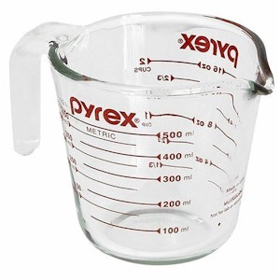
N. 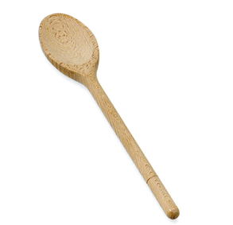 | O. | P. 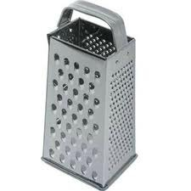 | 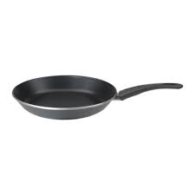  Q.
LEVEL 2
Q: What is the TERM: To work sugar and fat together until the mixture is soft and fluffy.  A: | Q: What is the TERM: To LIGHTLY sprinkle or coat with a powdered substance, often with crumbs or seasoning.  A: | Q: What is the TERM: To coat food HEAVILY with flour, breadcrumbs or cornmeal.  A: | Q: What is the TERM: To cut into very small CUBES.  A: | Q: What is the TERM: To cut or chop food as finely as possible.  A:
Q: What is the TERM: To mix ingredients by gently turning one part over another.  A: | Q: What is the TERM: To cut into small pieces.  A: | Q: What is the TERM: To finely divide food in various sizes by rubbing it on surface with sharp projections.  A: | Q: What is the TERM: To work dough to further mix the ingredients and develop the gluten.  A: | Q: What is the TERM: To cut fat into flour with a pastry blender or two knives.  A:
Q: What is the TERM: To remove or strip off the skin or rind of some fruits and vegetables.  A: | Q: What is the TERM: To cook by the vapor produced when water is heated to the boiling point.  A: | Q: What is the TERM: To beat rapidly to introduce air bubbles into food.  A: | Q: What is the TERM: To brown or cook foods with a small amount of fat using low to medium heat.  A: | Q: What is the TERM: To cook just below the boiling point.  A:
Q: What tool do we use for milk, oil and water?  A: | Q: What is the tool we use for soups, sauces and pasta?  A: | Q: What color cutting board do we use for raw meats?  A: | Q: What is the tool we use to remove the water from the pasta?  A: | Q: What is the tool we use to cut fat into flour?  A:
LEVEL 3
Q: T. / Tbsp. is the abbreviation for:  A: | Q: t. / tsp. is the abbreviation for:  A: | Q: gal. is the abbreviation for:  A: | Q: qt. is the abbreviation for:  A: | Q: pt. is the abbreviation for:  A:
Q: C. is the abbreviation for:  A: | Q: lb. / # is the abbreviation for:  A: | Q: oz. is the abbreviation for:  A: | Q: pkg. is the abbreviation for:  A: | Q: min. is the abbreviation for:  A:
Q: 1 Tbsp. = ______ tsp.  A: | Q: 1 c. = _______ Tbsp.  A: | Q: 1 gal. = ______ qt.  A: | Q: 1 stick of butter = ________ c.  A: | Q: 1/8 c. = ______ Tbsp.  A:
Q: 1 c. = ______ fl. oz.  A: | Q: 3/4 c. = ______ Tbsp.  A: | Q: 5 1/3 Tbsp. = ______ c.  A: | Q: 1 qt. = ________ c.  A: | Q: 1/3 c. = _______Tbsp.  A:

LEVEL 4
Q: What substance should you NEVER pour on a grease fire?  A: 1. | Q: What is the first treatment for a bleeding cut?  A: | Q: What should you use when trying to reach items on a high shelf?  A: | Q: What should you do FIRST if someone is being shocked by an electrical appliance?  A: | Q: What direction should all pan handles be facing on the stovetop?  A:
Q: What would a mixture of chlorine bleach and ammonia create?  A: | Q: What temperature should ground beef be cooked to?  A: | Q: What is the Temperature Danger Zone?  A: | Q: Finish the phrase: When in doubt, _____ ___ ______!  A: | Q: What three things do bacteria need to grow?  A: 1.  2.  3.
Q: The most common food source for E. coli is:  A: | Q: The most common food source for salmonella is:  A: | Q: The most common food source for staph is:  A: | Q: The most common food source for botulism is:  A: | Q: The most common food source for hepatitis A is:  A:
Q: What is the most common cause of norovirus?  A: | Q: What is the most likely cause of Clostridium perfringens?  A: | Q: What is the most common food source of campylobacter?  A: | Q: What temperature should all poultry and leftovers be cooked to?  A: | Q: What temperature should all solid cuts of meat and seafood be cooked to?  A:
LEVEL 5:
Q: What are the two safest ways to thaw frozen foods?  A: 1.  2. | Q: List 3 microwave safe materials.  A: 1.  2.  3. | Q: What material repels microwaves and should NEVER be placed in the microwave?  A: | Q: What THREE things are microwaves attracted to?  A: 1.  2.  3. | Q: Which type of container will cook more evenly: round or square?  A:
Q: Foods will not brown in the microwave because there is no _________.  A: | Q: Keep hot foods ____ and cold foods_____.  A: | Q: Why is Standing Time important?  A: | Q: Which would cook faster: a whole potato or thin potato slices?  A: | Q: Why are dull knives dangerous?  A:
Q: Who are the YOPI’s? (most vulnerable to food borne illness)  A: | Q: What is the FIRST thing you should wash when washing dishes?  A: | Q: 9 tsp. = _______ Tbsp.  A: | Q: 1/2 c. = ______ Tbsp.  A: | Q: One half of 2/3 c. = ______ c.  A:
Q: One half of 1/2 c. = _______ c.  A: | Q: 1 qt. = ______ pt.  A: | Q: 1/2 Tbsp. = _____ tsp.  A: | Q: 2 c. = ______ Tbsp.  A: | Q: What two cups do you use to measure 3/4 c.?  A:
Q: Give an example of cross contamination:  A: | Q: Why are we finding salmonella and E. coli on fruits and vegetables?  A: | Q: What first aid should you apply to a 1st degree burn?  A: | Q: What are some of the common symptoms of food-borne illness?  A: | Q: Food should not be in the danger zone for more than _______ hours:  A:

LEVEL 6
Q: Fats that are LIQUID at room temperature are called:  A: | Q: All fats and oils are grouped into the category called: _____________  A: | Q: How many calories per gram do lipids provide?  A: | Q: What are the FOUR Fat-Soluble Vitamins?  A: 1.  2.  3.  4. | Q: Which type of cholesterol is the GOOD lipoprotein: LDL or HDL?  A:
Q: What are the THREE types of fatty acids?  A: 1.  2.  3. | Q: Saturated fats are ______ in texture at room temperature.  A: | Q: Unsaturated fats are (usually) ________ in texture at room temperature.  A: | Q: List one food high in cholesterol:  A: | Q: What is the best type of fat for you?  A:
Q: What effect does Saturated fat have on HDL and LDL Levels?  A: __________HDL levels  __________LDL Levels | Q: What effect does Polyunsaturated fat have on HDL and LDL Levels?  A: __________HDL Levels  __________LDL Levels | Q: What effect does Monounsaturated fat have on HDL and LDL Levels?  A: __________HDL Levels  __________LDL Levels | Q: The chemical process that turns a liquid fat into a solid fat by adding extra hydrogen atoms is called:  A: | Q: What is the risk of high levels of LDL cholesterol in your bloodstream?  A:
Q: True or False: Fats do not add flavor to food.  A: | Q: True or False: Fat acts like a “cushion” to protect vital organs from shock.  A: | Q: True or False: Exercise is an excellent way to lower fat and cholesterol in the body.  A: | Q: True or False: Fat will help your body build strong bones.  A: | Q: True or False: One function of fat is to act as a reserve or emergency store of energy.  A:
LEVEL 7
Q: How many calories per gram do Carbohydrates provide?  A: | Q: What FOOD GROUP do we get most of our carbohydrates from?  A: | Q: What is the main function of carbohydrates?  A: | Q: What are the three types of Carbohydrates?  A: 1.  2.  3. | Q: What is a better energy choice: simple sugars or complex starches?  A:
Q: Another name for Glucose is:  A: | Q: Another name for Sucrose is:  A: | Q: How many grams of fiber should we get every day?  A: | Q: If a product claims that it is “Whole Wheat” that means it must use _______ parts of the wheat kernel.  A: | Q: What type of rice has the MOST fiber in it?  A:
Q: The ratio for cooking rice is:  _____ c. uncooked rice = _____ c. cooked rice.  A: | Q: The ratio for cooking pasta is:  _____ c. uncooked pasta = _____ c. cooked pasta.  A: | Q: Rice should be cooked with the lid _______.  A: | Q: Pasta should be cooked with the lid _______.  A: | Q: Fiber is located in what part of the grain kernel?  A:
Q: If a bread product is refined, what part of the kernel is left?  A: | Q: What parts of the fruits and vegetables contain insoluble fiber?  A: | Q: What part of the body does soluble fiber clean out?  A: | Q: What type of carbs give you quick energy?  A: | Q: In quick breads, what is an example of a leavening agent?  A:
LEVEL 8
Q: How many calories per gram do proteins provide?  A: | Q: What is the main function of proteins?  A: | Q: What food group do we get most of our protein from?  A: | Q: What are the “building blocks” of protein?  A: | Q: How many essential amino acids are there?  A:
Q: What is the danger of consuming raw milk/dairy products?  A: | Q: What are two plant foods that are complete proteins?  A: 1.  2. | Q: Can you combine incomplete proteins to create a complete protein?  A: | Q: Where should you store your eggs?  A: | Q: What are the five functions of eggs?  A:
Q: What mineral is naturally found in milk for strong, healthy bones?  A: | Q: Milk is fortified with what TWO vitamins?  A: 1.  2. | Q: What is the process in which milk is heat treated to kill harmful bacteria?  A: | Q: What is the process in which fat particles have been broken down and distributed evenly in milk?  A: | Q: Which has the most amount of fat: skim milk or whole milk?  A:
Q: You should cook milk products at a low heat to prevent them from ____________.  A: | Q: How much seafood should you eat each week?  A: | Q: True of False:  Skim milk and whole milk have the same amount of calcium.  A: | Q: Give an example of a complementary protein:  A: | Q: True or False:  Substitute yogurt for mayonnaise to reduce the amount of fat eaten.  A:
LEVEL 9
Q: How many calories per gram do Vitamins/ Minerals provide?  A: | Q: True or False: Sports drinks can replace electrolyte loss during high intensity workouts:  A: | Q: What TWO Food Groups do we get most of our Vitamins and Minerals from?  A: 1.  2. | Q: What three colors of fruits and vegetables are most nutrient dense?  A: 1.  2.  3. | Q: How much water should we drink every day?  A:
Q: What is the main function of an electrolyte?  A: | Q: What is the term used to describe getting “too much” of something?  A: | Q: What is the term used to describe “not getting enough” of something?  A: | Q: This is also called the “Sunshine” Vitamin:  A: | Q: Getting enough of this vitamin will help prevent Scurvy:  A:
Q: This vitamin will help prevent night blindness and poor eyesight:  A: | Q: This mineral helps to prevent osteoporosis:  A: | Q: This vitamin can help prevent neural tube defects like spina bifida:  A: | Q: This vitamin helps our blood clot normally:  A: | Q: Another name for ascorbic acid is:  A:
Q: Anemia may be prevented by getting enough of this mineral:  A: | Q: What THREE things destroy nutrients in fruits and vegetables?  A: 1.  2.  3. | Q: Oxidation occurs when cut fruit is exposed to:  A: | Q: What is one major advantage of buying fruits in season?  A: | Q: What are the two ways to preserve nutrients in fruits and vegetables during cooking?  A: 1.  2.
Q: What foods contain the most salt/sodium?  A: | Q: What kinds of vitamins need to be replaced daily? (fat or water soluble)  A: | Q: What do vitamins ADEK need to dissolve in the body?  A: | Q: What types of vitamins does water carry in the body?  A: | Q: TRUE OR FALSE: A function of water is to regulate body temperature:  A:
LEVEL 10
Q: Why should you choose whole fruit instead of fruit juice?  A: | Q: Fruits and vegetables should be _____ of your plate:  A: | Q: Choose ________ protein (low in fat):  A: | Q: Try to replace ____ oz. of your protein with seafood each week:  A: | Q: DAIRY: Switch to ______% milk (lowfat) or fat free:  A:
Q: How often are the Dietary Guidelines updated?  A: | Q: What is the term for foods that contain high amounts of vitamins, minerals and other nutrients, but few calories?  A: | Q: Foods that have a lot of calories, solid fats and sugars, but few nutrients are called:  A: | Q: How many minutes of physical exercise should teens and adults get every day?  A: | Q: Finish the phrase:  Eat _____ dense foods.  A:
Q: Finish the phrase:  Balance ______ to manage weight.  A: | Q: What health problem is associated with high levels of sodium consumption?  A: | Q: Finish the phrase:  Enjoy your food, but eat _______.  A: | Q: Individual calorie needs are determined by what THREE things?  A: 1.  2.  3. | Q: What is a milk alternative for someone who cannot consume lactose?  A:
Q: True or False: Not one single food or food group can provide all the nutrients you need:  A: | Q: List 3 methods of cooking that do not add extra fat:  A: 1)  2)  3) | Q: Make at least ______ your grains whole grains:  A: | Q: What mineral is rich in dairy products (for healthy bones):  A: | Q: Why are oils not included as a food group on MyPlate?  A:

