Names_______________________________________________________
Period____________

Muddy Buddies:
½ C chocolate chips
½ C peanut butter
4 ½ C chex cereal
¾ C powdered sugar
In a microwave safe bowl, melt chocolate chips for 30 seconds at a time until mostly melted.
Add in peanut butter and microwave for 15 more seconds. Mix until smooth.
Pour cereal into a large bowl.
Pour chocolate peanut butter mixture over cereal and stir until well coated.
Pour chocolate covered cereal into a large Ziploc bag. Pour powdered sugar into bag. TIGHTLY close the bag and toss until cereal is well coated. Enjoy!

Write the abbreviation for each word.
TABLESPOON _________ PACKAGE _________
OUNCE _________ TEASPOON _________
CUP _________ QUART _________
POUND _________ HOUR _________
GALLON _________ MINUTE _________
PINT _________

Name the following cooking tools:
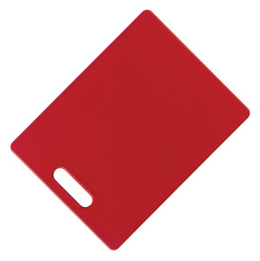 | 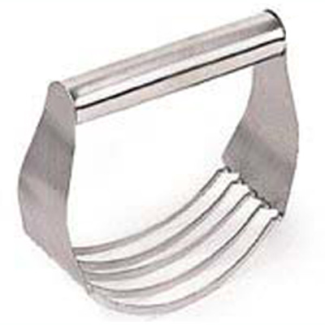 | 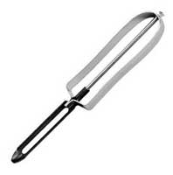 | 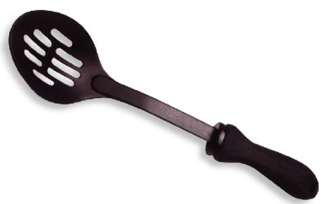 | 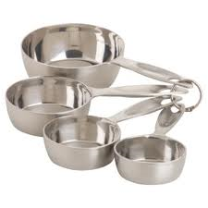
 | 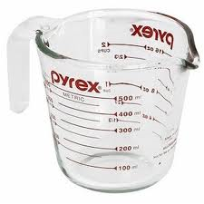 | 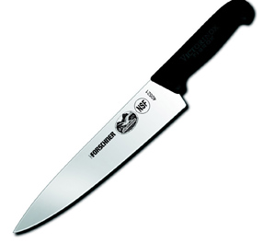 | 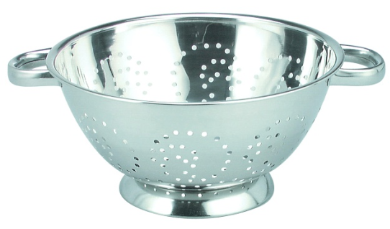 | 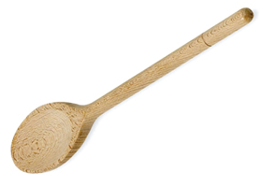
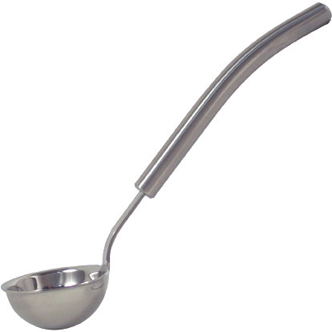 | 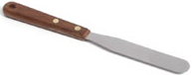 | 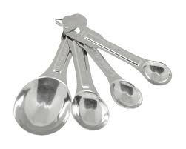 | 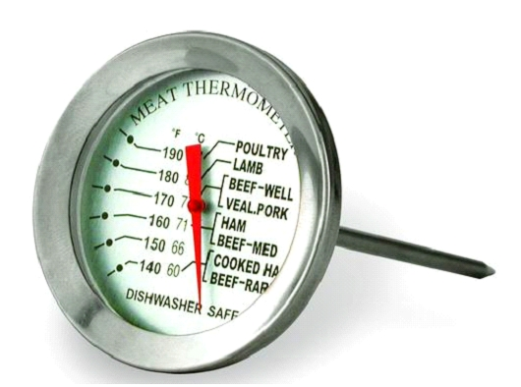
 |  | 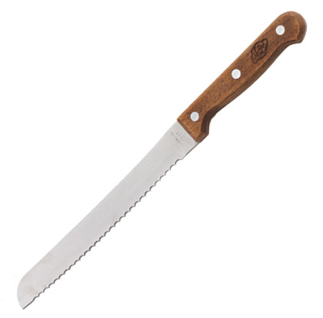 | 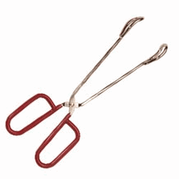
Identify the following vocabulary words.
CUTTING:
____________ : to cut food into small pieces
____________ : to cut food into very small cubes
____________ : the tear food into small thin strips using your hands or a grater
____________ : to cut food into the smallest irregular shaped pieces possible

MIXING:
____________ : to beat together a fat and a sugar until soft, creamy and smooth
____________ : to mix a fat and flour together using a cross cutting motion
____________ : to gently mix ingredients by folding one part over another
____________ : to work dough by pressing and folding until dough becomes smooth and elastic- develops gluten
____________ : to beat rapidly to incorporate air and increase volume

COOKING:
____________ : to cook or brown food in a small amount of fat until golden brown and tender
____________ : cooking food in a water or liquid, just below the boiling point
____________ : to cook by the vapor produced when water is heated to the boiling point

OTHER TASKS:
____________ : to coat food heavily with flour, breadcrumbs or cornmeal
____________ : to roll in or lightly sprinkle food with a dry ingredient
____________ : to remove a thin layer of peel from a fruit or vegetable

What 3 types of food are microwaves attracted to?
____________ ____________ ____________

Define “Standing Time”

Which cooking container is best when microwaving? Circle the correct answer.

What should you do if a person is suffering from:
Severely Bleeding Cut-
First Degree Burn-
Electrical Shock

Ammonia + Bleach = _____________________

Food that may cause a food-borne illnesses often looks and smells normal. What food-borne illness is associated with:
Undercooked ground beef or fecal matter-
Fresh poultry and raw eggs-
Improperly canned foods-
Improper hand washing-
Human mucas-

How do you put out a grease fire?

What is the danger zone?

What is the minimum amount of time you should wash your hands?

Give the equivalents below:
______ t = 1 T.
_____ fl oz = 1 c
_____ c = 1 gallon
_____ T = 1 c
_____ T = ¼ c
_____ c = 1 stick butter
_____ c = 1 pt
_____ pt = 1 qt
_____ qt = 1 gal.

Circle which one of the following changes when you are doubling or halving a recipe:
Cooking temperature Size of pan Length of cooking time-

Adjust this recipe:
Original | Double | Half
2/3 C
¾ C
1 T
1 pt

What are the functions of the 6 nutrients:
Nutrient | Calories per gram | Function
Carbohydrates
Water
Protein
Vitamins
Minerals
Fat
What are the two kinds of carbohydrates?
__________ sugars and ____________ starches

Label the parts of the Wheat kernel:
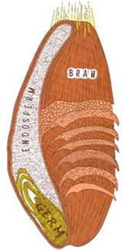

Draw the perfect muffin:

Draw the perfect biscuit:

Match the sugar with its other name.
Sucrose _____ A. blood sugar
Fructose _____ B. Milk sugar
Glucose _____ C. Table sugar
Maltose _____ D. Malt sugar
Lactose _____ E. fruit sugar

What are the two types of fiber? Which kind helps with digestion (because it doesn’t dissolve)?

Explain the purpose of each ingredient in a quickbread recipe:
Ingredient | Purpose
Flour
Eggs
Salt
Sugar
Liquid
Fat
Leavening

Saturated | Polyunsaturated | Monounsaturated
Appear to:  _____ HDL  _____ LDL | Appear to:  _____ HDL  _____ LDL | Appear to:  _____ HDL  _____ LDL
How many amino acids are considered essential? _____

What does it mean when a protein is considered complete?

What does it mean when a protein is considered incomplete?

Which of the following are complete proteins? Which are incomplete?
Milk
Nuts
Beans
Tofu
Fish
Eggs
Meat
Rice
Cereal
Cheese

What is homogenization?

What is pasteurization?

What are the five functions of eggs? Where are they used?
1.

2.

3.

4.

5.

Define the following:
Deficiency:
Toxicity:
Water soluble:
Fat soluble:
Macro:
Micro or trace:
Electrolyte:
Oxidation:

What three things destroy nutrients in fruits and vegetables?

How do you prevent oxidation?
Dietary Guidelines: Fill in the blanks
1. Eat ____________ foods.
2. Balance______________ to manage weight.
3. _____________sodium, fats and added sugars, refined grains and alcohol.
4. _____________vegetables, fruits, whole grains, milk seafood and use oils in place of solid fats.
5. Build healthy ______________that meet nutritional needs over time at an appropriate calorie level.
6. Include ______________________ as part of healthy eating patterns.
Healthy Eating Patterns:
1. Balance calories:
-Enjoy your food, but eat _________.
-Avoid _______________ portions.
2. Foods to increase:
-Make half your plate ___________________.
-Switch to fat-free or low-fat _________.
-Make at least half your grains
_______________.
3. Foods to reduce:
-Compare _______________ in foods and choose foods with the __________ numbers.
-Drink ___________ instead of sugary drinks.
Myplate uses three things to determine caloric needs. They are __________, __________, and __________.
Label each part of MyPlate, and identify the color and key consumer message for each food group.
