Utensil Drawer:
1 Rubber Scraper
2 Wooden Spoons
1 Level / Flat spatula
1 Metal spatula / turner
1 Plastic spatula / turner
1 Whisk
1 Tongs

Measuring equipment:
1 set measuring spoons
1 set dry measuring cups
1 liquid measuring cup

2 pot holders or oven mitts

Pots and Pans:
1 Small sauce pan with lid
1 Medium sauce pan with lid
1 Frying pan / skillet
1 Non-Stick Frying pan / skillet
1 Dutch oven/stock pot with lid
1 Colander

Mixing Bowls:
2 small mixing bowls
1 medium mixing bowl
1 large mixing bowl

General equipment:

1 Sifter
2 Cake cooling racks
1 strainer
1 grater

Cutlery:
4 forks
4 butter knives
4 teaspoons
4 tablespoons
1 serving fork
1 serving spoon

Dinnerware:
4 Dinner plates
4 Salad plates
4 Soup / salad bowls
4 Plastic water glasses
4 Coffee mugs
4 Custard cups
1 lg. Serving bowl
1 lg. Serving platter
1 set salt and pepper shakers
1 pitcher

Dishwashing Supplies:
1 dish bucket
1 jar hand soap (next to sink)
1 dish soap (under sink)

Cutting Boards:
1Yellow/White for fruit
1 Green/Blue for vegetables
1 Red/Orange for meats &fish

Knives:
2 chef’s knives
1 bread knife
2 paring knives
1 kitchen sheers
Drawer #1
Silverware
Can Opener
Peeler
Hot Pot Holders

Drawer #3
Rolling Pin
Tongs
Whisks (2)
Biscuit Cutter
Pastry Blender
Rubber Scraper
Turners (3)
Serving Spoon
Slotted Spoon
Mixing Spoon
Pasta Fork
Grater
Metal Spatula

Drawer #4
Dry Measuring Cups
Measuring Spoons
Liquid Measuring Cups
Hand Mixer

Drawer #2
Tin Foil
Plastic Wrap
Wax Paper

Cupboard #1
Flour
Sugar
Baking Soda
Baking Powder
Vanilla
Salt
Cooking Spray
Glass Mixing Bowls (3)

Cupboard #3
Plates (4)
Salad Plates (4)
Bowls (4)
Mugs (4)
Plastic Cups (4)
Custard Cups (4)

Cupboard #4 (Top Shelf)
Large Pot (1)
Saucepans (3)
Frying Pans (2)

Cupboard #4 (Bottom Shelf)
Tray
Cookie Sheet
Muffin Pan
Cooling Rack
Colander

Cupboard #5
Dish Drainer
Dish Soap
Hand Soap
Scrubber
Drain Plugs (2)

Blend Tec

Waffle Irons

Sandwich Makers

Equipment List
Drawer #1
- Cutting board Red and Green
- Oven Mitts
- Cooling Rack
Drawer #2
- Vegetable Peeler
- Can Opener
- Slotted Spoon
- Tongs
- Pastry Brush
- Pastry Blender
- Apple Corer
- Pizza Cutter
- Rolling Pin
- Biscuit Cutter
- Grater
- Egg Separator
- Portion Scoop

Drawer #3
- Electric Mixer/2 Beaters
Drawer #4
- 4 Forks
- 4 Spoons
- 4 Butter Knives
- 2 Serving Spoons
- Chef Knife
- Paring Knife
Cupboard #5
- 3 Sauce Pans
- 2 Skillets
- Pizza Pan
- Cookie Sheet
- 2 Muffin Tins
- Round Cake Pan

Cupboard #6
- Dish Mat/ Dish Soap
- Dish Scrubber/ Dish Stopper
Cupboard #7
- Dinner Plates
- Salad Plates
- Bowls
- Placemats
Cupboard #8
- Drinking Glasses
- Water Pitcher
- Blender
Cupboard #9
- Set of Measuring Cups
- Set of Measuring Spoons
- Liquid Measuring Cups
- Spatula
- 2 Rubber Scrapers
- 2 Wooden Spoons
- Turner
- 4 Custard Cups
- Whisk
- Tray
Cupboard #10
- 3 Mixing Bowls (Red, Yellow, Blue)
- Colander
- Strainer
- Casserole Dish w/lid
- Sifter
- Bosch Mixer

EQUIPMENT LOCATION IN THE LAB

DRAWER #1
2 wooden spoons
2 hot pads
1 turner
1slotted spoon
2 rubber scrapers

CUPBOARD #2
1 large saucepan w/lid
1 small saucepan w/lid
1 frying pan w/glass lid
1 Dutch oven (large pot)

CUPBOARD #4
1 cup liquid measuring cup
2 cup liquid measuring cup
1 pie pan
Glass casserole w/lid
1 round cake pan
1 square pan
6 count muffin pan
12 count muffin pan
Pitcher

DRAWER #8
Hand mixer

CUPBOARD #9
Dish mat & rack
Cleanser

DRAWER #10
Biscuit cutter
Vegetable peeler
Kitchen shears
Pastry brush
Pastry blender
Wire Whisk
Tongs

CUPBOARD #11
Colander
Grater
Blender

DRAWER #12
2 sets measuring spoons
2 sets measuring cups
1 metal spatula
3 small custard cups
3 large custard cups
DRAWER #13
2 cookie sheets
2 cooling racks
Supply tray
Cutting board
6 Placemats

DRAWER #14
6 butter knives
6 forks
6 spoons
3 large spoons

DRAWER #15
Attachment to mixer
Rolling pin

DRAWER #16
Aluminum foil
Plastic wrap
Wax paper

DRAWER #17
Baking powder
Baking soda
Vanilla
Salt & pepper
Flour sifter
Cinnamon
Vegetable Spray

CUPBOARD #18
6 Plates
6 Salad plates
6 Cereal bowls
6 cups

DRAWER #19
3 mixing bowls (3 sizes)
1 glass casserole w/lid
Pour bowl

TOP OF COUNTER
Flour canister
Sugar canister
Standing mixer w/bowl

IN BASKET BY SINK
Dish Soap
Scrubber
2 sink stoppers

BY SINK
Hand soap

Drawer 1
6 forks
6 knives
6 spoons
3 tablespoons
Vegetable peeler

Drawer 2
Rubber spatula
Dough scraper
Lg & Sm Wire whisk
Can opener

Drawer 3
Measuring spoons
Dry measuring cups
Metal spatula
grater

Drawer 4
Colander
Strainer
Hand mixer
2 beaters

Cupboard 5
Top
6 large plates
6 cereal bowls
6 cups
Bottom
2 quart pitcher

Cupboard 6
Top
2 large mixing bowls
2 small mixing bowls
1 extra large mixing bowl
1 cup liquid measuring cup
2 cup liquid measuring cup
1 qt liquid measuring cup
2 qt mixing glass pitcher

Cupboard 6
Bottom
Two-9x9 pan
Two-9x13 pan
Two pie pans
Two bread pans

Cupboard 7
2 metal spatulas
Brownie spatula
2 wooden spoons
Slotted spoon
Large spoon
Ladle

Cupboard 8
Large Mixer

Cupboard 9
Large wire rack
Dish drainer

Drawer 10
2 hotpads

Cupboard 11
2 cookie sheets
2 pizza pans
2 wire racks

Cupboard 12
Top
1 dutch oven/lids
2 large saucepans/lids
2 small saucepans/lids
Bottom
1 wok frying pan
1 large frying pan
2 small saute’ pans
Griddle

Storage #1
Spices

Storage #2
White Plates

Storage #3

Storage #4

Storage #5
Glass dishes and plates

Storage #6

Storage #7

Storage #8
Double Boilers

Storage #9
Goblets
Mini loaf pans

Storage #10
Dessert Cups

Storage #11
Dessert Cups
Sprinkle bottles

Storage #12
Glass Pitchers
Emersions Blenders
Electric Knife
Liquid measuring cups

Kitchen 1
#13-Thermometers
#14
#15
#16

Kitchen 2
#13
Scoops
#14
#15
#16
Oven drawer-muffin tins

Kitchen 3
#13
#14
#15
#16-extra beaters
Oven drawer-broiler pan

Kitchen 4
#13
#14
#15-pressure cooker lids
#16-presurre cookers
Oven drawer-muffin tins, broiler pan

Kitchen 5
#13
#14
#15
#16-
Oven drawer-cooling racks

Kitchen 6
#13 one-size gloves
#14-small gloves
#15-medium gloves
#16-Large & Extra Large gloves
Oven drawer-Muffin Tins

Kitchen 7
Towels/dishcloths
#13-Parchment paper
#14
#15
#16
Oven drawer-cooling racks
Kitchen number: ______________
Top drawer: 5 forks, 5 spoons, 5 butter knives, 1 peeler, 1 can opener, 1 paring knife
2nd drawer: 1 slotted spoon, 1 serving spoon, 2 rubber spatulas (large and small), 1 pancake turner, 1 whisk, measuring spoon set, dry measuring cup set,2wooden spoons, 1 ladle
3rd drawer: 1 hand mixer (with attachments), 1 rolling pin, 1 dough cutter, 1 pastry cutter, tongs, grater
4th drawer (or by the cookie sheet – wherever it fits best): 6 placemats, 1 cutting board

Cupboard next to the stove:
Top shelf: 3 pots with lids – large, medium, small, 1 frying pan
Bottom shelf: 1 cookie sheet, 1 muffin tin, 1 cooling rack, 1 tray (with handles), 1 cake pan
Cupboard across from the stove:
Top shelf: 6 large plates, 6 small plates, 6 bowls, 6 cups
Bottom shelf: 2 strainers (large and small), 3 mixing bowls (large, medium, small), 1 glass bowl with lid, 2 liquid measuring cups (large and small)

What’s Missing???
_______________________________________________________________________________________________________________________________________________________________________________________________________________________________________________________________________________________________________________________________________________________________________________________________________________________________________________________________________________________________________________________________________________________________________________________________________________________________________________________________________________________________________________________________________________________________________________________________________________________________________________________________________________________________________

Storage #1
Spices

Storage #2
Popcorn poppers

Storage #3
Fry daddy

Storage #4
Extra Mixing bowls
Aluminum chafing pans
Bundt pans

Storage #5
Glass dishes and plates
Waffle irons
Toasters

Storage #6
Small loaf Trays

Storage #7
Extra Cereal Bowls
Small serving bowls

Storage #8
Double Boilers

Storage #9
Goblets
Mini loaf pans

Storage #10
Dessert Cups

Storage #11
Dessert Cups
Sprinkle bottles
Syrup pitchers
Extra cups

Storage #12
Glass Pitchers
Emersions Blenders
Electric Knife
Liquid measuring cups

Kitchen 1
#13-Thermometers
#14
#15
#16

Kitchen 2
#13-Scoops
#14
#15
#16
Oven drawer-wire racks

Kitchen 3
#13-large knives
#14-paring knives
#15-placemats
#16-extra beaters

Kitchen 4
#13
#14
#15
#16
Oven Drawer-broiler pans

Kitchen 5
#13
#14
#15
#16-

Kitchen 6
#13 one-size gloves
#14-small gloves
#15-medium gloves
#16-Large & Extra Large gloves
Oven drawer-9x13, 9x9 pans

Kitchen 7
Towels/dishcloths
#13-Parchment paper
#14 &#15
#16 Oven drawer-muffin tins

Kitchen Unit Organization
Master List-CHECK OFF SHEET
Cupboard 1: (One of Each)
Tbsp./Tsp. Liquid Measuring Cup (Mini)
1 Cup Liquid Measuring Cup (Small)
2 Cup Liquid Measuring Cup (Medium)
4 Cup Liquid Measuring Cup (Large)

Staple Ingredients:
1 Flour 1 Cooking Spray
1 Sugar 1 Vanilla
1 Salt (Large Canister) 1 Baking Soda
1 Salt/Pepper Shakers 1 Baking Powder
1 Oil

Drawer 2:
4 Hot Pads (2 Squares & 2 Gloves)
2 Cooling Racks
2 Cutting Boards

Drawer 3:
1 Electric Mixer
2 Beaters

Cupboard 4:
1 Large Pot with Lid
1 Medium Saucepan with Lid
1 Small Saucepan with Lid
1 Large Skillet
1 Small Skillet

Cupboard 5:
1 Dish Soap
1 Dish Drainer with Mat
1 Supply Tray
1 Sanitizer Spray Bottle
2 Drain Plugs
1 Roll of Garbage Bags
1 Dish Scrub Brush

Cupboard 6:
5 Large Drinking Cups
5 Mugs
1 Pitcher
5 Small Plates
5 Medium Plates
5 Large Plates
5 Cereal Bowls
5 Custard Cups
1 Extra Blender Cup and Lid

Cupboard 7:
3 Metal Mixing Bowls
4 Plastic Mixing Bowls
4 Glass Mixing Bowls
1 Colander
1 Strainer
1 Sifter
1 Food Steamer

Drawer 8:
2 Sets of Dry Measuring Cups-(Hooked Together)
(1/4 c., 1/3 c., 1/2 c., 1 c.)
2 Sets of Measuring Spoons-(Hooked Together)
(1/8 tsp., 1/4 tsp., 1/2 tsp. 3/4 tsp., 1 tsp., 1 Tbsp.)
2 Turners
2 Spatulas
2 Rubber Spatulas
2 Mixing Spoons
1 Whisk

Drawer 9:
1 Pair of Tongs
1 Egg Separator
1 Pastry Brush
1 Rolling Pin
1 Vegetable Scrubber/Brush
1 Slotted Spoon
1 Ladle
1 Pasta Scoop
1 Garlic Press

Cupboard 10:
1 Muffin Tin (6 count)
1 Muffin Tin (12 count)
1 Cookie Sheet
1 Square Glass Dish
1 Round Glass Dish
1 Square or Rectangle Metal Pan
1 Pizza Pan

Drawer 11:
1 Can Opener
1 Pizza Cutter
1 Apple Corer
1 Grater
1 Pastry Blender
1 Vegetable Peeler
3 Biscuit Cutters-(Small, Medium and Large)
1 Pair of Kitchen Shears
1 Thermometer with Cover

Drawer 12:
5 Butter Knives
5 Salad Forks
5 Spoons
2 Extra Large Metal Serving Spoons
1 Large Chopping Knife with Blue Safety Shield
1 Medium Serrated Knife with Blue Safety Shield
1 Small Paring Knife with Blue Safety Shield

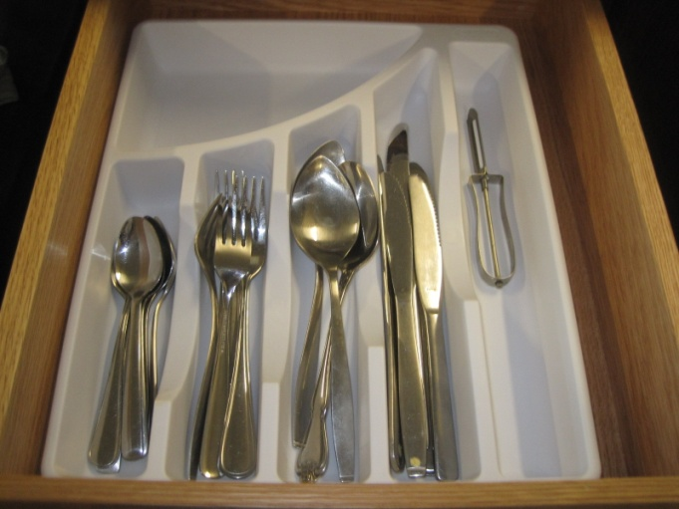
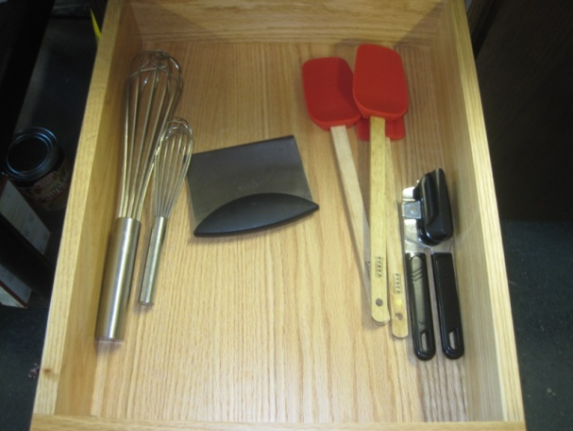
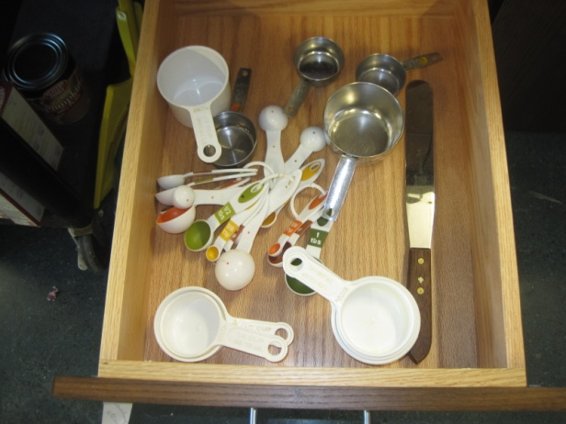
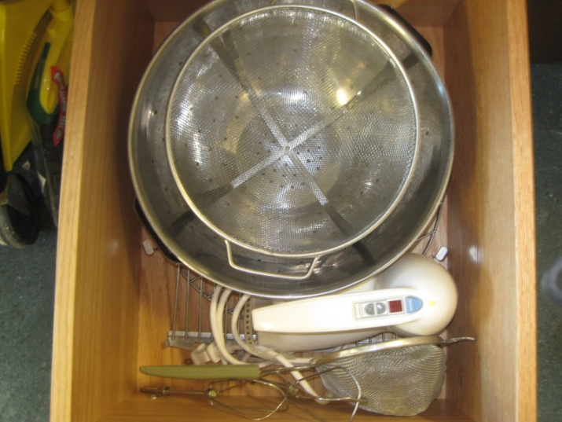
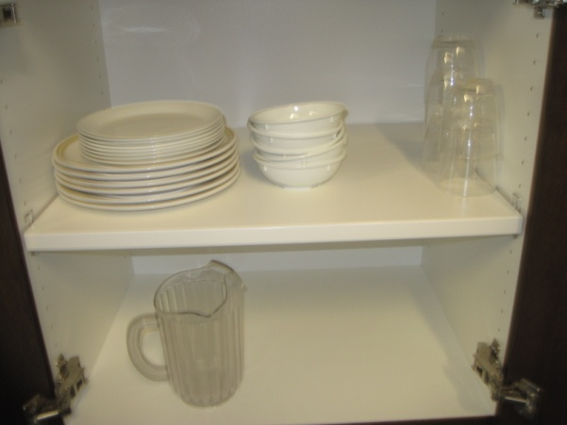
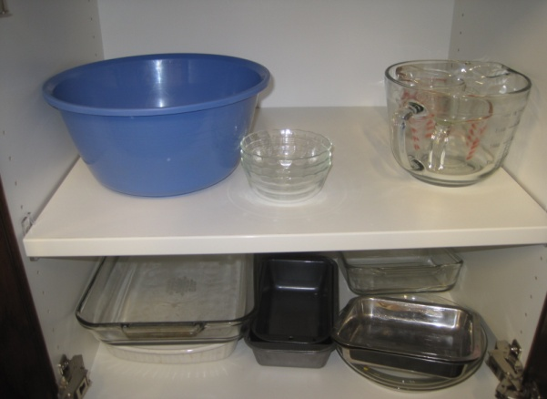
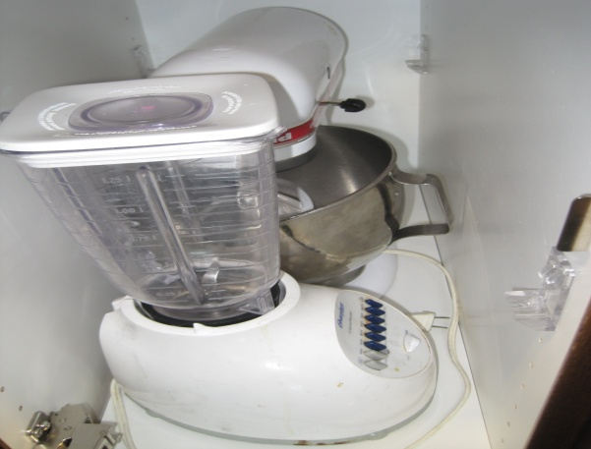
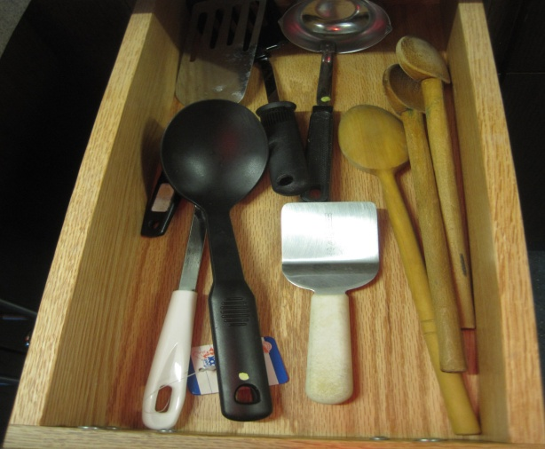
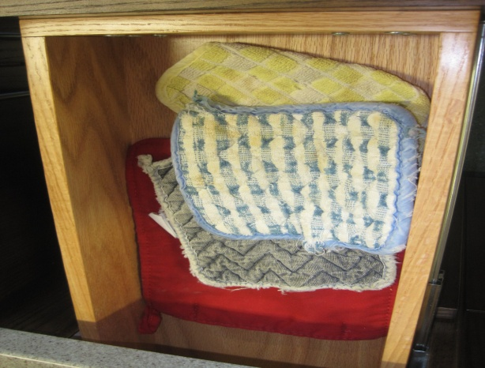
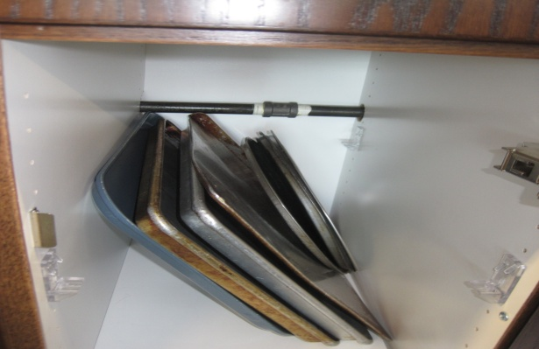
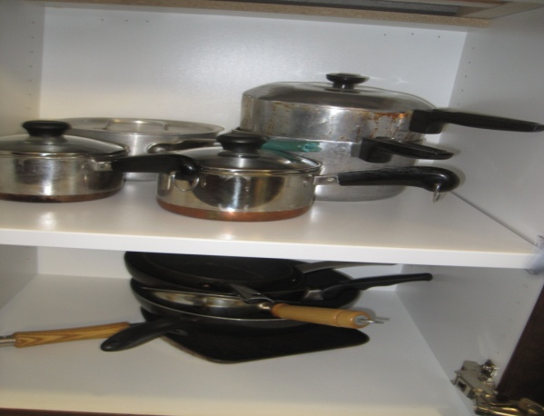

FOODS & NUTRITION AND CULINARY FACILITY GUIDE

The environment in a Family and Consumer Science (FACS) Foods & Nutrition and Culinary Facility classroom must provide students with a facility conducive to student learning, safe, able to function in a variety of activities, and able to adapt to an ever changing teaching environment. The facility should provide teachers a safe environment in which the facility is well-planned, organized, and equipped with appropriate technology to encourage learning in the classroom.

Students must feel physically and emotionally safe, have the opportunity to learn and explore, and have the opportunity to experience a well-orchestrated kitchen facility. The environment should provide a space for exploration for students to learn content information, complete their performance objectives, and develop career and daily life skills in relation to foods. The space should be an inviting well planned environment in which students can thrive.

LOCATION
Location of a Foods & Nutrition and Culinary Facility in a school needs some considerations of placement. Factors involve convenience for delivery of supplies, convenience of equipment installation and repair, convenience near bathroom facilities, and easy student assess to the classroom. Consideration should be given to allow the room to be on ground level, or near an elevator for ease of transportation of supplies.

PURPOSE
FACS classes in this facility may include Foods and Nutrition I-II, Food Service/Culinary Arts, ProStart I-II. Classes will include nutrition, food selection and preparation, meal planning, and personal health and well-being. It also includes safety and sanitation and consumerism. Students may also be introduced to restaurant and hospitality, catering, and food service. A laboratory experience is essential to the FACS foods program. Facility should provide equal opportunity for all students.

Family and Consumer Science classrooms should be clustered together where ever possible to build and support the department, build relationships with other teachers and students, and support FACS curriculum. Multiple classrooms including foods laboratories are dependent upon student population, district needs, staff, and facility availability. Appropriate storage, laundry, and classroom space is essential to student learning and teacher facilitation. Classrooms should be designed to allow computer equipment, media, technology, and other equipment to enhance the effectiveness of instruction.

The facility may be a standalone kitchen facility, or a multipurpose room that may be share other activities and classes. If shared, adequate storage should be provided to ensure student safety, adequate storage of equipment, and integrity of each program for which it serves. The facility should provide adequate space for individual, group, and teacher-student interactions.

There should be observable from all angles, provide stationary units, and have space for traffic flow and student interactions. Students with special needs require correct accommodations to be able to work with other students. Labs should have appropriate ventilation and exhaust fans as needed. Adequate refuse disposal must also be considered.

PHYSICAL FACILITY
Walls and ceilings should be covered with washable surfaces in accordance with state and local fire codes and to ensure proper sanitation in the kitchen. Walls should hold blackboards, bulletin boards, and provide adequate space for technology while staying within fire codes.
Flooring must also be washable to maintain sanitation. Carpets are high maintenance and are not recommended for a food preparation area. If restaurant or catering classes are involved, commercial drains, equipment, and washing facility are needed.

Horizontal work surfaces should be of laminate, Formica, steel, granite, or other smooth, cleanable surface which is easy to clean and sanitize. Work areas and counters should be 36-inches with one kitchen unit in compliance with current ADA 32-inch height. Other accommodations may include a wheelchair accessible height as needed.

Utility Systems should be convenient, efficient, and safe as it provides heat, cooling, lighting, and ventilation needs of the room. Windows and lighting should be adequate and provide aesthetics, safety to maintain ease, cost, and maintenance as well as energy conservation. Drapes and blinds should also be and available for use with audiovisual equipment. They should be aesthetically pleasing and able to be sanitized and cleaned.

A FACS foods facility requires high voltage power (220 volts) to accommodate a dryer and ranges. If a commercial kitchen is part of the facility, additional high voltage power may be needed. 110 outlets should be placed conveniently in kitchen units and around the room to accommodate appliances. Outlets should have ground fault interrupters and have an emergency shutdown system in place.

The water supply should available throughout the school day and be of sufficient volume and pressure. Hot water must be available for kitchen operation, dishwashing, and laundry equipment to meet safety and sanitation needs.

STORAGE
Storage should be considered when designing a foods facility. It should be convenient and well-placed in relationship to the classroom. It may be in-room or may be a separate room convenient to the FACS area. Storage should be securable and near the classroom. Storage needs include:
- Bookshelves
- Locked cabinets or storage for supplies, records, etc.
- File cabinet
- Cabinets and shelves to store class and teaching supplies
- Individual kitchen cabinets, shelves, and drawers to store kitchen supplies and equipment
- Pantry area or cupboards

FURNITURE AND EQUIPMENT NEEDS
Tables and chairs or desks should adequate for the number of students. Ideal number of students per lab is 3 to 5 students. Adequate traffic lanes should be placed between tables and chairs or desks. In addition, classroom equipment should include current teaching and learning technology. Along with ease of sanitation, versatility, function, it should also be aesthetically pleasing. Equipment should be durable, have an affordable quality, provide an ease of operation as well as maintenance and sanitation.

TEACHER’S AREA
The teacher’s area should include a desk, chair, file cabinet, book cases, and other storage needs. A computer system should also be included for research, grading, storage, etc. If room size and arrangement permit, a demonstration area could also be included. This could include a permanent or mobile demonstration table, complete with electricity. It could also include demonstration equipment storage.

APPLIANCES
Appliance should be durable, have an affordable quality, provide an ease of operation as well as maintenance and sanitation. State of the art equipment should be acquired if monetarily possible.
Appliances should be in good repair, replaced in a timely manner, and versatile for the functions to which it will be placed in.

FOOD STORAGE
Commercial Freezer
Commercial Fridge or 2 residential fridges

PREPARATION APPLIANCE
It is recommended that kitchens should be equipped with ½ Electric Ranges and ½ Gas Ranges to provide students with the experience to work with both types. Gas stoves are highly recommended for culinary kitchens as students prepare to work in industry. Kitchens should be equipped with Ranges or a cooking surface and built-in oven.
Microwave
Sink

----------------------------------------------------------------------

Foods and Nutrition I-II – Grades 9-12

Laboratory areas should be equipped with standard appliances. Because there is a wide variety of small appliances and equipment available, teachers should be consulted in making final equipment choices. Sturdy, durable, and state-of-the-art equipment is essential; however, the primary criterion for selection should be safety in using the equipment in laboratory settings.

A portable service cart and a demonstration center with observation capability are also recommended. A minimum number of kitchen units to accommodate a recommended ratio of 3-5 students per kitchen unit to ensure student safety. At a minimum, each unit should contain a sink, counter space, and range.

The following materials, equipment, and access are recommended:

1. An adequately equipped instructional area is essential. Ideally, it is part of the laboratory space and includes a management center where planning, organizing, and accounting are done. A desk and chair, file cabinet, telephone, and computer are necessary furnishings.
2. Easy access to laundry facilities and storage is necessary equipped with a washing machine and clothes dryer. Depending on the number of classes offered 2 of each machine might be ideal.
3. Fire extinguishers of appropriate type as approved by the district and state guidelines. These must meet minimum requirements. Mounted in the kitchen area.
4. An appropriate array of equipment, tools, and accessories should be available to furnish these work centers. Facility planners should seek out the recommendations of teachers who will be implementing the curriculum, so that appropriate choices can be made.
5. It is advisable to select representative brands and models of equipment, so that students can compare and evaluate various features.

LABRORATORY FACILITIES
Each individual school and classroom will require many supplies to be able to teach food concepts and allow students to meet performance objectives and promote good teaching opportunities.

Individual Kitchen Supplies needed for each unit:
Silverware and Knives
4-6 forks
4-6 knives
4-6 spoons
3 tablespoons
1-2 paring knives
1 Chef Knife
1 Serrated Knife
1 Vegetable peeler

Table service
4-6 large plates
4-6 small plates
4-6 cereal bowls
4-6 glasses
1-2 serving bowls
2 quart pitcher
Salt and Pepper Shaker

Measuring utensils
1 set of measuring spoons
1 set Dry measuring cups
1 or 2 cup liquid measuring cup

Mixing Utensils and equipment
1 Heat Resistant Rubber Spatula
1 Bench Scraper
1 Wire Whisk
2 large mixing bowls
2 small mixing bowls
1 extra large mixing bowl

Preparation Utensils and equipment
1 Can opener
1 Pastry blender
1 Biscuit cutter
1 Grater
1 Colander
1 Strainer
1 metal/plastic Turner
1 Wooden spoon
1 Slotted spoon
1 Ladle
1 Cooling Rack
1 Meat Thermometer
1 Rolling pin
1 Pastry brush
1 Pizza Wheel
1 plastic supply tray
2 cutting boards
1 Tong
1 Cookie Scoop

Pans
1 9x9 baking pan
1 9x13 baking pan
1 pie pan
1 cookie half sheet pan
1 pizza pan
1 large sauce pan with lid
1 small sauce pan with lid
1 large sauté pan
1 muffin tin
1 glass baking dish – microwave safe

Electric equipment
Stand Mixer – one per kitchen if possible

Linens and laundry
2 hot pads per unit
2 dish clothes per unit for each class
2 dish towels per unit for each class

Kitchen Equipment Needed for the classroom
Blender – 1 per kitchen unit
Griddle – 1-2 per classroom
Food Processor 1-2 per classroom
Electric Scales – 1 per unit or 3-4 per classroom
Garlic Press 2-4 per classroom
Reamer – (Juicer) 2-4 per classroom

Additional items needed:
Step Stool – depending on storage arrangement in room
Trash cans
Broom and dustpan – 1 per kitchen or 1 for every 2 kitchens
Parchment paper ½ sheet size
Small, medium, large, gloves

Addition items to consider: (nice to have but not essential to the program)
Mini loaf pans
Emersions Blenders 1 per classroom
Ice cream scoops 2-3 per classroom
Pressure cookers 1 per classroom
Cake decorating supplies- piping bags, a few tips and coloring paste
Stock Pot 1-2 per classroom
Aprons – 1 per person – not required by health department
Large Bins for Flour & Sugar on casters
1 set of flour & sugar canisters in each kitchen
Pasta makers 2-4 per classroom
Cart for food – especially for moving groceries into the school
Waffle maker 1-2 per classroom
Tablecloths or placemats for tables in class
Ice Machine
Food Service/Culinary Arts - ProStart 1 & 2 - Grades 11-12
APPLIANCES
Appliance should be durable, have an affordable quality, provide an ease of operation as well as maintenance and sanitation. State of the art equipment should be acquired if monetarily possible.
Appliances should be in good repair, replaced in a timely manner, and versatile for the functions to which it will be placed in.

ProStart programs can be taught in regular residential style kitchens. If possible additional commercial equipment can be added and space and finances permit. The equipment listed in the above section for Foods and Nutrition 1 & 2 is necessary for the ProStart program. Ideally the following should be added:

FOOD STORAGE
Walk in Refrigerator & Freezer or commercial grade refrigerator and freezer

HOT FOOD EQUIPMENT LIST
4-6 Burner commercial range
1 Convection Oven or Combi Oven (Convection Oven & Steamer)
1 Hood – this will be required for the above listed equipment

NICE TO HAVE – BUT NOT ESSENTIAL
Salamander (broiler)
Commercial Grill
Meat Slicer
Floor Standing Mixer
Hand Washing Sinks
Proofing or Holding Box
Speed Rack
Steamer – unless a Combi oven is purchased
Stainless Prep Tables – as space is available
3 Compartment Sink
Under counter or larger commercial dish washer

LABRORATORY FACILITIES
Each individual school and classroom will require many supplies to be able to teach food concepts and allow students to meet performance objectives and promote good teaching opportunities. If a school chooses to open a restaurant or does a large amount of catering additional equipment and supplies would be needed.

The Prostart lab would be more beneficial for student learning if the following items can be supplied.

Pots – 3.5 quart – 1 per unit
Pots – 5 quart – 1 per unit
6” Sauté pans – 1 per unit
9” Sauté Pans – 1 per unit
10 Quart Stock pot – 2-3 per classroom
Stainless Bowls – various sizes – 10-12 per classroom
Serving Spoons – 6-8 per classroom
Serving Spoons – Slotted – 6-8 per classroom
8” Wire Whisk – 1 per unit
Serving Tongs – 6-8 per classroom
Meat Forks – 2 per classroom
Full Sheet Pans – 12 or more per classroom
Cutting Boards – 1 per student
8” Chef Knife – 1 per student
6” Boning Knife – 1 per unit
6-8” serrated knife – 1 per unit
Full Hotel Pans – 3-4 per classroom
Half Hotel Pans – 3-4 per classroom
Chafing Dish – 2-3 per classroom
Round Cake Pan 1-2 per unit
Chef Coats – 1 per student

