KITCHEN EQUIPMENT AND MANAGEMENT – UNIT 1 TEST

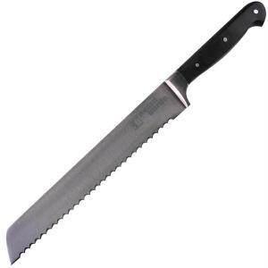
DO NOT WRITE ON THIS TEST. MARK YOUR ANSWERS ON THE BUBBLE SHEET.

- What is the proper name of this piece of kitchen equipment?
  - Chef Knife
  - Paring Knife
  - Bread Knife
  - Santuko Knife

- What is the proper name of this piece of kitchen equipment?
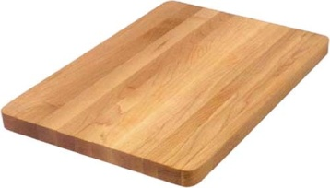
  - Cutting Board
  - Chopping Block
  - Butcher Block
  - Chopping Board

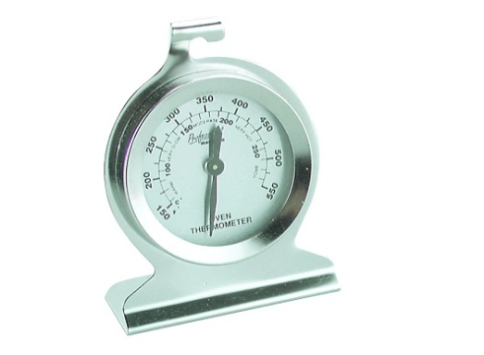
- What is the proper name of this piece of kitchen equipment?
  - Cooking Thermometer
  - Oven Thermometer
  - Candy Thermometer
  - Meat Thermometer

- What is the proper name of this piece of kitchen equipment?
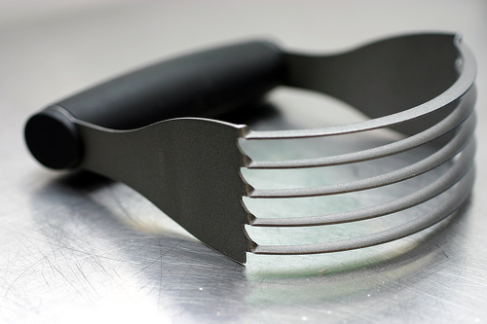
  - Pastry Blender
  - Dough Cutter
  - Blender
  - Pastry Mixer

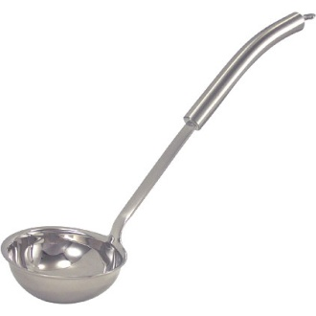
- What is the proper name of this piece of kitchen equipment?
  - Soup Spoon
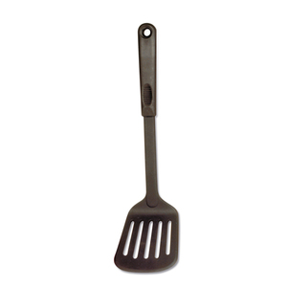
  - Scooper
  - Dipper
  - Ladle

- What is the proper name of this piece of kitchen equipment?
  - Flipper
  - Pancake Turner
  - Spatula
  - Server
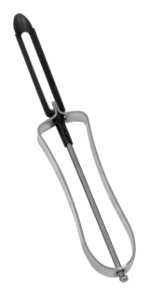
- What is the proper name of this piece of kitchen equipment?
  - Potato Peeler
  - Fruit Peeler
  - Vegetable Peeler
  - Carrot Peeler
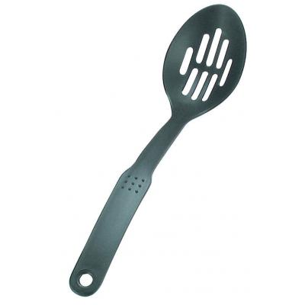
- What is the proper name of this piece of kitchen equipment?
  - Hole Spoon
  - Slotted Spoon
  - Slatted Spoon
  - Serving Spoon

- What is the proper name of this piece of kitchen equipment?
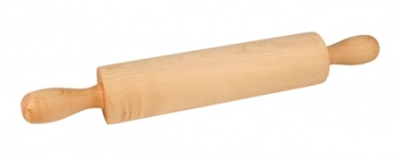
  - Roller
  - Rolling Pin
  - Dough Roller
  - Spinning Pin

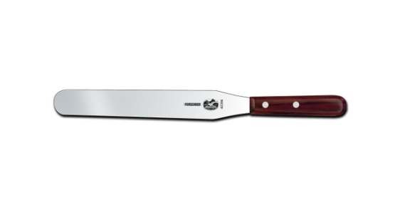
- What is the proper name of this piece of kitchen equipment?
  - Straight Edge Spatula
  - Spreader
  - Spatula
  - Leveler

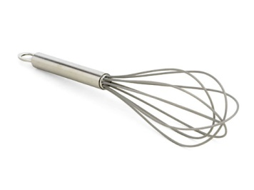
- What is the proper name of this piece of kitchen equipment?
  - Whipper
  - Wire Whip
  - Wire Whisk
  - Whisker

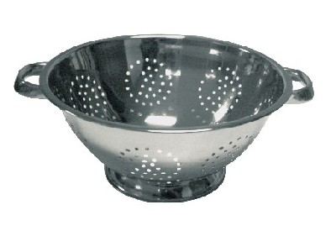
- What is the proper name of this piece of kitchen equipment?
  - Strainer
  - Colander
  - Sieve
  - Sifter

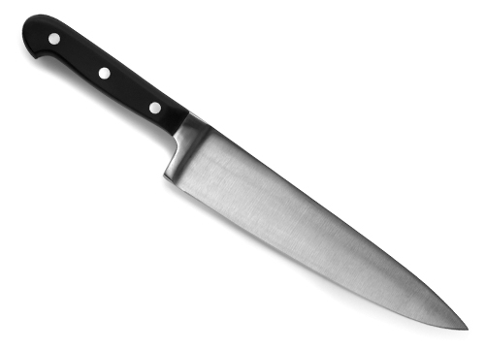
- What is the proper name of this piece of kitchen equipment?
  - Chef Knife
  - Vegetable Knife
  - Paring Knife
  - Cleaver Knife

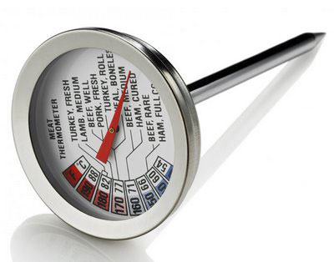
- What is the proper name of this piece of kitchen equipment?
  - Oven Thermometer
  - Candy Thermometer
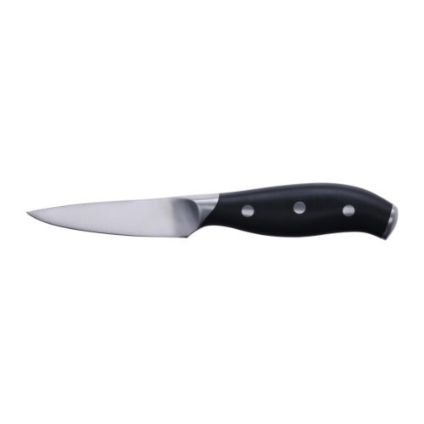
  - Cooking Thermometer
  - Meat Thermometer

- What is the proper name of this piece of kitchen equipment?
  - Paring Knife
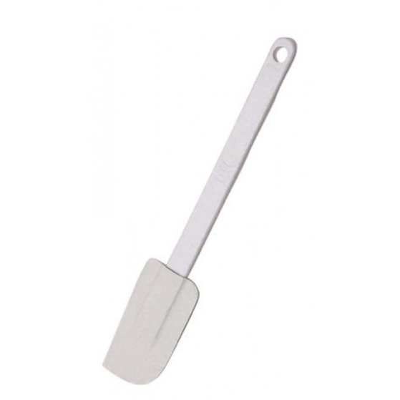
  - Santuko Knife
  - Chef Knife
  - Bread Knife

- What is the proper name of this piece of kitchen equipment?
  - Rubber Spatula
  - Rubber Stirrer
  - Rubber Scraper
  - Rubber Turner
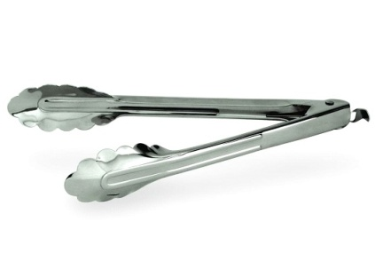
- What is the proper name of this piece of kitchen equipment?
  - Pinchers
  - Tongs
  - Grippers
  - Pliers
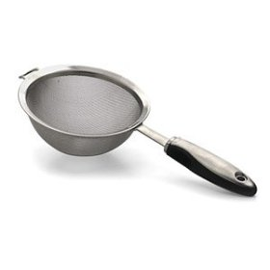
- What is the proper name of this piece of kitchen equipment?
  - Colander
  - Sieve
  - Strainer
  - Sifter

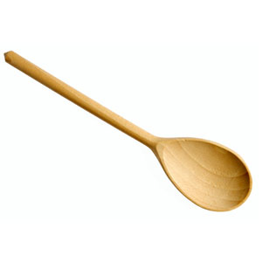
- What is the proper name of this piece of kitchen equipment?
  - Wooden Stirrer
  - Wooden Ladle
  - Wooden Scooper
  - Wooden Spoon

- Which of the following is NOT the correct abbreviation for tablespoon?
  - Tbsp.
  - Tb.
  - T.
  - Tbs.

- One tablespoon equals how many teaspoons?
  - 2
  - 3
  - 4
  - 5

- To cut into small pieces is to _____.
  - Dice
  - Chop
  - Mince
  - Slice

- When a recipe asks you to “cut the fat into the flour”, what piece of kitchen equipment should you use?
  - Chef Knife
  - Wire Whisk
  - Pastry Blender
  - Dinner Fork

- In microwave cooking, friction produces ________, which cooks the food.
  - Heat
  - Intensity
  - Coolness
  - Boiling

- Use ____ measuring cups for liquid ingredients.
  - Glass
  - Dry
  - Solid
  - Liquid

- Use ______ measuring cups for dry ingredients.
  - Solid
  - Liquid
  - Dry
  - Glass

- To cut or chop food as finely as possible is to _____.
  - Dice
  - Chop
  - Peel
  - Mince

- What piece of kitchen equipment should be used when leveling off ingredients or spreading frosting?
  - Dinner Knife
  - Straight Edge Spatula
  - Rubber Spatula
  - Frosting Knife

- Covering foods while cooking in the microwave oven prevents food from _______.
  - Burning
  - Splattering
  - Cooking Evenly
  - Toasting

- When measuring liquid ingredients, measure at _______ on a flat, level surface.
  - Waist high
  - A counter
  - Eye level
  - A table

- What is the correct abbreviation for ounce?
  - Oz.
  - Ounz.
  - oz.
  - onz.

- To sprinkle or coat with a powdered substance, often with crumbs of seasonings is to _____.
  - Sauté
  - Dredge
  - Cut-in
  - Flour

- What piece of kitchen equipment should be used for cooking on the top of the stove?
  - Chef Knife
  - Pastry Blender
  - Tablespoon
  - Wooden Spoon

- What increases cooking and standing time in microwave cooking?
  - Quality and quantity of food
  - Height and length of food
  - Quantity and volume of food
  - Size and scope of food

- What is the correct abbreviation for gallon?
  - Gal.
  - G.
  - gal.
  - ga.

- How many ounces are in one pound?
  - 12
  - 16
  - 18
  - 20

- To coat food heavily with flour, bread crumbs or cornmeal is to _____.
  - Fold-in
  - Flour
  - Dredge
  - Cream

- You should use caution with sharp objects such as ___________ and blender blades.
  - Knives
  - Forks
  - Spoons
  - Straight Edge Spatula

- Vibration from microwaves creates _______.
  - Friction
  - Heat
  - Pulsations
  - Tremors

- What is the correct abbreviation for pint?
  - pt.
  - P.
  - Pt.
  - p.

- Two cups equals how many pints?
  - 1
  - 2
  - 3
  - 4

- To finely divide food in various sizes by rubbing it on a surface with sharp projections is to _____.
  - Peel
  - Steam
  - Grate
  - Cut-in

- Which of the following helps to prevent burns when using a microwave oven?
  - Use a wet dish towel and direct the steam towards your body.
  - Use your hands and direct the steam directly up to the ceiling.
  - Use aluminum foil and don’t worry about where the steam goes.
  - Use pot holders and direct the steam away from your body.

- When measuring dry ingredients, level the measuring cup with a ________.
  - Table knife
  - Rubber scraper
  - Chef knife
  - Straight edge spatula

- Use appropriate ______ principles for increasing/decreasing fractions.
  - Equation
  - Math
  - Equivalent
  - Proportion

- To work sugar and fat together until the mixture is soft and fluffy is to _____.
  - Fold-in
  - Cream
  - Whip
  - Dredge

- For even cooking in the microwave, what should be done with the food?
  - Replace and switch out
  - Poke and stab
  - Adjust and modify
  - Stir and rotate

- What is the correct abbreviation for quart?
  - Qt.
  - qtr.
  - q.
  - qt.

- How many quarts equals one gallon?
  - 2
  - 4
  - 6
  - 8

- To mix ingredients by gently turning one part over another is to _____.
  - Cut-in
  - Whip
  - Fold-in
  - Knead

- Microwaves are attracted to all EXCEPT which of the following?
  - Fat
  - Water Molecules
  - Protein
  - Sugar

- Do NOT measure directly over the ______.
  - Sink
  - Mixing bowl
  - Counter
  - Floor

- Four tablespoons equals how many cups?
  - 1/4
  - 1/3
  - 1/2
  - 3/4

- To cut into very small cubes is to _____.
  - Mince
  - Dice
  - Chop
  - Grate

- Which of the following statements are true about microwave cooking?
  - Microwave cooking often brown foods but never gives a crisp crust.
  - Microwave cooking does brown foods and gives a crisp crust.
  - Microwave cooking does not brown foods or give a crisp crust.
  - Microwave cooking sometimes brown foods and never gives a crisp crust.

- What is the correct abbreviation for teaspoon?
  - Tsp. and tsp.
  - tsp. and t.
  - T. and t.
  - tbs. and Tbsp.

- What is the correct abbreviation for pound?
  - lb. and #
  - Lb. and %
  - lbs. and #
  - Lbs. and @

- To cut fat into flour with a pastry blender or two knives is to _____.
  - Fold-in
  - Cream
  - Mince
  - Cut-in

- Microwaves cause molecules to __________.
  - Melt
  - Vibrate
  - Explode
  - Disappear

- Use the most _____ tools for measuring.
  - Effective
  - Useful
  - Helpful
  - Valuable

- What is the correct abbreviation for minute?
  - min.
  - mn.
  - Min.
  - mins.

- To work dough to further mix the ingredients and develop the gluten is to _____.
  - Knead
  - Whip
  - Cream
  - Sauté

- Which of the following containers should NEVER be used in a microwave oven?
  - Plastic
  - Metal
  - Paper
  - Glass

- How many cups are in one gallon?
  - 6
  - 13
  - 16
  - 17

- How many cups are in one stick of butter?
  - 1/4
  - 1/3
  - 1/2
  - 2/3

- How many tablespoons are in one cup?
  - 8
  - 15
  - 16
  - 19

- To remove or strip off the skin or rind of some fruits and vegetables is to _____.
  - Mince
  - Dice
  - Chop
  - Peel

- All of the following are appropriate and safe cooking containers for the microwave oven EXCEPT for which one?
  - Microwave safe plastic
  - Microwave safe glass
  - Microwave safe paper
  - Metal

- Brown sugar is _____ and leveled in dry measuring cups.
  - Packed
  - Scooped
  - Sifted
  - Spooned

- What is the correct abbreviation for hour?
  - hr.
  - Hr.
  - H.
  - h.

- To brown or cook foods with a small amount of fat using low to medium heat is to _____.
  - Simmer
  - Steam
  - Sauté
  - Cream

- The time food continues to cook after the microwave has stopped is called what?
  - Standing time
  - Microwave cooking time
  - Cooling off time
  - Holding time

- Shortening is ______ into dry measuring cups and leveled.
  - Pressed
  - Sifted
  - Lightly placed
  - Forced Down

- What is half of 2/3?
  - 1/8
  - 1/4
  - 1/3
  - 3/4

- To cook just below the boiling point is to _____.
  - Steam
  - Simmer
  - Sauté
  - Cream

- Which of the following coverings should NEVER be used in a microwave oven?
  - Plastic Wrap
  - Aluminum Foil
  - Paper Towel
  - Wax Paper

- What is the correct abbreviation for cup?
  - C.
  - cu.
  - c.
  - cp.

- Which of the following will remain the same and not change when doubling and cutting a recipe in half?
  - The amount of ingredients
  - The length of cooking time
  - The size of the pan
  - The cooking temperature

- To cook by the vapor produced when water is heated to the boiling point is to _____.
  - Cream
  - Sauté
  - Steam
  - Simmer

- What type of containers cook more evenly in the microwave oven?
  - Deep and round
  - Deep and square
  - Shallow and round
  - Shallow and square

- Use measuring spoons for ingredients less than ______.
  - 1/8 cup
  - 1/3 cup
  - 1/4 cup
  - 1/2 cup

- One cup equals how many fluid ounces?
  - 6
  - 8
  - 10
  - 12

- To beat rapidly to introduce air bubbles into food is to _____.
  - Knead
  - Cut-in
  - Cream
  - Whip

- Shortening can also be measured using the _______ method.
  - Water dislodgment
  - Water disruption
  - Water disorder
  - Water displacement

KITCHEN EQUIPMENT AND MANAGEMENT – UNIT 1 TEST-KEY

DO NOT WRITE ON THIS TEST. MARK YOUR ANSWERS ON THE BUBBLE SHEET.

- What is the proper name of this piece of kitchen equipment?
  - Chef Knife
  - Paring Knife
  - Bread Knife
  - Santuko Knife

- What is the proper name of this piece of kitchen equipment?
  - Cutting Board
  - Chopping Block
  - Butcher Block
  - Chopping Board

- What is the proper name of this piece of kitchen equipment?
  - Cooking Thermometer
  - Oven Thermometer
  - Candy Thermometer
  - Meat Thermometer

- What is the proper name of this piece of kitchen equipment?
  - Pastry Blender
  - Dough Cutter
  - Blender
  - Pastry Mixer

- What is the proper name of this piece of kitchen equipment?
  - Soup Spoon
  - Scooper
  - Dipper
  - Ladle

- What is the proper name of this piece of kitchen equipment?
  - Flipper
  - Pancake Turner
  - Spatula
  - Server
- What is the proper name of this piece of kitchen equipment?
  - Potato Peeler
  - Fruit Peeler
  - Vegetable Peeler
  - Carrot Peeler
- What is the proper name of this piece of kitchen equipment?
  - Hole Spoon
  - Slotted Spoon
  - Slatted Spoon
  - Serving Spoon

- What is the proper name of this piece of kitchen equipment?
  - Roller
  - Rolling Pin
  - Dough Roller
  - Spinning Pin

- What is the proper name of this piece of kitchen equipment?
  - Straight Edge Spatula
  - Spreader
  - Spatula
  - Leveler

- What is the proper name of this piece of kitchen equipment?
  - Whipper
  - Wire Whip
  - Wire Whisk
  - Whisker

- What is the proper name of this piece of kitchen equipment?
  - Strainer
  - Colander
  - Sieve
  - Sifter

- What is the proper name of this piece of kitchen equipment?
  - Chef Knife
  - Vegetable Knife
  - Paring Knife
  - Cleaver Knife

- What is the proper name of this piece of kitchen equipment?
  - Oven Thermometer
  - Candy Thermometer
  - Cooking Thermometer
  - Meat Thermometer

- What is the proper name of this piece of kitchen equipment?
  - Paring Knife
  - Santuko Knife
  - Chef Knife
  - Bread Knife

- What is the proper name of this piece of kitchen equipment?
  - Rubber Spatula
  - Rubber Stirrer
  - Rubber Scraper
  - Rubber Turner
- What is the proper name of this piece of kitchen equipment?
  - Pinchers
  - Tongs
  - Grippers
  - Pliers
- What is the proper name of this piece of kitchen equipment?
  - Colander
  - Sieve
  - Strainer
  - Sifter

- What is the proper name of this piece of kitchen equipment?
  - Wooden Stirrer
  - Wooden Ladle
  - Wooden Scooper
  - Wooden Spoon

- Which of the following is NOT the correct abbreviation for tablespoon?
  - Tbsp.
  - Tb.
  - T.
  - Tbs.

- One tablespoon equals how many teaspoons?
  - 2
  - 3
  - 4
  - 5

- To cut into small pieces is to _____.
  - Dice
  - Chop
  - Mince
  - Slice

- When a recipe asks you to “cut the fat into the flour”, what piece of kitchen equipment should you use?
  - Chef Knife
  - Wire Whisk
  - Pastry Blender
  - Dinner Fork

- In microwave cooking, friction produces ________, which cooks the food.
  - Heat
  - Intensity
  - Coolness
  - Boiling

- Use ____ measuring cups for liquid ingredients.
  - Glass
  - Dry
  - Solid
  - Liquid

- Use ______ measuring cups for dry ingredients.
  - Solid
  - Liquid
  - Dry
  - Glass

- To cut or chop food as finely as possible is to _____.
  - Dice
  - Chop
  - Peel
  - Mince

- What piece of kitchen equipment should be used when leveling off ingredients or spreading frosting?
  - Dinner Knife
  - Straight Edge Spatula
  - Rubber Spatula
  - Frosting Knife

- Covering foods while cooking in the microwave oven prevents food from _______.
  - Burning
  - Splattering
  - Cooking Evenly
  - Toasting

- When measuring liquid ingredients, measure at _______ on a flat, level surface.
  - Waist high
  - A counter
  - Eye level
  - A table

- What is the correct abbreviation for ounce?
  - Oz.
  - Ounz.
  - oz.
  - onz.

- To sprinkle or coat with a powdered substance, often with crumbs of seasonings is to _____.
  - Sauté
  - Dredge
  - Cut-in
  - Flour

- What piece of kitchen equipment should be used for cooking on the top of the stove?
  - Chef Knife
  - Pastry Blender
  - Tablespoon
  - Wooden Spoon

- What increases cooking and standing time in microwave cooking?
  - Quality and quantity of food
  - Height and length of food
  - Quantity and volume of food
  - Size and scope of food

- What is the correct abbreviation for gallon?
  - Gal.
  - G.
  - gal.
  - ga.

- How many ounces are in one pound?
  - 12
  - 16
  - 18
  - 20

- To coat food heavily with flour, bread crumbs or cornmeal is to _____.
  - Fold-in
  - Flour
  - Dredge
  - Cream

- You should use caution with sharp objects such as ___________ and blender blades.
  - Knives
  - Forks
  - Spoons
  - Straight Edge Spatula

- Vibration from microwaves creates _______.
  - Friction
  - Heat
  - Pulsations
  - Tremors

- What is the correct abbreviation for pint?
  - pt.
  - P.
  - Pt.
  - p.

- Two cups equals how many pints?
  - 1
  - 2
  - 3
  - 4

- To finely divide food in various sizes by rubbing it on a surface with sharp projections is to _____.
  - Peel
  - Steam
  - Grate
  - Cut-in

- Which of the following helps to prevent burns when using a microwave oven?
  - Use a wet dish towel and direct the steam towards your body.
  - Use your hands and direct the steam directly up to the ceiling.
  - Use aluminum foil and don’t worry about where the steam goes.
  - Use pot holders and direct the steam away from your body.

- When measuring dry ingredients, level the measuring cup with a ________.
  - Table knife
  - Rubber scraper
  - Chef knife
  - Straight edge spatula

- Use appropriate ______ principles for increasing/decreasing fractions.
  - Equation
  - Math
  - Equivalent
  - Proportion

- To work sugar and fat together until the mixture is soft and fluffy is to _____.
  - Fold-in
  - Cream
  - Whip
  - Dredge

- For even cooking in the microwave, what should be done with the food?
  - Replace and switch out
  - Poke and stab
  - Adjust and modify
  - Stir and rotate

- What is the correct abbreviation for quart?
  - Qt.
  - qtr.
  - q.
  - qt.

- How many quarts equals one gallon?
  - 2
  - 4
  - 6
  - 8

- To mix ingredients by gently turning one part over another is to _____.
  - Cut-in
  - Whip
  - Fold-in
  - Knead

- Microwaves are attracted to all EXCEPT which of the following?
  - Fat
  - Water Molecules
  - Protein
  - Sugar

- Do NOT measure directly over the ______.
  - Sink
  - Mixing bowl
  - Counter
  - Floor

- Four tablespoons equals how many cups?
  - 1/4
  - 1/3
  - 1/2
  - 3/4

- To cut into very small cubes is to _____.
  - Mince
  - Dice
  - Chop
  - Grate

- Which of the following statements are true about microwave cooking?
  - Microwave cooking often brown foods but never gives a crisp crust.
  - Microwave cooking does brown foods and gives a crisp crust.
  - Microwave cooking does not brown foods or give a crisp crust.
  - Microwave cooking sometimes brown foods and never gives a crisp crust.

- What is the correct abbreviation for teaspoon?
  - Tsp. and tsp.
  - tsp. and t.
  - T. and t.
  - tbs. and Tbsp.

- What is the correct abbreviation for pound?
  - lb. and #
  - Lb. and %
  - lbs. and #
  - Lbs. and @

- To cut fat into flour with a pastry blender or two knives is to _____.
  - Fold-in
  - Cream
  - Mince
  - Cut-in

- Microwaves cause molecules to __________.
  - Melt
  - Vibrate
  - Explode
  - Disappear

- Use the most _____ tools for measuring.
  - Effective
  - Useful
  - Helpful
  - Valuable

- What is the correct abbreviation for minute?
  - min.
  - mn.
  - Min.
  - mins.

- To work dough to further mix the ingredients and develop the gluten is to _____.
  - Knead
  - Whip
  - Cream
  - Sauté

- Which of the following containers should NEVER be used in a microwave oven?
  - Plastic
  - Metal
  - Paper
  - Glass

- How many cups are in one gallon?
  - 6
  - 13
  - 16
  - 17

- How many cups are in one stick of butter?
  - 1/4
  - 1/3
  - 1/2
  - 2/3

- How many tablespoons are in one cup?
  - 8
  - 15
  - 16
  - 19

- To remove or strip off the skin or rind of some fruits and vegetables is to _____.
  - Mince
  - Dice
  - Chop
  - Peel

- All of the following are appropriate and safe cooking containers for the microwave oven EXCEPT for which one?
  - Microwave safe plastic
  - Microwave safe glass
  - Microwave safe paper
  - Metal

- Brown sugar is _____ and leveled in dry measuring cups.
  - Packed
  - Scooped
  - Sifted
  - Spooned

- What is the correct abbreviation for hour?
  - hr.
  - Hr.
  - H.
  - h.

- To brown or cook foods with a small amount of fat using low to medium heat is to _____.
  - Simmer
  - Steam
  - Sauté
  - Cream

- The time food continues to cook after the microwave has stopped is called what?
  - Standing time
  - Microwave cooking time
  - Cooling off time
  - Holding time

- Shortening is ______ into dry measuring cups and leveled.
  - Pressed
  - Sifted
  - Lightly placed
  - Forced Down

- What is half of 2/3?
  - 1/8
  - 1/4
  - 1/3
  - 3/4

- To cook just below the boiling point is to _____.
  - Steam
  - Simmer
  - Sauté
  - Cream

- Which of the following coverings should NEVER be used in a microwave oven?
  - Plastic Wrap
  - Aluminum Foil
  - Paper Towel
  - Wax Paper

- What is the correct abbreviation for cup?
  - C.
  - cu.
  - c.
  - cp.

- Which of the following will remain the same and not change when doubling and cutting a recipe in half?
  - The amount of ingredients
  - The length of cooking time
  - The size of the pan
  - The cooking temperature

- To cook by the vapor produced when water is heated to the boiling point is to _____.
  - Cream
  - Sauté
  - Steam
  - Simmer

- What type of containers cook more evenly in the microwave oven?
  - Deep and round
  - Deep and square
  - Shallow and round
  - Shallow and square

- Use measuring spoons for ingredients less than ______.
  - 1/8 cup
  - 1/3 cup
  - 1/4 cup
  - 1/2 cup

- One cup equals how many fluid ounces?
  - 6
  - 8
  - 10
  - 12

- To beat rapidly to introduce air bubbles into food is to _____.
  - Knead
  - Cut-in
  - Cream
  - Whip

- Shortening can also be measured using the _______ method.
  - Water dislodgment
  - Water disruption
  - Water disorder
  - Water displacement

