Nutrition and Cost Analysis of Biscuits
Performance Objective 5: Complex Carbohydrates Scratch vs. Convenience

Food | Cost per Package | Cost per dozen biscuits recipe | Time: Prep (est.) + Cooking | Totals  Time and Cost
1-3/4 c flour | $2.36 for 5-pound bag—75 fourth-cup servings--$0.16 per cup | $0.28
2- 1/2 tsp baking powder | $2.13 for 10 oz (284 g) can—1/2 tsp = 2.3 g | $0.10
1/2 tsp salt | $1.12—26 oz. (737 g)  1 tsp = 6 g | $0.01
1/4 cup shortening | $4.98—48 oz.  (136 kg) 113 servings at 12 g each  12 g = 1 TB | $0.18
3/4 cup milk | $2.79 gallon  16 cups in a gallon | $0.14 | 15 min + 12 to 15 minutes = | Estimate of 30 minutes  $0.61 cost for 12 biscuits
Pillsbury Grands! Southern Style Biscuits (frozen) | $3.98 for 20 count package |  | Rising (thawing) time + 10 to 12 minutes cooking = | $2.39 cost for 12 biscuits, but need to spend $3.98
Pillsbury Grands! Southern Style Biscuits (refrigerator) | $1.68 for 8 biscuits— but two packages needed to get to 12 biscuits--$3.36 | 1.5 packages needed for 12 biscuits--$2.52 | 5 minutes + 10 to 12 minutes = | 15 to 17 minutes  $2.52 cost per 12 biscuits, but would need to spend $3.36
2 cups Jiffy Baking Mix | $2.93 for 40 oz (1.13 kg) box—35 fourth-cup servings in box  $0.34 per cup | $0.68
2/3 cup milk | $2.79 gallon | $0.12 | 10 minutes + 10 to 12 minutes | 20 minutes  $0.80 cost for 12 biscuits

Homemade Biscuits from Scratch

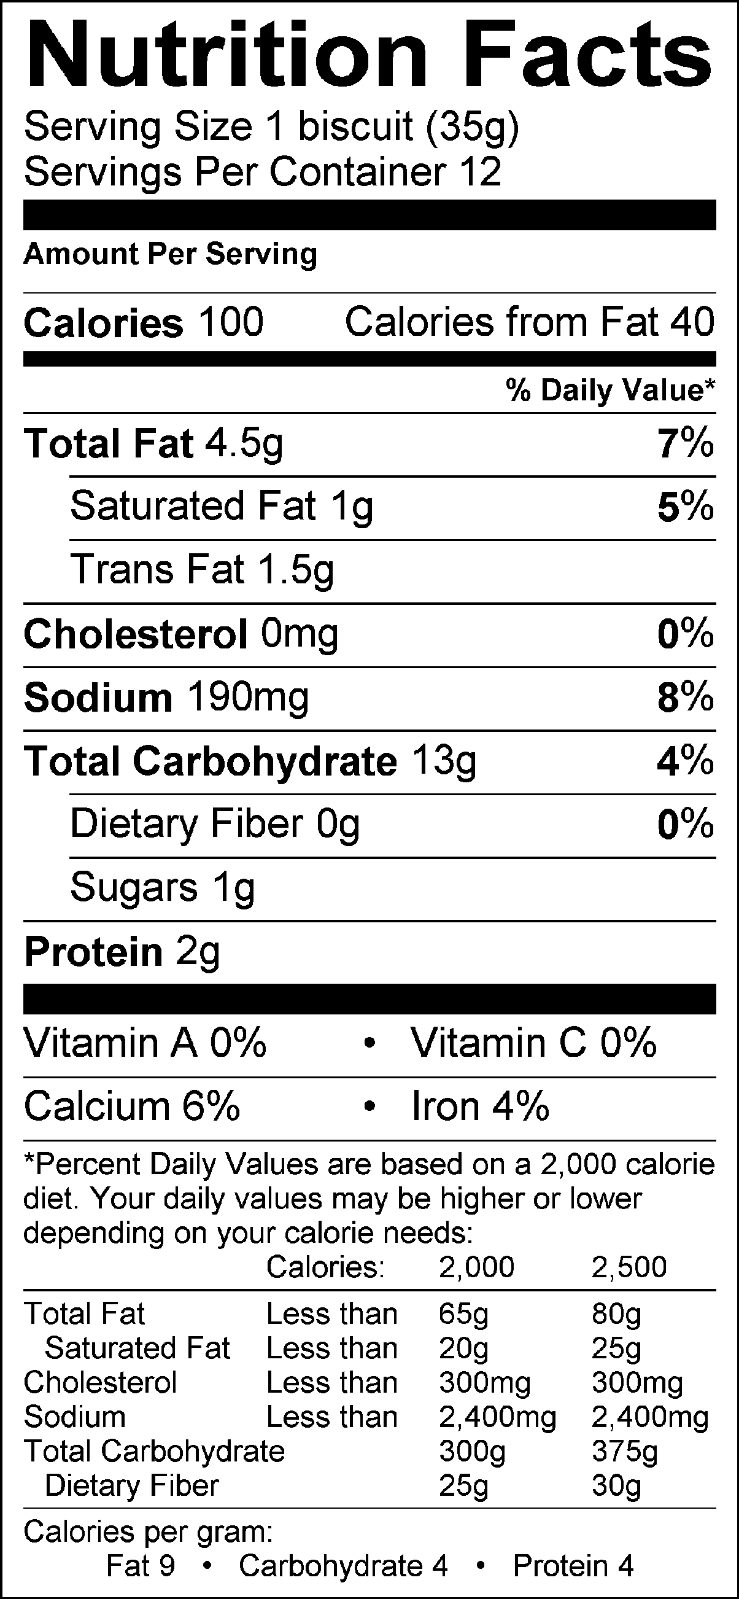

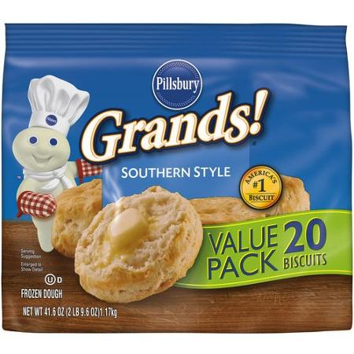
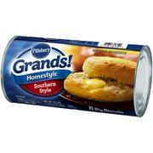

Pillsbury Grands! Southern Style Biscuits (refrigerator) 8 biscuits
Nutrition Facts
Serving Size | 1 biscuit (58g)
Amount Per Serving | As Packaged

Calories | 170

Total Fat 6g | 9%
Saturated Fat 2.5g | 13%
Trans Fat 0g
Polyunsaturated Fat 0g
Monounsaturated Fat 0g
Cholesterol 0mg | 0%
Sodium 470mg | 20%
Total Carbohydrate 25g | 8%
Dietary Fiber 1g | 3%
Sugars 4g
Protein 3g

Vitamin A | 0%
Vitamin C | 0%
Calcium | 0%
Iron | 6%
Thiamin | 0%
Riboflavin | 0%
Niacin | 0%
Folic Acid | 0%

Pillsbury Grands! Southern Style Biscuits (frozen)
Nutrition Facts
Serving Size | 1 biscuit (59g)
Amount Per Serving | As Packaged

Calories | 170

Total Fat 8g | 12%
Saturated Fat 3.5g | 18%
Trans Fat 0g
Polyunsaturated Fat 0g
Monounsaturated Fat 0g
Cholesterol 0mg | 0%
Sodium 550mg | 23%
Total Carbohydrate 23g | 8%
Dietary Fiber 1g | 2%
Sugars 2g
Protein 4g

Vitamin A | 0%
Vitamin C | 0%
Calcium | 0%
Iron | 6%
Thiamin | 0%
Riboflavin | 0%
Niacin | 0%
Folic Acid | 0%

Jiffy Baking Mix Biscuits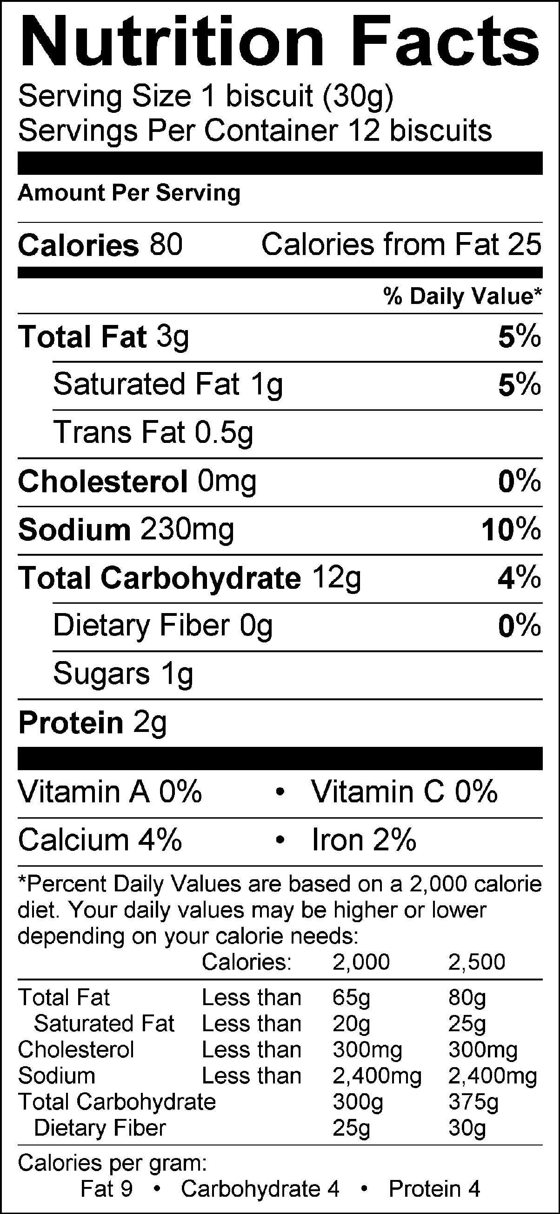

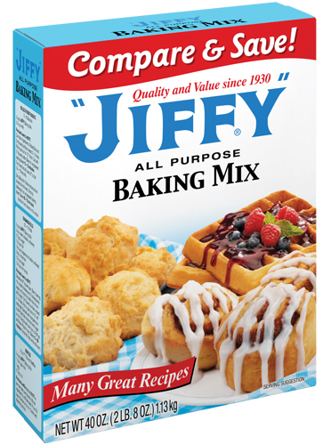

Analysis:
Calories: The biscuits from scratch are about two-thirds the size of the Pillsbury Grands! If the Grands! were two-thirds of 59 g, they would be 39g size biscuits; their calorie count would be 114 calories per biscuit. So, calories are about the same between the commercial and homemade. The Jiffy biscuits are 5 g smaller than the homemade, and about half the size of the commercial biscuits. If the Jiffy biscuits were 35 g and 59 g, their calorie count would be 94 calories and 158 calories respectively, making Jiffy the lowest calorie count—but not by much.
Cost: The commercial biscuits are approximately four times the price of the scratch biscuits and three times more costly than the Jiffy Baking Mix biscuits.

Time: The cooking time for all the biscuits is essentially the same. The preparation time is longer for the scratch biscuits, but only by about 10 minutes more than the commercial refrigerator rolls and the Jiffy mix. The freezer biscuits take the longest because of rising time.

Taste: Typically fresh-made from scratch products taste better than commercial products. However, running a personal taste test is the best way to determine taste preferences.

Nutrition: Biscuits are basic products, but scratch will have fewer preservatives added to preserve freshness than the commercial varieties and even the Jiffy Baking Mix. Preservatives are important to retain nutrition and freshness in a commercial product, but choosing to make food without added preservatives is usually going to be healthier.

HOMEMADE BISCUITS
--Lindsey Maxfield

Ingredients:
1-3/4 cups all-purpose flour
2-1/2 tsp. baking powder
1/2 tsp. salt
1/4 c. shortening
3/4 c. milk

Directions:
- Preheat oven to 425 (or as assigned)
- Sift flour, baking powder (or as assigned) and salt. Cut-in shortening with two butter knives, until the fat pieces are about the size of rice. Make a well in the center of the mixture and pour in milk. Stir with a fork just until mixed (25 strokes).
- On a lightly floured surface, roll the dough out to ½ inch thick (USE A RULER!) Cut the biscuits, and transfer to a baking sheet.
- Gather the remaining dough and re-roll and cut additional biscuits. (Keep these separate from the original biscuits on the baking sheet).
Place in preheat oven (or as assigned). Bake on greased cookie sheet until tops are golden brown (12-15 min.) Transfer baked goods to a cooling rack. Using a ruler, measure the height of all the biscuits. Get an average (add up the height of all the biscuits, and then divide the total number by how many biscuits you measured).

