Nutrition and Cost Analysis of Cheddar Biscuits
Performance Objective 5--Complex Carbohydrates: Scratch vs. Convenience

Almost-Famous Cheddar Biscuits from Food Network (totally scratch) | Cost per Package | Cost per 12 biscuit serving recipe | Time: Pre + Cooking | Totals
1-3/4 cups flour | $2.36 for 5-pound bag—75 fourth-cup servings--$0.16 per cup | $0.28
1 TB plus 2 tsp baking powder  (5 tsp = 23 g) | $2.13 for 10 oz. (284 g) can—1/2 tsp = 2.3 g | $0.18
2-1/2 tsp sugar  1 tsp = 4.2 g | $1.88 for 2 lb  (907 g) | $0.03
1/4 tsp salt  (1.5 g) | $1.12 for 26 oz. (737 g)  1 tsp = 6 g | $0.01
3 TB vegetable shortening | $4.98 for 48 oz. (136 kg)  12 g = 1 TB | $1.32
4 TB unsalted butter (1/4 c or half a stick) | $2.89 for 1 lb  (four 8 TB or 1/2 c. sticks) | $0.37
6 oz. grated yellow cheddar cheese (abt 1-1/4 cups) | $4.72—16 oz or 1 lb. (abt 4 cups) | $1.77
3/4 c whole milk | $2.79 gallon  16 cups in a gallon | $0.14 | Prep: 15 min  Cook: 20 min
Topping: Garlic Butter
--3 TB unsalted butter | $2.89 for 1 lb  (four 8 TB or 1/2 c. sticks) | $0.28
--1 clove garlic, smashed  one clove = 3g | $3.76 for 3 oz. (85.05g) | $0.14
--1 tsp chopped fresh parsley  1 TB = 3.8g  10 sprigs = 10 g | $0.68 per bunch—about 48 sprigs = 48 g | $0.02 | (done while biscuits cook) | Time: 35 min.  Cost: $4.54
Cheddar Biscuits—Red Lobster copy cat recipe--partial convenience
2-1/2 c Bisquick baking mix | $3.16 for 40 oz. (1.13 kg)  1 c = 120 g | $0.84
3/4 c plus 2 TB cup cold milk (or 7/8 cup of milk) | $2.79 gallon  16 cups in a gallon | $0.16
4 TB cold butter | $2.89 for 1 lb  (four 8 TB or 1/2 c. sticks) | $0.37
1/4 tsp garlic powder  (0.775 g) | $2.24 for 3.12 oz (88 g)  1 tsp = 3.1 g | $0.02
1 cup cheddar cheese | $4.72—16 oz (abt 4 cups) | $1.18 | Prep: 10 min  Cook: 15 to 17 min
TOPPING:  --2 TB butter, melted | $2.89 for 1 lb  (four 8 TB or 1/2 c. sticks) | $0.19
--1/4 tsp dried parsley flakes  1 tsp = 0.5 g | $1.98 for 7 g (0.25 oz.) of dried chopped parsley | $0.04
--1/2 tsp garlic powder  (1.55g) | $2.24 for 3.12 oz (88 g)  1 tsp = 3.1 | $0.04
--Pinch of salt  Abt 1/8 tsp  (0.75g) | $1.12 for 26 oz. (737 g)  1 tsp = 6 g | $0.01 | (done while biscuits are cooking) | Time: 25 to 27 minutes  Cost: $2.85
Red Lobster Cheddar Bay Biscuit Mix-- more convenience

Need 1-1/5 packages for 12 biscuits  1 pkg = 322 g | $5.98 for 34.06 oz (966 g) makes 30 biscuits contains three 11.36 oz packages, 1 pkg makes 10 biscuits | $2.40 for 12 biscuits
1 c water | n/a | n/a
2/3 c. Cheese | $4.72—16 oz (abt 4 cups) | $0.80 | Prep: 3 minutes  Cook: 14-16 min.
Topping:
--6 TB Butter, melted and mixed with (included in pkg) seasoning packet | $2.89 for 1 lb  (four 8 TB or 1/2 c. sticks) | $0.55 | (done while biscuits cook) | Time: about 20 minutes  Cost: $3.75
Betty Crocker Bisquick Complete Cheese Garlic Biscuit Mix
TWO 7.75 oz.Biscuit Mixes (about 4 cups total) | $1.00 for 7.75 oz.—6 muffins: would need two packages | $2.00
1c Water | n/a | n/a | 3 minutes to mix lightly +  8 to 11 minutes to cook
Topping:
--4 TB Butter, melted | $2.89 for 1 lb  (four 8 TB or 1/2 c. sticks) | $0.37 |  | Time: 11 to 14 minutes  Cost: $2.37
Furlani Frozen Cheddar Chive and Garlic Biscuits—throw in the oven | $2.97 for 11.3 oz.—8 biscuits (320 g) need to buy two pkg. | $4.46 for twelve biscuits (1-1/2 packages) | Prep: 2 min to put on oven sheet +  8 minutes to cook (already totally cooked, so this reheats) | Time: 10 minutes  Cost: $4.46 for 12 biscuits (but $5.94 for two packages)
Almost-Famous Cheddar Biscuits
from Food Network
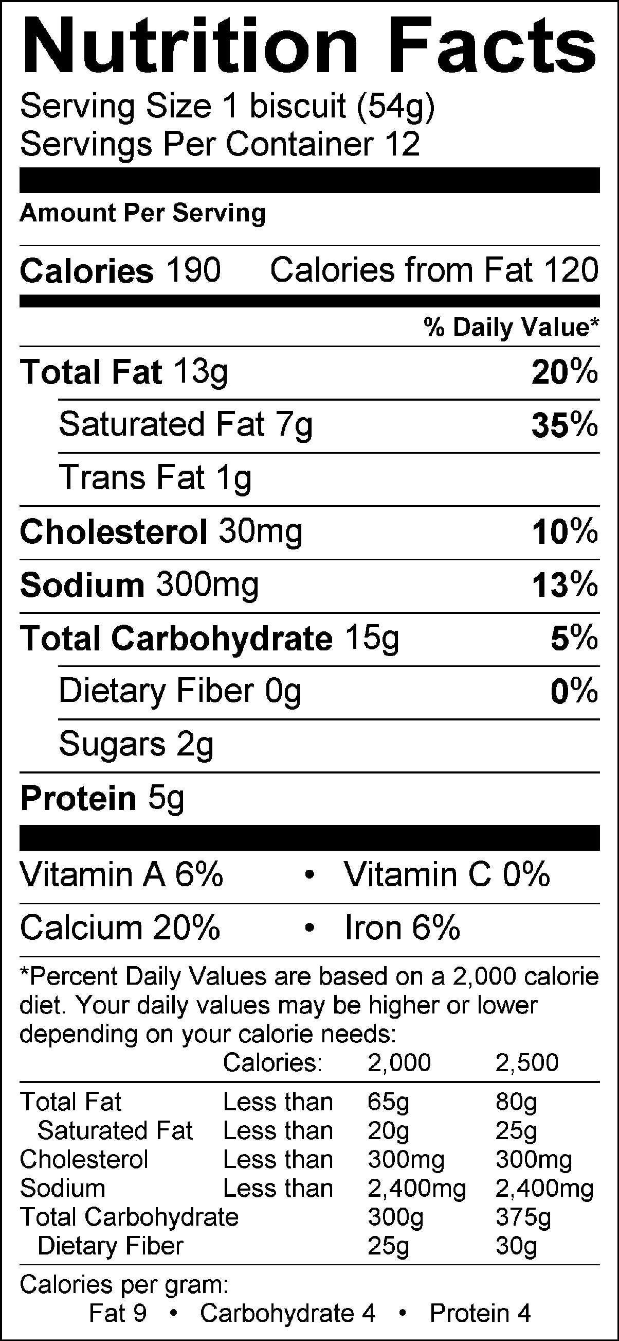

Cheddar Biscuits Red Lobster Copy Cat Recipe
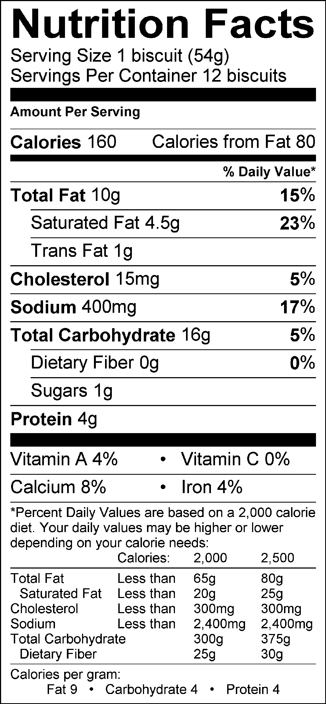

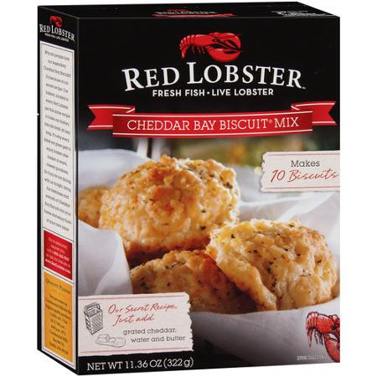

Nutrition Facts

Red Lobster Cheddar Bay Biscuit Mix
Serving Size 32 G
Servings Per Container 10
Amount Per Serving
Calories | 140
Calories From Fat | 60

% Daily Value
Total Fat 7 G | 11
Saturated Fat 3 G | 15
Trans Fat 0 G
Cholesterol 0 Mg | 0
Sodium 420 Mg | 18
Total Carbohydrate 18 G | 6
Dietary Fiber <1 G | 2
Sugars 1 G
Protein 2 G

Vitamin A | 0
Vitamin C | 0
Calcium | 4

(-) Information is currently not available for this nutrient.
* Percent Daily Values are based on a 2,000 calorie diet. Your daily values may be higher or lower depending on your calorie needs:**

Additions to Red Lobster Mix
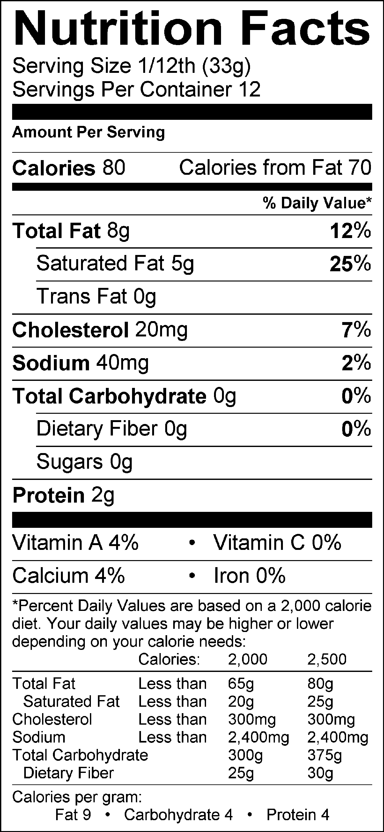

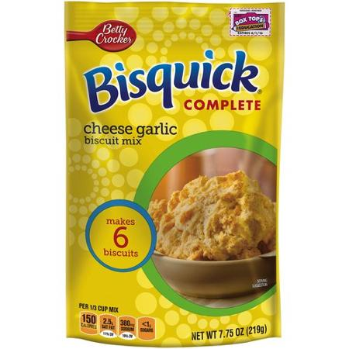

Nutrition Facts

Bisquick Complete Cheese Garlic Biscuits
Serving Size 37 G
Servings Per Container 6
Amount Per Serving
Calories | 160
Calories From Fat | 70

% Daily Value
Total Fat 7 G | 11
Saturated Fat 2.5 G | 11
Trans Fat 2.5 G
Cholesterol 0 Mg | 0
Sodium 350 Mg | 14
Potassium 55 Mg | 2
Total Carbohydrate 22 G | 7
Dietary Fiber <1 G | 2
Sugars 2 G
Protein 2 G

Calcium | 4
Thiamin | 10
Riboflavin | 6
Niacin | 6
Folic Acid | 8

(-) Information is currently not available for this nutrient.

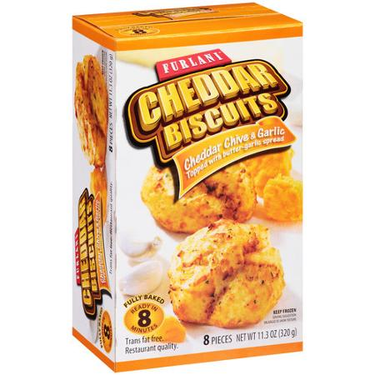

Nutrition Facts

Furlani Cheddar Chives & Garlic Biscuits
Serving Size 40 G
Servings Per Container 70
Amount Per Serving
Calories | 150
Calories From Fat | 70

% Daily Value
Total Fat 8 G | 12
Saturated Fat 3.5 G | 18
Trans Fat 0 G
Cholesterol 10 Mg | 3
Sodium 240 Mg | 10
Total Carbohydrate 16 G | 5
Dietary Fiber 1 G | 4
Sugars 1 G
Protein 4 G

Vitamin A | 4
Vitamin C | 0
Calcium | 6

Analysis:
Cost: Surprisingly, the scratch cheddar biscuits cost the most at $4.54. The cheapest recipe was the Betty Crocker Bisquick Complete Cheese Garlic Biscuit Mix at $2.37.
Time: the Furlani frozen biscuits were the shortest on time: only 10 minutes. The most time was the Almost-Famous biscuits totally from scratch: about 35 minutes.
Nutrition: The Red Lobster Mix had the highest calories: 220 (remember the to add the additions to the mix—80 calories plus the 140 from the mix).
Taste: That remains to be seen: What is the vote among the tasters?
Overall: IF (!) all the biscuits taste the same, the cheapest and fastest way to get cheddar garlic biscuits is to use the Bisquick Complete Cheese Garlic Biscuit Mix. In all likelihood, the taste will be better from the Copy Cat Recipe and it is almost as fast and almost as cheap.

Almost-Famous Cheddar Biscuits
Recipe courtesy of Food Network Kitchen
Almost-Famous Cheddar Biscuits
Total Time: 35 min
Prep: 15 min
Cook: 20 min
Yield: 12-14 biscuits
Level: Easy
Ingredients:
For the biscuits:
Cooking spray
1 3/4 cups all-purpose flour
1 tablespoon plus 2 teaspoons baking powder
2 1/2 teaspoons sugar
1/4 teaspoon salt
3 tablespoons vegetable shortening, at room temperature
4 tablespoons cold unsalted butter, cut into 1/2-inch pieces
6 ounces grated yellow cheddar cheese (about 1 1/4 cups)
3/4 cup whole milk
For the garlic butter:
3 tablespoons unsalted butter
1 clove garlic, smashed
1 teaspoon chopped fresh parsley
Directions:
Position a rack in the upper third of the oven and preheat to 425 degrees. Lightly mist a large baking sheet with cooking spray.
Make the biscuits: Pulse the flour, baking powder, sugar and salt in a food processor. Add the shortening and pulse until combined. Add the butter; pulse 4 or 5 times, or until the butter is in pea-size pieces. Add the cheese and pulse 2 or 3 times. Pour in the milk and pulse just until the mixture is moistened and forms a shaggy dough. Turn out onto a clean surface and gently knead until the dough comes together. Do not overwork the dough or the biscuits will be tough.
Drop the dough onto the baking sheet in scant 1/4-cup portions, 2 inches apart, and bake until golden, 15 to 20 minutes.
Meanwhile, make the garlic butter: Melt the butter with the garlic in a small saucepan over medium heat; cook for 1 minute. Remove from the heat and stir in the parsley. Brush the biscuits with the garlic butter and serve warm.
Recipe courtesy of Food Network Magazine
© 2015 Television Food Network, G.P. All Rights Reserved.
Read more at: http://www.foodnetwork.com/recipes/food-network-kitchens/almost-famous-cheddar-biscuits-recipe.print.html?oc=linkback

CHEDDAR BISCUITS
Red Lobster Copy Cat Recipe—Wilson

Ingredients:
2-1/2 cups Bisquick baking mix
7/8 cup (3/4 cup plus 2 TB) cold milk
4 TB cold butter (1/2 stick)
1/4 tsp garlic powder
1 cup cheddar cheese

Topping:
2 TB butter, melted
1/4 tsp dried parsley flakes
1/2 tsp garlic powder
Pinch of salt

Directions:
1. Preheat oven to 400 degrees.
2. Cut butter into Bisquick using a pastry blender (cutter) until it resembles pea sizes.
3. Add cheddar cheese, milk, and 1/4 tsp garlic powder. Mix with a spoon until well combined, but don’t over mix!
4. Drop 1/4 cup portions of the dough onto a greased cookie sheet (or use parchment paper). Bake for 15 – 17 minutes or until the tops of the biscuits are light brown.
5. While biscuits are baking, melt 2 TB of butter in a small custard cup (glass bowl) for 30 seconds in the microwave.
6. Add and stir 1/4 tsp garlic powder and parsley flakes.
7. Use a pastry brush to spread this over the tops of the biscuits.
8. Serve warm.

Return custard cup to back counter leave pastry brush on microwave.

