Nutrition and Cost Analysis of Lemon Poppy Seed Muffins
Performance Objective 7—Full-fat Food vs. low-fat/fat-free

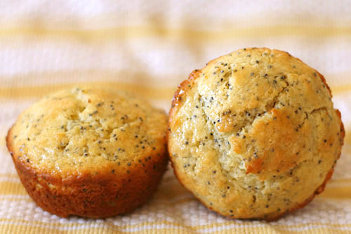
http://www.crumblycookie.net/wp-content/uploads/2011/01/lemon-muffins-4.jpg

Lemon Poppy Seed Muffins-Full-Fat Recipe | Cost per Package | Cost per 12 Serving Recipe | Time: Prep + Cooking | Totals:  Cost  Time Estimate
2/3 cup sugar  (133 g) | $1.88—2 lb.  (907 g) 1 cup = 200 g | $0.28
1 lemon—juiced and zested | 4 for $1.00 | $0.25 | About 3 minutes (1.5 min YouTube)
2 c flour | $2.48—5 lb. (2.26 kg)  1 c = 125 g | $0.28
2 tsp baking powder | $2.13 for 10 oz (284 g) can—  1 tsp = 4.6 g | $0.07
1/4 tsp baking soda | $0.58—8 oz (227 g)  1 tsp = 4.6 g | $0.01
1/4 tsp salt | $1.12—26 oz. (737 g)  1 tsp = 6 g | $0.01
3/4 c sour cream | $1.98 –16 oz. (453 g)  1 cup = 230 g | $0.76
2 eggs | $2.68—dozen  $0.23 per egg | $0.46
1 tsp vanilla | $3.68—2 fl oz. or 12 teaspoons  1 tsp = 0.167 fluid oz. | $0.31
1/2 cup butter, melted | $3.44 for 1 lb.—(2 cups)  (4- 1/2 c sticks) | $0.86
2 tsp poppy seeds | $3.97—2.4 oz.  (68 g)  1 tsp = 2.8 g | $0.33 | Prep abt 20 min + 20 min cooking = | 40 minutes  $3.62 for 12 muffins
Lemon Poppy Seed Muffins Low-Fat Recipe
1 c + 2 TB flour | $2.48—5 lb. (2.26 kg)  1 c = 125 g  1 TB = 7.8 g | $0.16
3/4 c sugar | $1.88—2 lb.  (907 g) 1 cup = 200 g | $0.32
2 tsp poppy seeds | $3.97—2.4 oz.  (68 g)  1 tsp = 2.8 g | $0.33
1-1/2 tsp baking powder | $2.13 for 10 oz (284 g) can—  1 tsp = 4.6 g | $0.06
2 eggs | $2.68—dozen  $0.23 per egg | $0.46
1 c fat-free milk | $2.37 per gal  16 cups in gal | $0.15
1/2 c applesauce | $3.32 for 46 oz. (1.304 kg)  1 c = 244 g | $0.32
1 tsp lemon extract | $2.88 for 2 fl. oz. or 12 teaspoons  1 tsp = 0.167 fluid oz. | $0.24 | Prep time about 15 minutes +  22 minutes cooking | Time: 27 min  Cost: $2.04
Lemon Poppy Seed Muffins
Fat-free Recipe
1-1/4 c flour | $2.48—5 lb. (2.26 kg)  1 c = 125 g | $0.18
1/4 c sugar | $1.88—2 lb.  (907 g) 1 cup = 200 g | $0.32
2 tsp baking powder | $2.13 for 10 oz (284 g) can—  1 tsp = 4.6 g | $0.04
1 tsp baking soda | $0.58—8 oz (227 g)  1 tsp = 4.6 g | $0.02
1/2 tsp salt | $1.12—26 oz. (737 g)  1 tsp = 6 g | $0.01
Zest of one lemon (about 1 TB) | 4 lemons for $1 | $0.25 | About 3 min. (1.5 min on YouTube)
2 tsp poppy seeds | $3.97—2.4 oz.  (68 g)  1 tsp = 2.8 g | $0.33
1 tsp lemon extract | $2.88 for 2 fl. oz. or 12 teaspoons  1 tsp = 0.167 fluid oz. | $0.24
2 egg whites | $2.68—dozen  $0.23 per egg | $0.46 | About 2 minutes (30 seconds using a water bottle)
1 c fat free lemon or plain yogurt | $2.00 for two 5.3 oz. (150 g) containers  1 c = 8 fl oz. or 245 g | $1.64
1/2 cup orange juice (not the concentrate) | $2.82 for 48 fl oz. (1493 g) (1 fl. oz = 31.1 g)  1 c = 249 g | $0.24 | Prep time 20 minutes + cook time 22 minutes = | Time: 42 minutes  Cost: $3.73

LEMON POPPY SEED MUFFINS

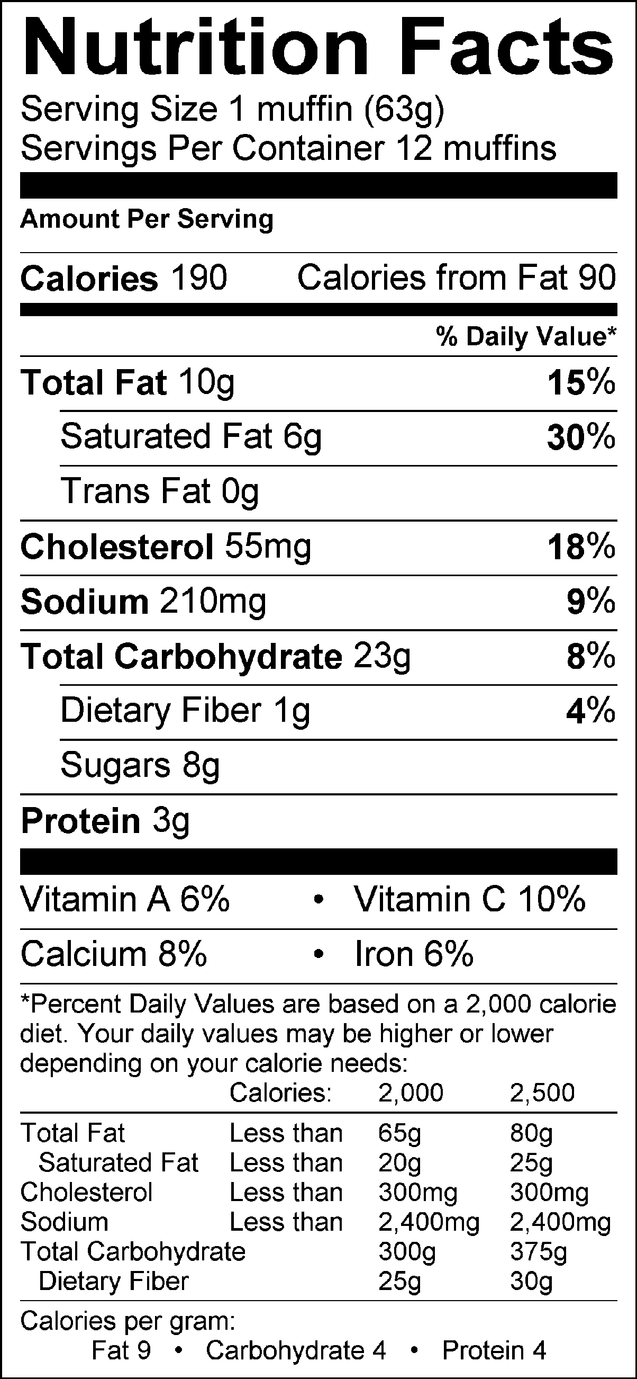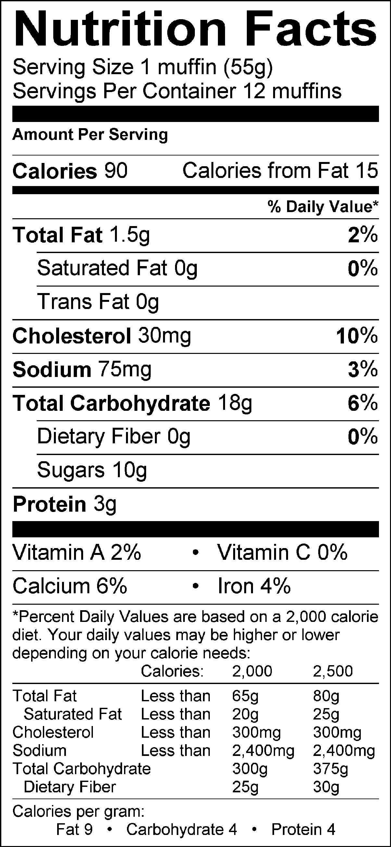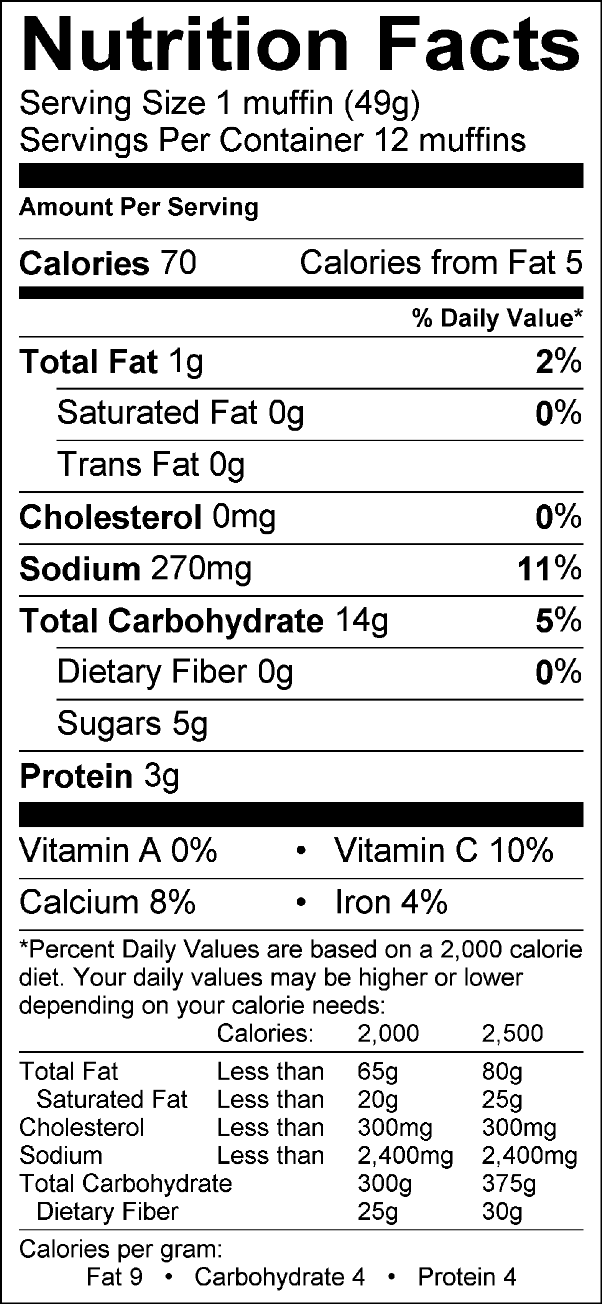
Full-Fat Muffins Low-Fat Muffins Fat-Free Muffins

Analysis:
Cost: Low-fat recipe is cheapest at $2.04, $1.58 less than the full fat and $1.69 less than the fat-free.

Time: Low-fat recipe is fastest at approximately 27 minutes, between 13 and 15 minutes faster than the other two.

Nutrition: Low-fat has by far the lowest sodium at 75 mg; the cholesterol for low-fat is high at 30 mg (10%); but the total fats is as low as the fat-free; the vitamins are the lowest of all the recipes, however the vitamins are not particularly high for any of the recipes; calorie count is about half of the full-fat and only 20 calories higher than the fat-free. Overall, the Low-fat recipe seems to be best.

Taste: Taste is up to the cooks!

Lemon Poppy Seed Muffins
Regular

2/3 c. sugar 3/4 c. sour cream
1 lemon, juiced and zested 2 eggs
2 c. flour 1 tsp. vanilla
2 tsp. baking powder 1/2 c. butter, melted
1/4 tsp. baking soda 2 tsp. poppy seeds
1/4 tsp. salt 12 paper muffin liners

1. Preheat the oven to 400°.
2. In a large sized mixing bowl, combine the sugar and lemon zest (about 1 Tbsp.). Rub them together with your fingers until the sugar is moist and the fragrance of lemon is strong.
3. Add the flour, baking powder, baking soda and salt to the large mixing bowl and stir together until combined. Make a well in the center of the dry ingredients and set aside.
4. In a separate medium sized mixing bowl, combine the sour cream, eggs, vanilla, lemon juice and melted butter and stir until combined.
5. Pour the liquid ingredients into the well of the dry ingredients and gently stir to blend. Do not over mix. Stir in the poppy seeds.
6. Pour the batter evenly into 12 muffin liners. Bake for 18 to 20 minutes, or until the tops are golden and a toothpick inserted comes out cleanly.
7. Transfer the muffins to a cooling rack. After the muffins are cooled down, cut each muffin into four pieces and bring them to the supply table.

Lemon Poppy Seed Muffins
Low-Fat

1 c. + 2 Tbsp. flour 1 c. fat-free milk
3/4 c. sugar 1/2 c. applesauce
2 tsp. poppy seeds 1 tsp. lemon extract
1 1/2 tsp. baking powder 12 paper muffin liners
2 eggs

1. Preheat the oven to 375°.
2. In a large sized mixing bowl, combine the flour, sugar, poppy seeds and baking powder. Mix together until combined. Make a well in the dry ingredients and set aside.
3. In a small sized mixing bowl, combine the eggs, milk, applesauce and lemon extract. Stir until combined.
4. Add the liquid ingredients to the well of the dry ingredients. Stir until combined, but do not over-stir.
5. Pour the batter evenly into 12 muffin liners. Bake for 18 to 22 minutes, or until the tops are golden and a toothpick inserted comes out cleanly.
6. Transfer the muffins to a cooling rack. After the muffins are cooled down, cut each muffin into four pieces and bring them to the supply table.

Lemon Poppy Seed Muffins
Fat-Free

1 1/4 c. flour 2 tsp. poppy seeds
1/4 c. sugar 1 tsp. lemon extract
2 tsp. baking powder 2 egg whites
1 tsp. baking soda 1 c. fat free lemon or plain yogurt
1/2 tsp. salt 1/2 c. orange juice (ready to drink)
Zest of one lemon (About 1 Tbsp.) 12 paper muffin liners

1. Preheat the oven to 375°.
2. In a large sized mixing bowl, combine the flour, sugar, baking powder, baking soda, salt, lemon zest and poppy seeds. Stir until combined. Make a well in the center of the dry ingredients and set aside.
3. In a separate small sized mixing bowl, combine the lemon extract, egg whites, yogurt and orange juice stir until combined.
4. Pour the liquid ingredients into the well of the dry ingredients and gently stir to blend. Do not over mix.
5. Pour the batter evenly into 12 muffin liners. Bake for 18 to 22 minutes, or until the tops are golden and a toothpick inserted comes out cleanly.
6. Transfer the muffins to a cooling rack. After the muffins are cooled down, cut each muffin into four pieces and bring them to the supply table.

