Nutrition and Cost Analysis of Pepperoni Calzones
Performance Objective 6: Convenience vs. scratch, complete and/or incomplete protein

Scratch Calzone | Cost per Package | Cost per 4 Serving Recipe | EstimatedTime: Prep + Cooking | Totals
Dough:
1 TB yeast  (12 g) | $4.62 for 4 oz. (113.4 g)  1 TB = 12 g | $0.49
1 tsp sugar  1 tsp = 4.2 g | $1.88 for 2 lb. (907 g) | $0.01
1 c warm water | n/a
1/4 tsp salt  (1.5 g) | $1.12 for 26 oz. (737 g)  1 tsp = 6 g | $0.01
2 TB oil | $2.32 for 48 fl. oz. (1 TB = serving; 96 TB in 48 fl oz.) | $0.05 for 2 TB
2-3 cups flour | $2.36 for 5-pound bag--$0.16 per cup | $0.48 | About 15 minutes to prep  $1.04 cost | Time for dough: about 15 minutes
Frozen Dinner Rolls  (about 3 rolls for 1 calzone)  (114 g) | $2.98 for 36 count rolls  1 roll = 38 g | $1.00 | Thaw/let rise for 2 hours, then roll out thin and use as Calzone
Filling:
1/2 c pizza sauce  (126 g) | $0.98 per 14 oz. (397 g)  1/4 c = 63 g | $0.32
30 pepperoni slices  (60 g) | $2.00 for 6 oz. (170 g)  (1 oz. = 28 g)  1 slice = 2 g | $0.71
1/4 c sliced olives  (33.6 g) | $2.32 for 6.5 oz. (784 g)  1 TB = 8.4 g | $0.10
1/4 c sliced mushrooms  (39 g) | $0.98 for 7 oz.  (199 g)  1/2 cup pieces canned = 78 g | $0.20
1/2 c pineapple  (90.5 g) | $1.47 for 20 oz. (567 g)  1 cup chunks = 181 g | $0.24
1-1/2 c mozzarella cheese, grated  (129 g) | $4.93 for 1 lb (454 g)  1 c shredded = 86 g 1 oz. = 28.35 g | $1.41 | Prep about 10 minutes + 20 minutes cooking time = 30 minutes  $2.98 filling cost | Total time: about 40-45 minutes  Total Cost: $2.98 + $1.04  = $4.02
Hot Pockets Pepperoni Pizza in a garlic buttery seasoned crust | $1.98 for 9 oz., 2 count sandwiches  (255 g) | $3.96 (need two boxes for 4 servings) | About 2 minutes per calzone—for 4 calzones = 8 to 10 minutes | Time: about 10 minutes  Cost: $3.96

Analysis: The cost of convenience vs. scratch is very close: only $0.06 difference. Remember the Hot Pockets do not have the pineapple, mushrooms, and olives that are in the scratch recipe. The frozen dough adds 2 hours of rising time in order to use it, so it’s not very convenient for a convenience food! Notice also, that the scratch recipe calzones are nearly twice as big as the Hot Pockets. If the recipe is halved, the cost for the same size of calzone as the Hot Pocket calzone would be $2.01 for the scratch and still $3.96 for Hot Pocket.

Taste is for the student to decide! Is the scratch worth the work?

Pepperoni Calzone from Scratch | Hot Pocket Pepperoni Pizza [Sandwich] | Pepperoni Calzone from Scratch, Half Calzone Serving
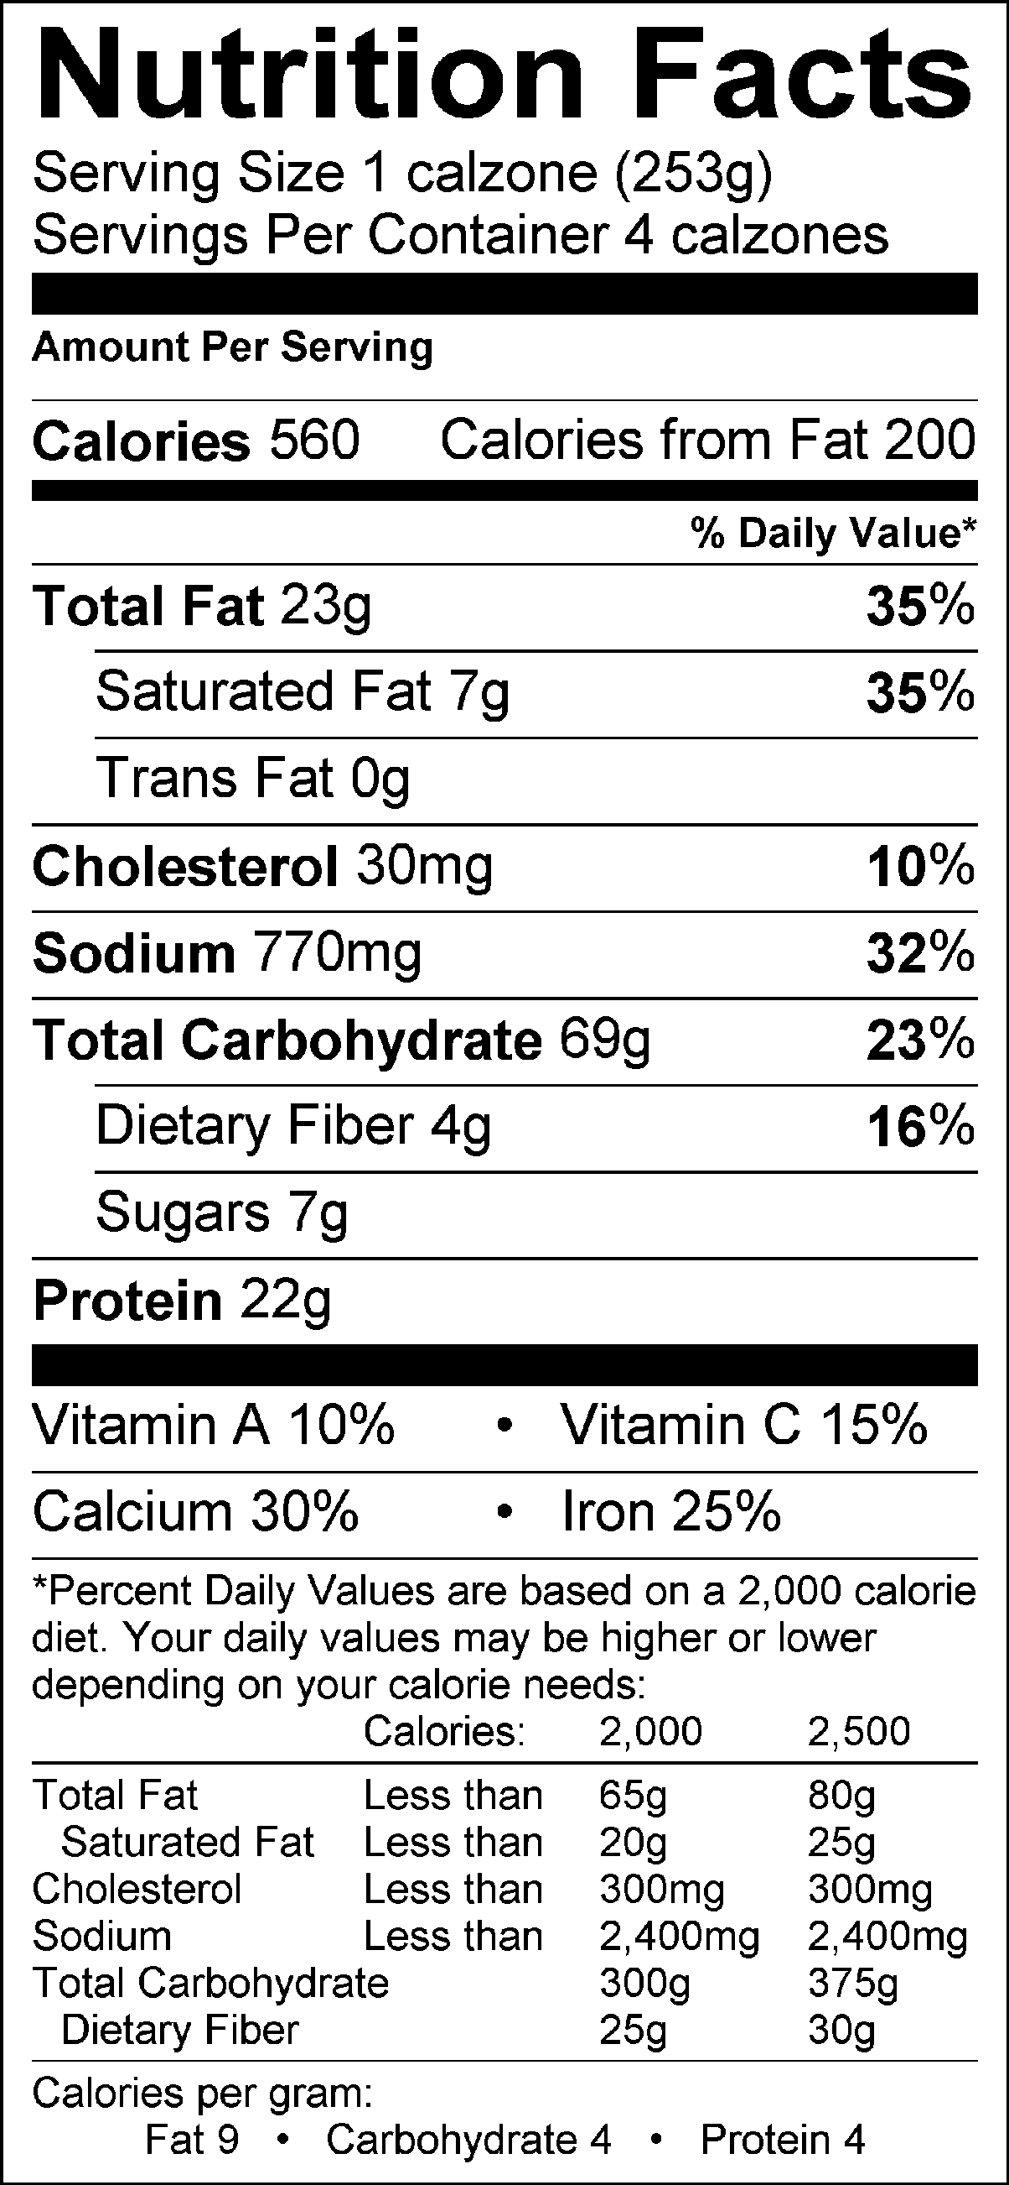 | Nutrition Facts  Serving Size 127 g  Servings Per Container 2  Amount Per Serving  Calories 320 Calories from Fat 140  %Daily Value*  Total Fats 15 g 23%  Saturated Fat 6 g 30%  Trans Fat 0 g  Cholesterol 25 mg 8%  Sodium 700 mg 29%  Total Carbohydrate 35g 12%  Dietary Fiber 1 g  Sugars 3 g  Protein 11g  Vitamin A 2%  Vitamin C 4%  Calcium 20%  Iron 10%  *Percent Daily Values are based on a 2,000 calorie diet. Your daily values may be higher or lower depending on your calories needs.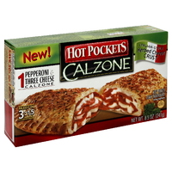 | 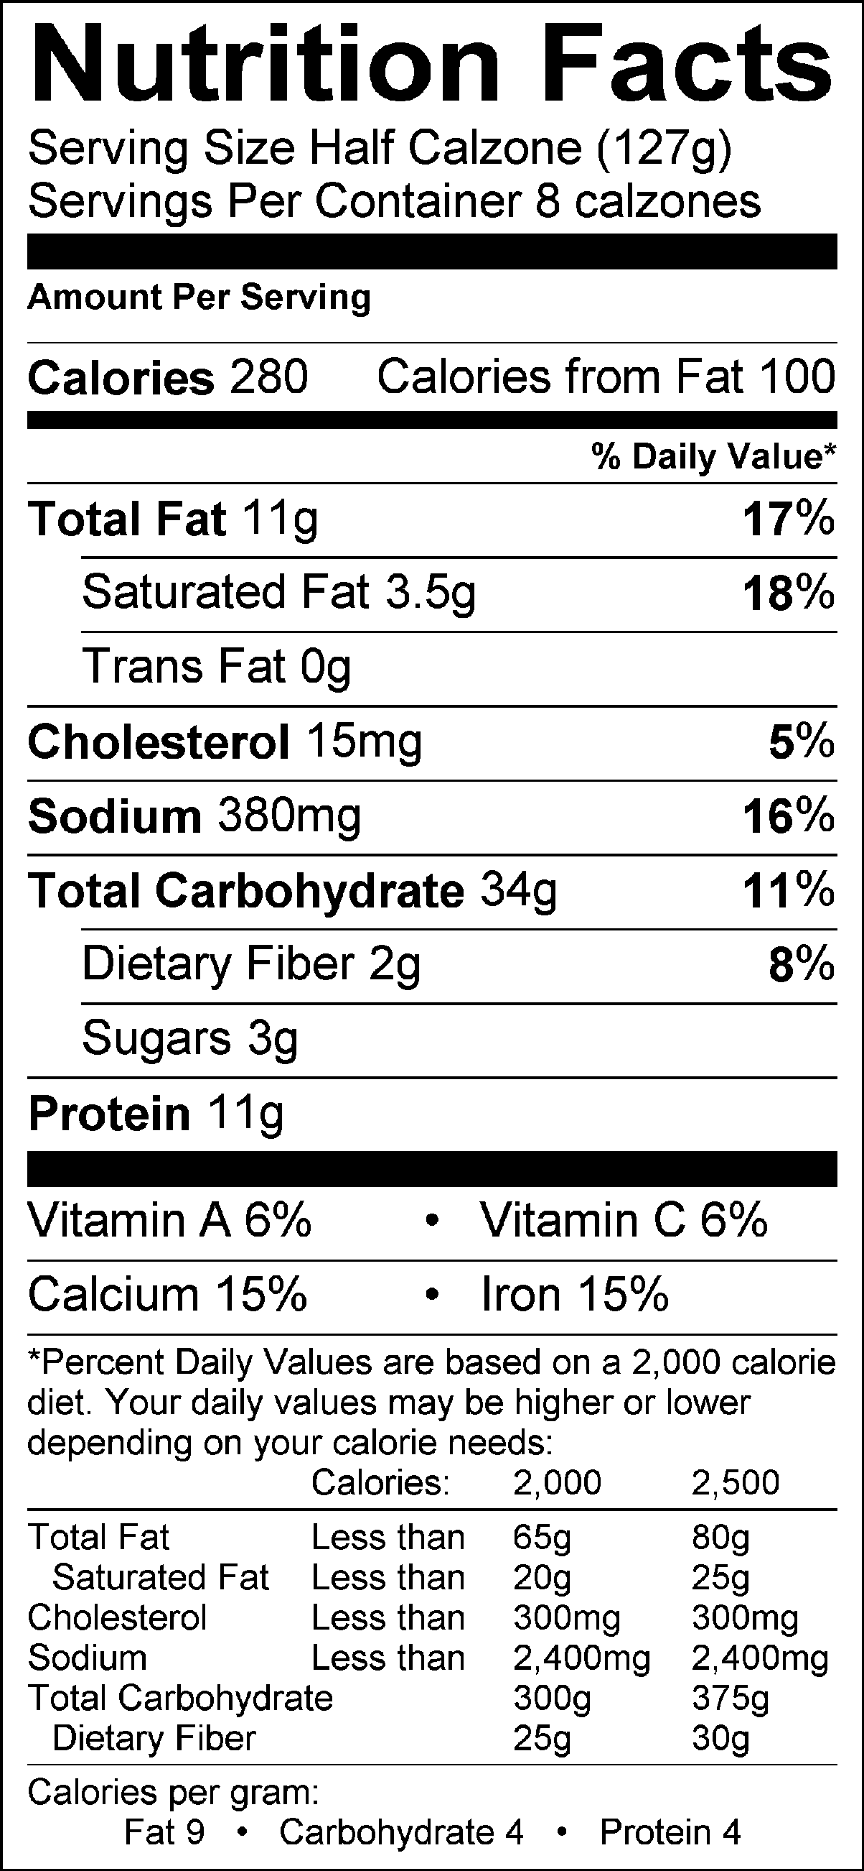

Calzones

Dough Ingredients: Filling Ingredients:
1 Tbsp. yeast 1/2 c. pizza sauce
1 tsp. sugar 30 pepperoni slices
1 c. warm water (115°-125°) 1/4 c. sliced olives
1/4 tsp. salt 1/4 c. sliced mushrooms
2 Tbsp. oil 1/2 c. pineapple
2-3 c. flour 1-1/2 c. grated mozzarella cheese

- Preheat the oven to 375°.
- In the bowl attachment of the KitchenAid mixer, combine the yeast, sugar and warm water. (Be sure to use your thermometer to measure the temperature of the water. Also, be sure to take the cover off of the thermometer before using.) Stir to allow yeast to dissolve then cover with a large towel and allow it to activate.
- After the yeast is activated, (it should be frothy and foamy), add the salt and oil.
- Using the dough hook attachment, slowly add the flour, 1/2 c. at a time, mixing until it is ready to be kneaded on the countertop. You might not use all of the flour. Allow the dough hook to knead the dough for about 2 minutes. Be sure to turn the motor up to the appropriate speed.
- Sanitize and lightly flour your countertop and knead the dough by hand for about 5 minutes. Don’t add too much flour. Only add flour if it sticks to you or the countertop.
- Divide the dough into equal pieces for each member of the group. Roll each section into a large circle.
- Spread the pizza sauce onto 1/2 of the circle, leaving about ½-inch around the edge so you can seal it.
- Layer the remaining filling ingredients onto the dough circle, (on top of the pizza sauce side). Evenly distribute all of the filling ingredients between all of the calzones before you close them up.
- Fold the other half of the dough circle over the filling and seal the edge by pressing it together with a fork. Be sure to seal the edge securely so that none of the filling will leak out.
- Poke holes or cut small slits in the top to allow the steam to escape.
- Carefully transfer the calzones onto a greased cookie sheet.
- Bake on the top rack of your oven at 375° for 20-25 minutes, or until golden brown.

