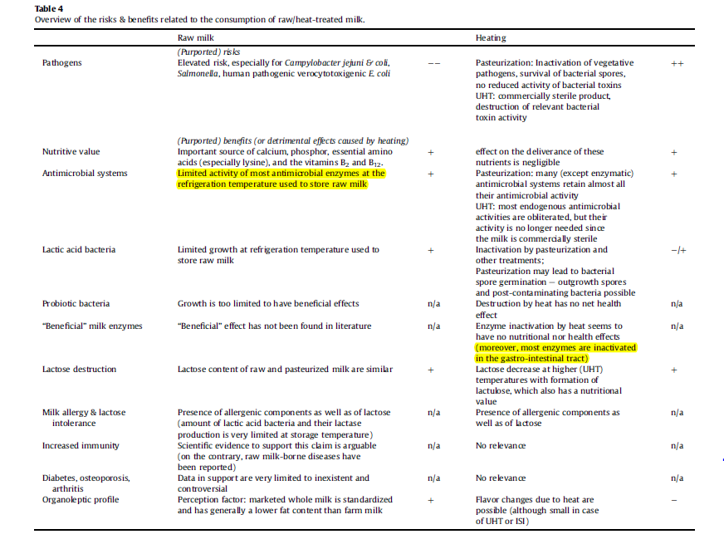

Claeys, W.L., Varraes, C., Cardoen, S., De Block, J., Huyghebaert, A., Raes, K.,Dewettinck, K., Herman, L. (2014). Consumption of raw or heated
milk from different species: An evaluation of the nutritional and potential health benefits. Food Control, Volume 42, pp 188-201.
http://dx.doi.org/10.1016/j.foodcont.2014.01.045

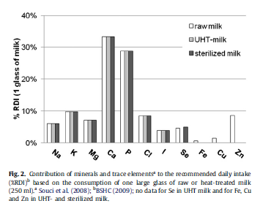
These two tables are referenced at W.L. Claeys et al. (2014) Food Control, Vol 42, pp. 188-201. “Consumption of raw or heated milk from different species: An evaluation of the nutritional and potential health benefits.” Accessed at http://dxdoi.org/10.1016/j.foodcont.2014.01.045

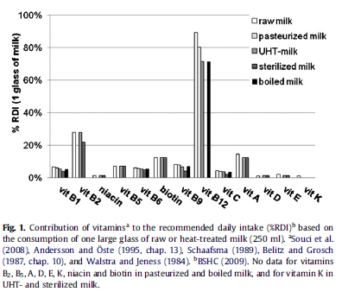

Conclusion: Pathogens indigenous to farms, animals and raw (unpasteurized) milk are potentially dangerous and very real. The nutrition content is diminished very little by pasteurization or other heat treatments. It is not worth the risk to drink raw milk or to eat foods made from unpasteurized milk. Organic cows, farms or milk are not exempt.

