Nutrition and Cost Analysis of Chicken Pillows/Chicken Crescents
Performance Objective 6—Complete/Incomplete Protein Scratch vs. Convenience
Performance Objective 7—Full fat vs. Low Fat

Chicken Pillows | Cost per Package | Cost per 4 serving recipe | Time: Prep + Cooking | Totals
1 raw chicken breast, trimmed | $2.49 per pound raw—1 chicken breast is about 118 g  1 lb = 454 g | $0.63 for 1/4 of a pound of chicken (about one chicken breast) | Dice chicken and cook = about 10 minutes
8 oz. cream cheese, softened | $2.26—8 oz. pkg | $2.26
1/2 tsp dried chives  (about 0.04 g) | $4.28 for 0.25 oz. bottle, (7 g)  1 TB = 0.2g | $0.03
1/8 tsp salt | $1.12—26 oz.  (737 g)  1/4 tsp = 1.5 g | $0.01
1/8 tsp pepper  (0.2875 g) | $3.25 for 4 oz. (113 g)  1 tsp = 2.3g | $0.01
1/2 tsp onion powder | $2.24 for 2.62 oz. (74 g)  1 tsp = 2.4 g | $0.04
1 can crescent rolls | $1.82 for 8-roll can | $1.82
1/3 c crushed croutons or bread crumbs | $2.00 Panko Bread Crumbs, 8 oz (227 g)  1 c = 108g | $0.32
1/4 c melted margarine | $1.57 for 1 lb. (four 1/2 c sticks) | $0.20 | Total Prep about 25 minutes + 25 minutes cooking | Time: 50 minutes  Cost: $5.32
Sauce: 1/2 can cream of chicken soup diluted with 1/4 c. water | $1.58 for 10.75 oz.  (heat while chicken cooking) | $0.79 |  | Time: 50 minutes  Cost including sauce: $6.11
Chicken Crescent Rolls (Convenience method)
4 oz. cream cheese | $2.26—8 oz. pkg | $1.13
2 TB milk | $2.79 gallon  256 TB = gallon | $0.03
1 small can cooked chicken. | $2.28 for 10 oz. can (283 g) | $2.28 | 1 minute to open the can
1 green onion, sliced thin  (12 g) | 3 bunches for $1  1 bunch = 1/4 lb. (115 g) | $0.04 | 1 minute to slice
1/4 tsp dried parsley  (0.125g) | $4.63 for 1.2 oz. (34 g)  1 tsp = 0.5g | $0.02
1/8 tsp salt | $1.12—26 oz.  (737 g)  1/4 tsp = 1.5 g | $0.01
1/8 tsp pepper | $3.25 for 4 oz. (113 g)  1 tsp = 2.3g | $0.01
1 can crescent rolls | $1.82 for 8-roll can | $1.82 | 10 minutes prep + 20- 25 minutes | Time: 30 to 35 minutes  Cost: $5.34
Sauce: 1/3 cup Soup or Sauce Mix (SOS Mix from USU Extension site)(32 g) mixed with 1-1/4 c cold water | $4.16 to make about 3-1/4 cups dry mix (303 g)  1 TB = 6 g | $0.44 | Cook sauce while chicken is cooking | Time: 30 to 35 minutes  Cost including sauce = $5.78

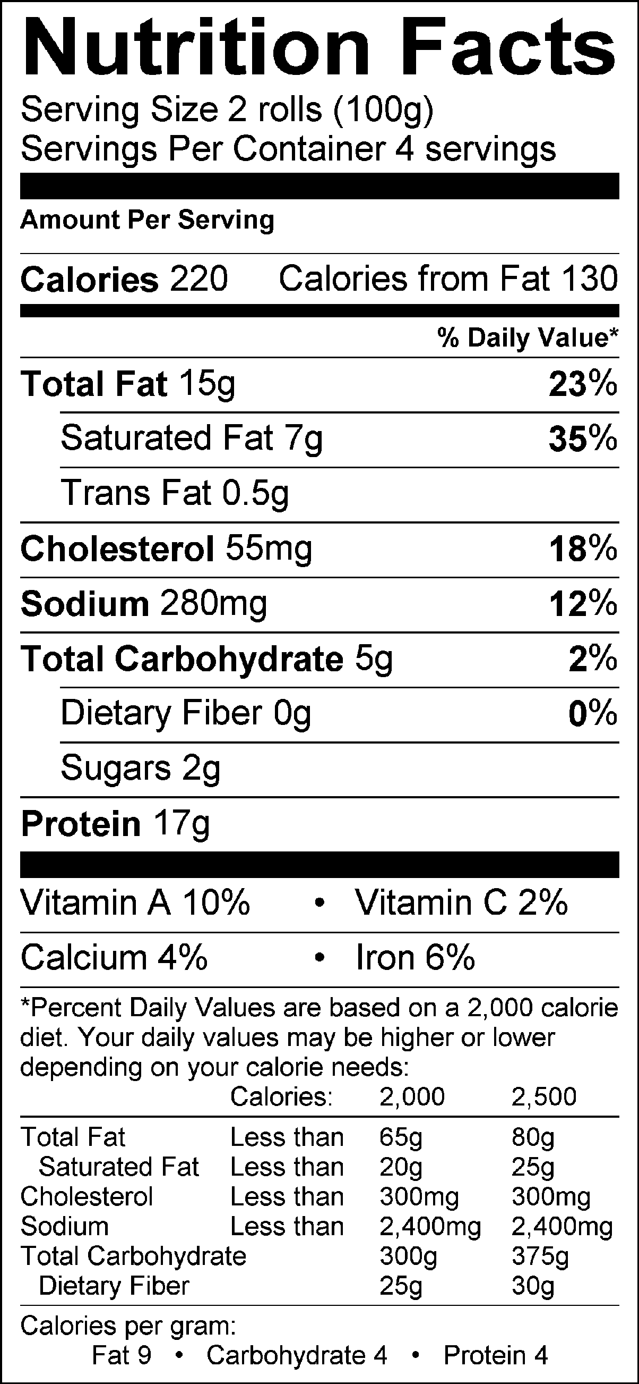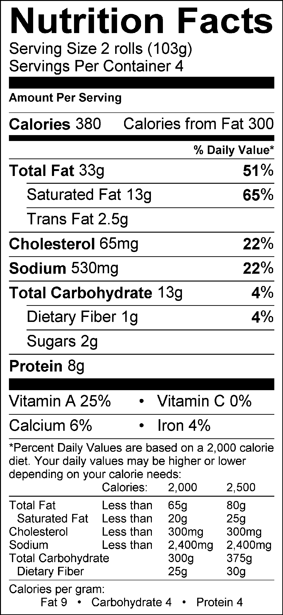

Chicken Crescent Rolls—Maxfield Chicken Pillows--Laura

Chicken Crescent, sauce—Maxfield Chicken Pillows, sauce--Laura
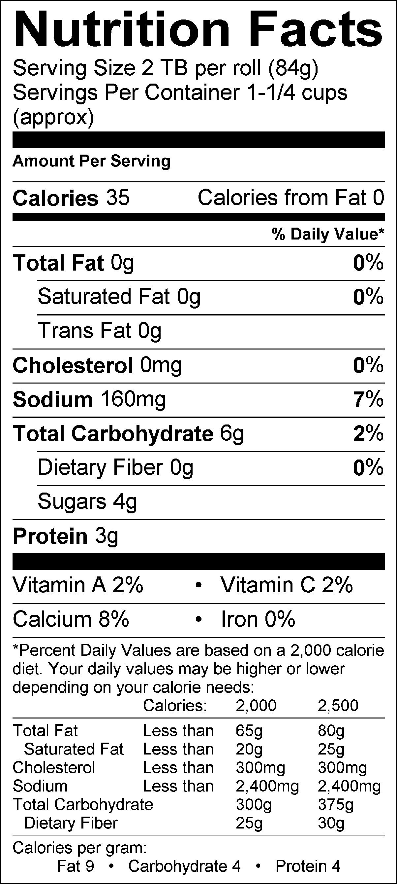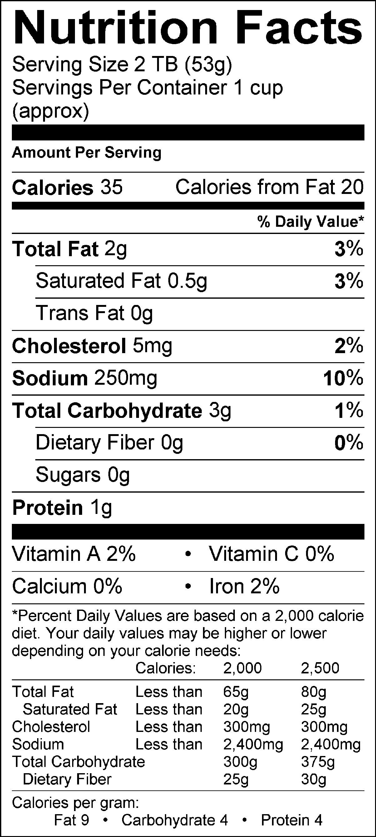
Analysis:
The cost of the chicken pastries themselves is within 2 cents of each other, it is the cost of the sauce that makes the final price difference of 33 cents. The Chicken Pillows not only start with raw chicken, but also have a coating, so the time is about 20 minutes longer to prepare than the Chicken Crescents. The fat content, due to the topping and twice as much cream cheese in the filling, is much higher in the Chicken Pillows than the Chicken Crescents. Even though the sauces are about the same calorically, the Chicken Pillows sauce using commercial Cream of Chicken soup has more of its calories from fat than does the SOS Mix sauce.

As easy as these are to make and freeze, it is surprising that a commercial version could not be found. The closest commercial chicken pastry was a Birdseye product sold in England that also contained potatoes, so it was more of a handheld chicken pot pie than a chicken pillow/chicken crescent roll.

Chicken Pillows

1 chicken breast, trimmed 1 can crescent rolls
8 oz. cream cheese, softened 1/3 c. crushed bread crumbs
1/2 tsp. dried chives 1/4 c. melted margarine
1/8 tsp. salt 1/2 can cream of chicken soup
1/8 tsp. pepper 1/4 c. water
1/2 tsp. onion powder

- Preheat the oven to 325°.
- With kitchen shears, trim and cut chicken into small, bite-sized pieces.
- In a large skillet over high heat, cook chicken breast until brown and cooked throughout. Set aside.
- With either the handheld electric mixer or the KitchenAid, whip the cream cheese until soft and creamy. Add dried chives, salt, pepper and onion powder and blend until combined.
- With a wooden spoon, stir in cooked chicken. Set aside.
- Open the crescent rolls and separate into individual triangles. Press out the triangles so that they double in size.
- Take a spoonful of the cream cheese/chicken mixture and place in the middle of each crescent roll until the entire mixture is evenly distributed before rolling up.
- Starting at the wide end, roll the crescent triangle toward the narrow end, pinching the dough together as you go, until all of the mixture is covered by the dough. (Make sure that all of the cracks are pressed together so that the mixture does not melt out as it bakes.)
- Roll the entire chicken pillow in the melted butter and then again in the crushed croutons.
- Place each chicken pillow on a greased cookie sheet, evenly spaced. Bake at 325° for 20 to 25 minutes, or until the crescent rolls are golden brown.
- While the chicken pillows are cooking, in a small saucepan, combine the cream of chicken soup and water and whisk over medium heat until completely combined. It should be smooth, with no lumps. When chicken pillows are done, remove from the oven, place on individual plates and cover with the cream sauce. Eat and enjoy.

Chicken Crescent Rolls

Ingredients
4 oz. cream cheese
2 Tbsp milk
1 small can chicken
1 green onion, sliced thin
1/4 tsp dried parsley
1/8 tsp salt
1/8 tsp pepper
1 crescent roll for each person in your group (1 can usually has 8 rolls)

Sauce
1/3 cup soup mix* (recipe below)
1 -1/4 cup water

Directions for crescent chicken rolls:
Preheat oven to 325°. Grease a cookie sheet.
In a medium glass bowl combine the cream cheese and milk with an electric mixer until well mixed and smooth.
Meanwhile slice green onion. Open chicken and drain off liquid.
Add chicken, onions, salt, pepper and parsley to cream cheese mixture and mix well.
Separate out crescent rolls. Flatten out until they are double the starting size. Place a spoon full in the middle of the big end of each crescent roll.
Fold the two corners of the big end over the mixture and roll the mixture up in the crescent roll.
Place on greased cookie/ parchment lined sheet and bake for 20-25 minutes or until golden brown.

Once in oven start sauce:
Combine 1/3 cup of sauce mix with 1 1/4 cup of cold water. Cook on a simmer until thick. Hold with lid on and removed from heat until chicken roll ups are done. To serve remove rolls from cookie sheet and drizzle sauce over the top. Enjoy!

Wrap Up Questions:
1. What three things in this recipe are complete proteins?
2. What acted as the protein extender in this meal?
3. If a vegetarian wanted to make this meal what would/ could they substitute in?

*SOUP OR SAUCE (SOS) MIX
USU Extension Services

Ingredients:
2 cups powdered non-fat dry milk
3/4 cup cornstarch
1/4 cup instant chicken bouillon (regular or low sodium)
2 TB dried onion flakes
2 tsp Italian seasoning (optional)

Directions:
Combine all ingredients in a recloseable plastic bag, mixing well.

Yield:
Equal to 9 (10.5 oz) cans of cream soup.

To substitute for 1 can of cream soup:
1. Combine 1/3 cup of dry mix with 1-1/4 cups of cold water. Whisk
until well blended.
2. Cook and stir on stove top or in microwave until thickened.
3. Add thickened mixture to casseroles as you would a can of soup.

Storage:
Store in sealed plastic bag or air-tight container until ready for use. It does not have to be refrigerated.

