Nutrition and Cost Analysis: Full-fat vs. Low-fat/fat-free Chocolate Cupcakes
Performance Objective 7

Food | Cost per package | Cost per recipe | Time: Prep + Cooking | Totals
1 Avocado | $1.05 | $1.05 | 10 +20 = 30 minutes | 30 minutes
3/4 c sugar  (150 g) | $1.88—2 lb. (907 g) | $0.32
1/2 c milk | $2.67—gallon | $0.09
1 tsp vanilla | $2.16—2 oz. | $0.16
1/4 tsp balsamic vinegar | $2.82—16 oz. | $0.01
1 egg WHITE | $2.68—dozen | $0.23
1 cup flour | $2.48—5 lb. (2.26 kg) | $0.14
1/4 c cocoa powder | $3.18—8 oz (226 g) | $0.31
1/2 tsp baking soda | $0.58—8 oz  (227 g) | $0.01
1/4 tsp salt | $1.12—26 oz.  (737 g) | $0.01 |  | $2.33
Betty Crocker Hershey’s Chocolate Cupcake Mix | $2.28—15 oz. box | $2.28 | 5 + 20 minutes = 25 minutes | 25 minutes  $2.28
Avocado recipe substituting 1/2 c. oil for the avocado | $2.32—48 oz | $0.20 |  | Recipe with oil and no avocado = $1.48

The prices and times are about the same, as are the total calories and fats. However, this is a good time for a discussion about types of fats and really reading the labels—the avocado cupcakes have a third of the saturated fats found in the mix, twice the dietary fiber, half the sodium and twice the potassium.

Chocolate Cupcakes with Avocado, whole milk, no frosting:
Betty Crocker Hershey’s Chocolate Cupcakes
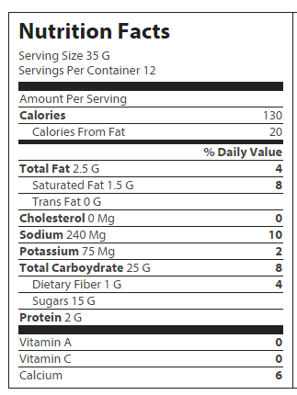

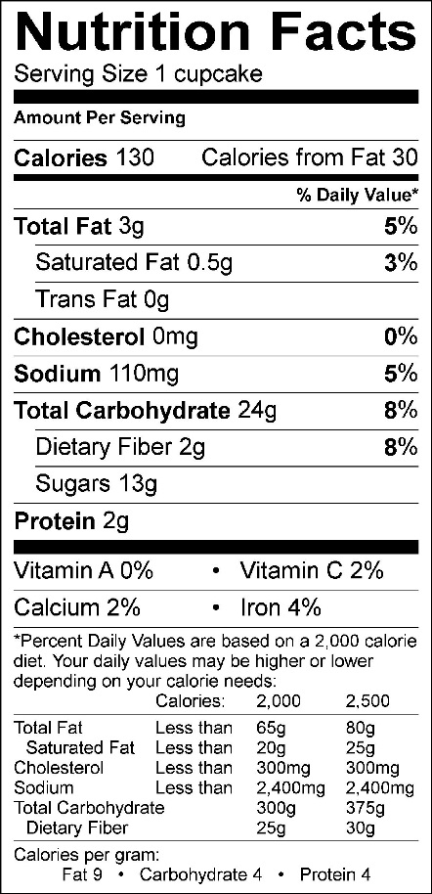

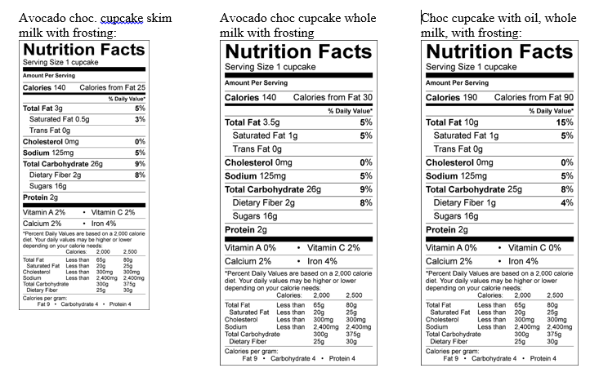
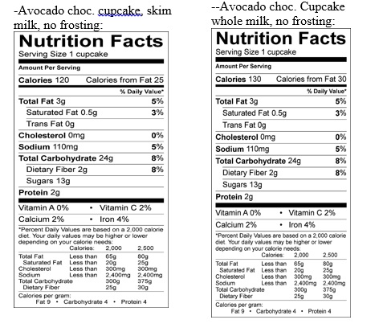

Chocolate Cupcakes (with avocado)

Ingredients
1 avocado, pureed
¾ c. sugar
½ c. milk
1 tsp. vanilla
¼ tsp. balsamic vinegar
1 egg WHITE (only)
1 c. flour
¼ c. cocoa powder
½ tsp. baking soda
¼ tsp. salt

Frosting:
¼ pkg. cream cheese, softened
¼ c. powdered sugar, sifted
½ tsp. vanilla
Pinch of salt

Directions:
- Preheat oven to 350 degrees F. Prepare muffin cups by spraying them with non-stick spray. (You will make 12 muffins)
- In a separate bowl, mash the avocado until smooth.
- Separate the egg yolks from the whites. Discard the yolks.
- In an electric mixer or bowl, beat the avocado puree, sugar, milk, vanilla and vinegar until smooth. Beat in the egg whites one at a time, just until incorporated.
- In a separate bowl, mix the flour, cocoa powder, baking soda, and salt. Add that to the wet batter and beat until smooth.
- Divide the batter among the muffin cups. Bake until the tops of the cupcakes are lightly browned and spring back to the touch for 20 minutes.
- Once finished, turn out onto a rack and cool completely before frosting.

Frosting:
Beat together the cream cheese, powdered sugar, vanilla and salt. Use the KitchenAid for easy clean up and less of a mess.

