-Actively participate in the preparation of a canned/frozen and/or fresh produce food. (Standard 5)
-Compare the nutritional content and cost of a comparable canned/frozen vs. fresh produce food. (Standard 5)

Canned/Frozen, Convenience Fruit/Vegetable vs. Fresh Produce Food
1- Strawberry Banana Smoothie vs. store bought Strawberry Banana Smoothie (mini bottles)
2- Chicken Stir-fry
3- Spinach Dip
1 – Strawberry Banana Smoothie
1 c. Strawberries
2 Ripe Bananas
1 c. Yogurt, any flavor
½ c. Sugar
1 tsp. Vanilla
½ c. Water
-----------------
4 c. Ice

Blend strawberries, bananas, yogurt, sugar, vanilla and water. Add ice cubes a cup at a time until well blended.
Vegetable Extravaganza, Spinach Dip,
Ingredient | Cost | Total Fat | Saturated Fat |  | Sodium
1 c. Strawberries
1 c. Strawberries
1 c. Yogurt, any flavor
1/2 c. Sugar
1 tsp. Vanilla
1/2 c. Water
Totals
Cost per Serving | Total Cost / Number of Servings = Cost per Serving

2 - Nutrition and Cost Analysis of Chicken Stir Fry—4 Servings
Performance Objective 8—Fresh vs. Frozen Produce

Food | Cost per Package | Cost per 4 Serving Recipe | Time: Prep + Cooking | Totals
1 tsp bouillon | $0.94—8 cubes | $0.12
1 c hot water | n/a
2 TB corn starch | $1.28—16 oz. (454 g) | $0.05
1/4 c soy sauce | $2.28—15 fl. oz. (444 mL) | $0.31
1/4 tsp minced garlic | $3.76—3 oz. | $0.03
1 chicken breast | $12.22—5 lb. | $1.47 | Prep time about 5 minutes
1-1/2 c instant brown rice | $2.00 per 14 oz. box | $0.68 |  | Subtotal: $2.66
1-1/2 c water | n/a |  | Rice cooking time 10 minutes | About 15 minutes
Vegetables:
1 c broccoli | $2.48—12 oz. florets pkg | $0.83
1 carrot—abt 1/2 cup | $0.68—16 oz. raw carrots | $0.09
1 celery | $1.36—16 oz. | $0.12
1/4 lg onion | $1.50—3 lb bag | $0.25 |  | Vege subtotal: $2.79
1/4 c. water chestnuts | $1.02—8 oz can (abt. 1/2 c) | $0.51 |  | Total recipe $5.45
1/4 c. snow peas | $2.48—8 oz. pkg | $0.99 | 10 + 15 = 25 minutes | Total recipe about 30-40 minutes
FROZEN VEGETABLES
1/4 pkg —10 oz  $1.67 |  | $.42 |  | Total recipe = $2.66 + $.42 = $3.08
--Broccoli, sugar snap peas, carrots, water chestnuts, peppers, mushrooms, baby corn |  |  | No prep time for vegetables + 4 minutes in microwave + 2 minutes in wok = 6 minutes | Total recipe using frozen = about 20 minutes
Innovation Chicken Fried Rice—18 oz. | $3.19 | $3.19 for 1 serving; 4 servings, $12.76 | Microwave 2 minutes, turn and 4 minutes | About 6 minutes
It is difficult to estimate time for these two recipes, but the advantages to frozen vegetables are: (1) no prep time washing, paring and chopping, (2) because they are blanched before they are frozen the cooking time is also shorter, (3) frozen vegetables last longer in than fresh so there is less waste, (4) total recipe cost is less.

Chicken Stir Fry:
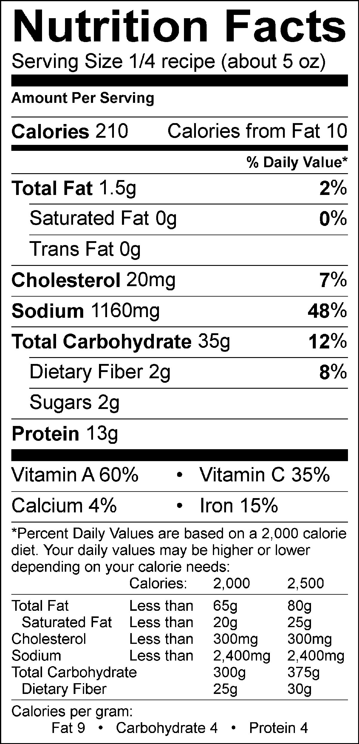

Chicken Stir Fry—Frozen Vegetables 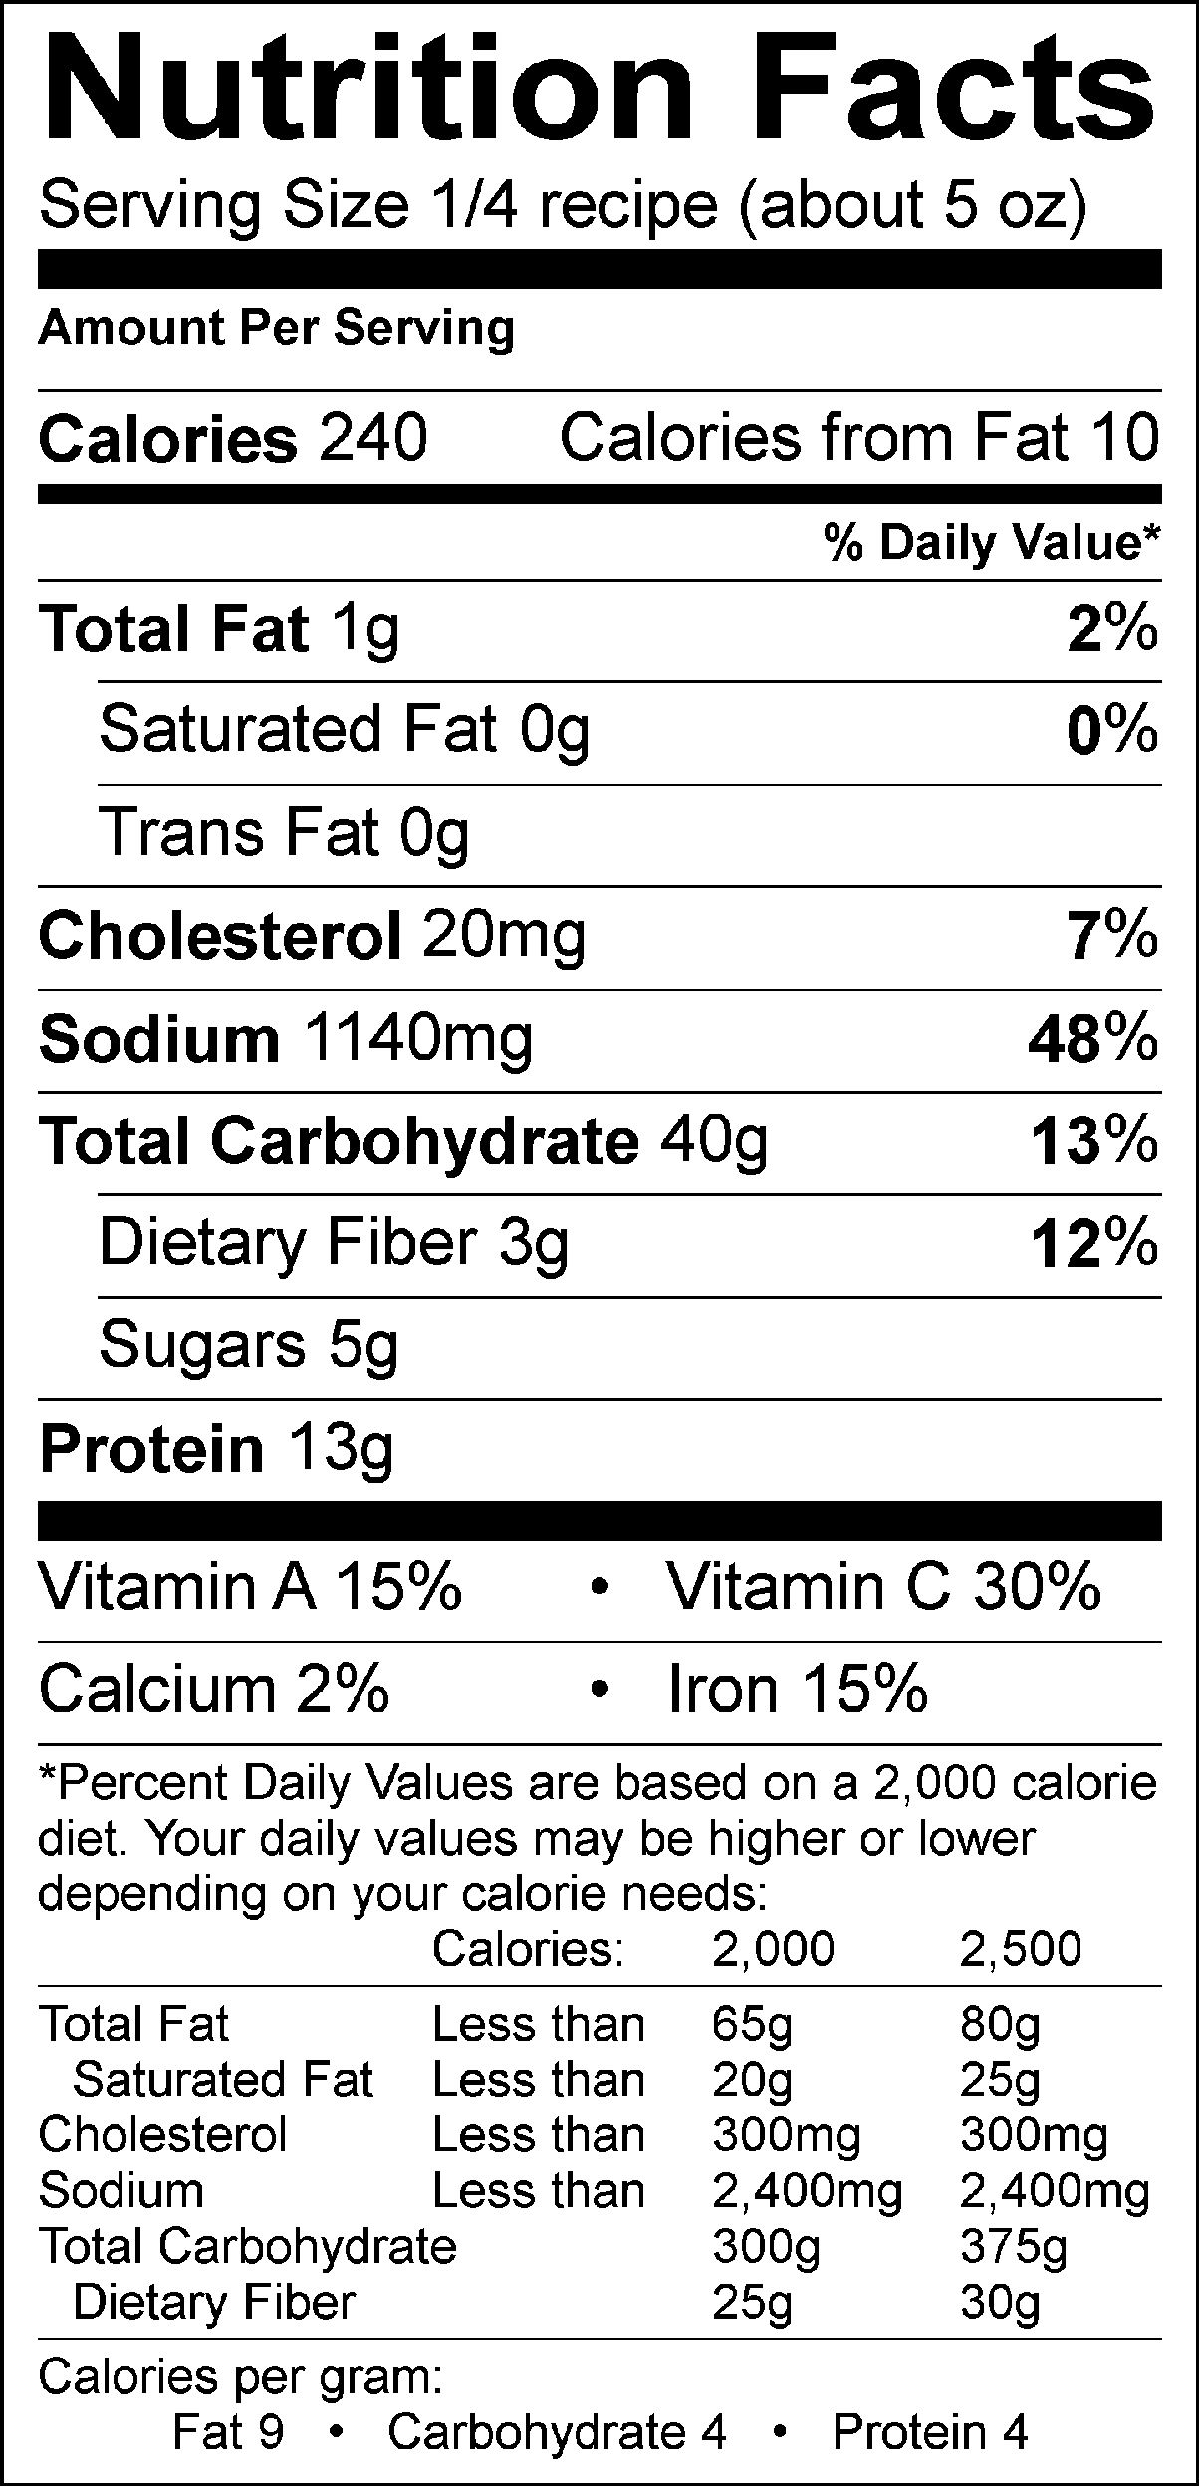

To go totally convenience food, here is the Innovation label:

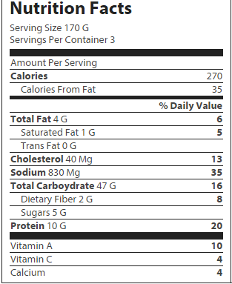

Birds Eye Oriental Stir Fry Vegetables:
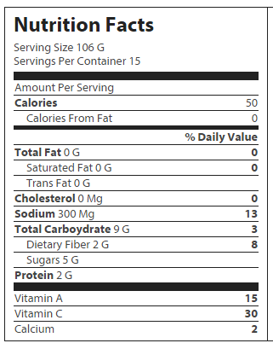

2 – Chicken Stir Fry—Fresh Vegetables

Base: Vegetables:
1 t. Bouillon 1 stalk of celery (about 3/4 c)
1 c. Hot water 1/4 of a large onion
2 Tbsp. corn starch 1/4 c. water chestnuts
1/4 c. Soy Sauce 1/4 c. snow peas (or sugar snap)
1/4 tsp. minced garlic 1 cup or 1 small bunch of broccoli
1 chicken breast, bite-sized pieces 1 carrot (about 1/2 cup)
1-1/2 c instant rice (brown is best)
1-1/2 c water (for the rice)

Pre-Heat
- Get out the biggest skillet you have and pre-heat on medium .

Chicken
- Cut chicken into bite-sized pieces. Pour 2 t. of oil into the pan. Then saute the minced garlic and onions. Next add the chicken pieces and cook on medium-high heat until cooked through and golden brown.

Vegetables
- Wash and cut up: broccoli, carrot (remember to peel first), celery and onion into bite-sized pieces. Cut the water chestnuts in half. Wash and trim snow peas. Keep your vegetables separated in bowls or custard cups. Do not combine them all together.
- Add only the carrots and broccoli stems to the skillet and cook for about 5 minutes or until tender with the lid off. Add celery, water chestnuts and snow peas and cook for an additional 10-15 minutes, or until all vegetables are tender. Add about 1/4 c. of water to the vegetables if they start to stick or burn while cooking. Stir the vegetables constantly.
- Add 1 c. hot water and bouillon and bring to a boil.
- In a cereal bowl, combine soy sauce and cornstarch. Stir with a fork until completely dissolved and smooth. Slowly add the soy sauce mixture to the stir fry. Stir on medium low heat until it thickens and turns dark brown. Remove from heat and pour over hot cooked rice.

Rice
- In a small glass bowl, combine instant rice and 1 ½ c. water. Cover with plastic wrap. (Remember to poke a hole in the top to allow some steam to escape.) Cook in the microwave for 5 minutes. Allow to stand for 2-4 minutes or until all water is absorbed. Watch the rice carefully. You may need to replace the plastic wrap a couple of times during the cooking process.

Name:______________________ Period:_________ Table #:_____

Performance #8-Fresh vs Frozen Produce

Directions: Write a 2 paragraph essay. In the first paragraph compare and contrast details of the products. Be sure to include nutritional facts like the amount of vitamins, minerals, calories, fat and anything else that you think would be significant to you nutritionally. Also be sure to include price facts, time, and any other specifics that you think are important like flavor and texture differences between fresh vs frozen. In the 2nd paragraph, state which product you think was better and justify why you would choose that product and give a scenario in which you would use the product

3 – Apple Crisp

Ingredient | Cost | Total Fat | Saturated Fat | Sodium
½ c. Flour
½ c. Brown Sugar
¼ c. Butter
¼ c. Oatmeal
2 Apples
2 Tbsp. Sugar
¼ tsp. Cinnamon
½ tsp. Cornstarch

- Make topping by cutting in the margarine/butter into the
flour and brown sugar using a pastry blender.
- Add the oatmeal and stir it in.
- Prepare the fruit filling by grating the apples then adding all of the rest of the ingredients together.
- Line a square pan with foil. Grease with cooking spray then place fruit on the bottom of the pan.
- Sprinkle crumbly mixture on top.
- Bake at 375º for 20 minutes or until crust is done

